Donation to help children with cancer: B&R supporting Project Sonneninsel
Building a future for children and teenagers – that is the goal of the Project Sonneninsel (Sun Island) follow-up care program undertaken by the Austrian Childhood Cancer Organization. With their donation of three thousand euros, B&R is making a considerable contribution to optimizing the psychosocial aftercare provided for children and teenagers who have suffered from cancer. "When a child becomes sick, it changes his or her life for years to come," explains project manager Peter Hettich. "Long-term therapy and spending days on end at the hospital take their toll on these young patients, their siblings and their parents. With Project Sonneninsel, we want to provide support for the entire family to help them deal with what they are going through while also doing our best to help them overcome the stress and anxiety they experience."
Positive rehabilitation and reflecting on things that happen during the course of the disease as well as strengthening the patient's sense of self-worth are the focus of the pyschotherapeutic care provided by project support staff. "Taking part in activities together on 'Sun Island' allows children and teenagers to share their experiences with one another," explains Nicole Rainer, personnel manager at B&R. "It's a place where they can rediscover their own abilities and explore their feelings in addition to reconditioning themselves physically. That's why we felt it was so important for us to support this initiative, to help these young people recover and get back to living their lives the way they want."

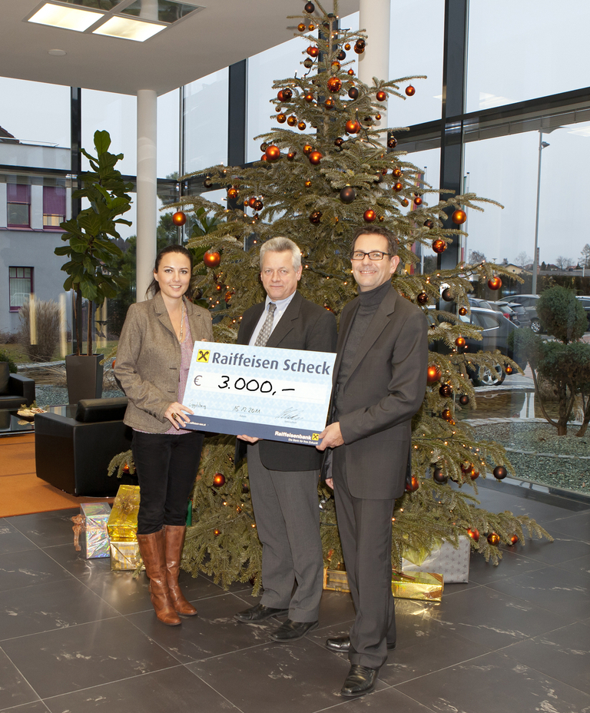
Follow-up care for young people suffering from cancer is extremely important to help them come to terms with what they are going through. Peter Hettich (center) is very grateful for receiving a 3000 euro donation from B&R for this valuable program.

About B&R
B&R, a division of ABB Group, is a global leader in industrial automation headquartered in Austria. B&R combines state-of-the-art technology with advanced engineering to provide customers in virtually every industry with complete solutions for machine and factory automation, motion control, HMI and integrated safety technology. With Industrial IoT communication standards including OPC UA, POWERLINK and openSAFETY as well as its Automation Studio software, B&R is constantly redefining the future of automation engineering. The innovative spirit that keeps B&R at the forefront of industrial automation is driven by a commitment to simplifying processes and exceeding customer expectations.
For more information, visit www.br-automation.com.

