Donation to help children with cancer: B&R supporting Project Sonneninsel
Building a future for children and teenagers – that is the goal of the Project Sonneninsel (Sun Island) follow-up care program undertaken by the Austrian Childhood Cancer Organization. With their donation of three thousand euros, B&R is making a considerable contribution to optimizing the psychosocial aftercare provided for children and teenagers who have suffered from cancer.
"When a child becomes sick, it changes his or her life for years to come," explains project manager Peter Hettich. "Long-term therapy and spending days on end at the hospital take their toll on these young patients, their siblings and their parents. With Project Sonneninsel, we want to provide support for the entire family to help them deal with what they are going through while also doing our best to help them overcome the stress and anxiety they experience."
Positive rehabilitation and reflecting on things that happen during the course of the disease as well as strengthening the patient's sense of self-worth are the focus of the pyschotherapeutic care provided by project support staff. "Taking part in activities together on 'Sun Island' allows children and teenagers to share their experiences with one another," explains Nicole Rainer, personnel manager at B&R. "It's a place where they can rediscover their own abilities and explore their feelings in addition to reconditioning themselves physically. That's why we felt it was so important for us to support this initiative, to help these young people recover and get back to living their lives the way they want."

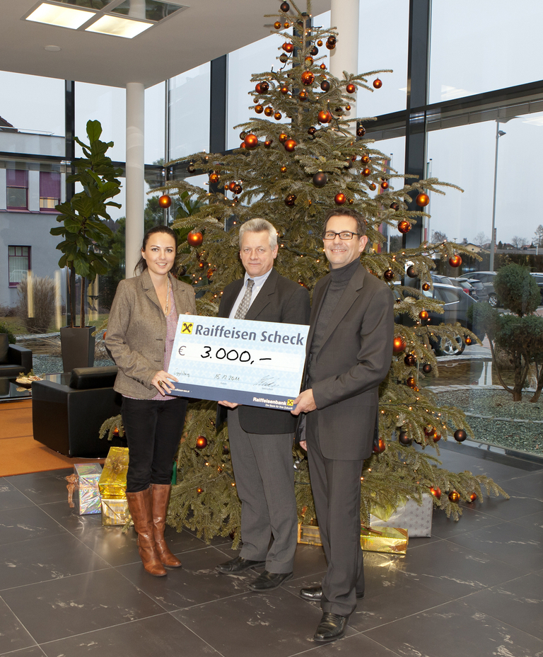
Follow-up care for young people suffering from cancer is extremely important to help them come to terms with what they are going through. Peter Hettich (center) is very grateful for receiving a 3000 euro donation from B&R for this valuable program.

关于贝加莱
贝加莱是一家总部位于奥地利并在全球拥有分公司的创新型自动化企业。2017年7月，贝加莱成为ABB集团的机械自动化事业部。作为工业自动化领域的全球领导者，贝加莱将前沿技术与领先工程相结合，为几乎每个行业的客户提供面向机器与工厂自动化、运动控制、HMI和集成安全技术的完整解决方案。借助于OPC UA、POWERLINK、openSAFETY等工业物联网通信标准，以及强大的Automation Studio软件开发平台，贝加莱不断重新定义自动化工程的未来。受简化流程和超出客户预期的承诺驱动，贝加莱始终保持创新精神并处于工业自动化领域的前沿。
获取更多信息，请访问www.br-automation.com。

