Career guidance for young engineers at B&R
Around 200 students from the nearby technical high school (HTBLA) in Braunau were able to get a firsthand look at many different career options during their visit to the B&R Open House held on December 20-21.
Touring around the company in small groups, students had a chance to meet B&R employees at their workstations and learn about the various technical, professional and developmental aspects related to each particular field. "A company like B&R is home to many different kinds of professions, including hardware and software developers, support and application engineers, and IT specialists, just to name a few," explains Thomas Dicker, B&R's in-house representative for student outreach. For students rapidly approaching graduation, the open house is the perfect opportunity to get a feel for the many different opportunities open to them as they start their careers.
I'm graduating, so now what?
Many of our young visitors took advantage of the open house to think about the direction their interests were leading them and also consider what having a career actually means. "The event was a great opportunity for the participants to find out more about the individual departments at B&R. For me, it is important to know specifically what career options I have after school," said Christina Gratzl, a 5th AHMEA student. David Sandru also took advantage of the chance to learn more about his options. "We got a firsthand look at the tasks handled by the various departments," he said. "And after finishing school, you definitely want to know what's coming next. I thought it was interesting that B&R also provides continued training to all of their new employees, which is very helpful when you've decided to make the jump into a particular profession."
B&R has had a close relationship with the HTBLA in Braunau for several years. In addition to sponsorship and support for final projects, our company has always made an effort to show students the advantages provided by the many careers options available in the field of industrial automation. Teacher Johannes Fasching sees advantages for his students not just through this close cooperation but also through events like the open house. "Probably the most positive thing about the open house is that students have the chance to approach workers who can explain the ins and outs of what they do every day," he said. "When we take field trips to other places, this usually isn't possible due to time constraints, which is another reason that we think the open house is such a great idea."

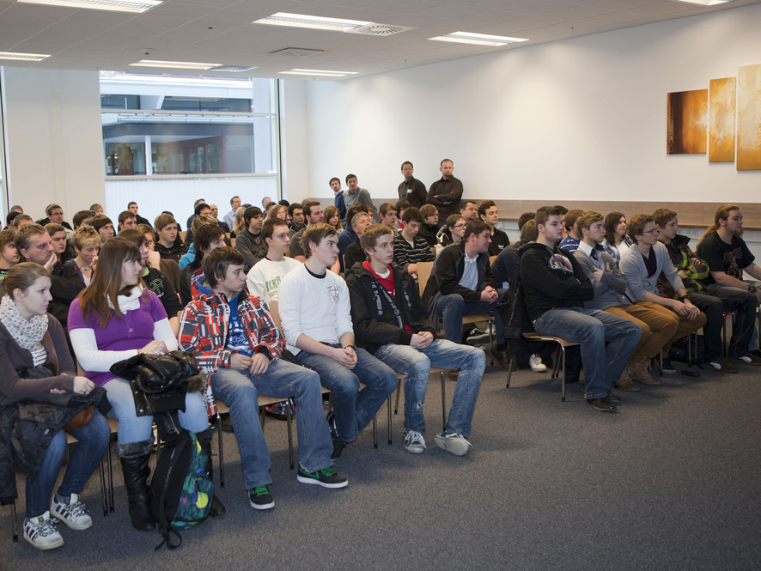
Upon arrival at the open house, students are greeted and given a brief introduction to B&R.
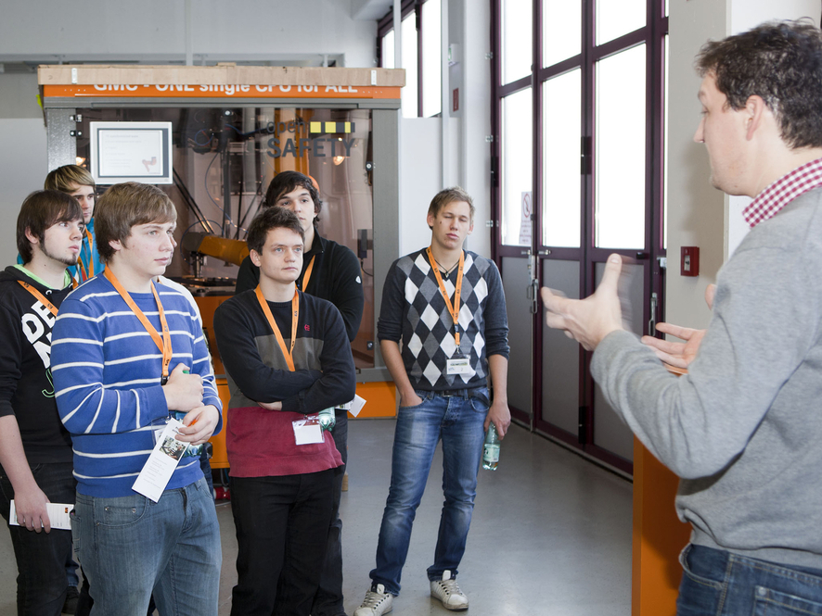
Herbert Maier, manager of the Application department, tells students what it means to be an application engineer.
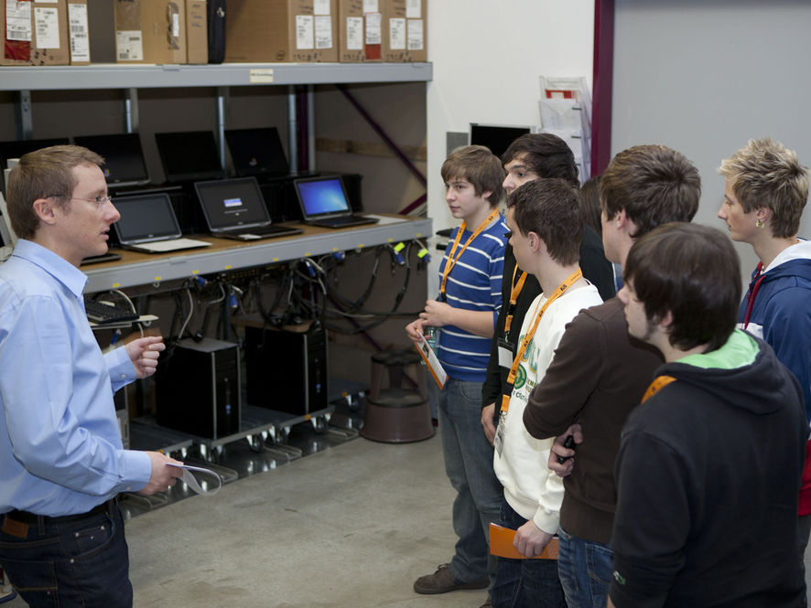
IT manager Reinhard Achatz explains some of the duties he performs on a daily basis.
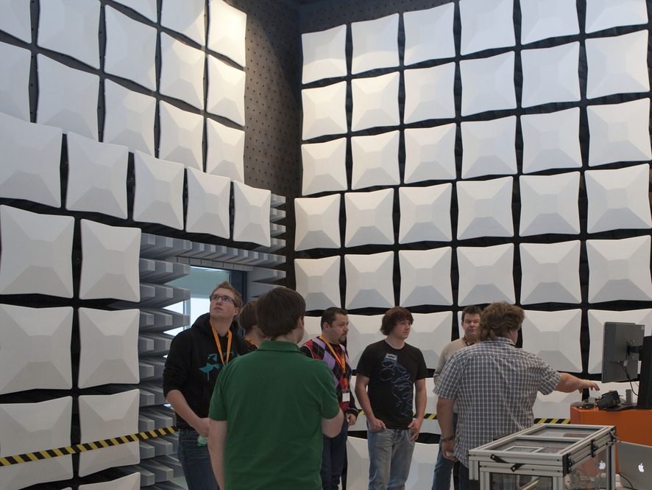
While in the absorber hall, students learn about the different tasks handled in the area of hardware development when it comes to control technology.

B&R Hakkında
ABB Grubunun bir bölümü olan B&R, merkezi Avusturya'da bulunan endüstriyel otomasyon alanında global bir liderdir. B&R, neredeyse her sektördeki müşterilere makine ve fabrika otomasyonu, hareket kontrolü, HMI ve entegre güvenlik teknolojisi için eksiksiz çözümler sunmak üzere en son teknolojiyi ileri mühendislikle birleştiriyor. OPC UA, POWERLINK ve openSAFETY gibi Endüstriyel IoT iletişim standartlarının yanı sıra Automation Studio yazılımıyla B&R, otomasyon mühendisliğinin geleceğini sürekli olarak yeniden tanımlıyor. B&R'ı endüstriyel otomasyonun ön saflarında tutan yenilikçi ruh, süreçleri basitleştirme ve müşteri beklentilerini aşma taahhüdünden kaynaklanmaktadır.
Daha fazla bilgi için www.br-automation.com adresini ziyaret edin.

