Not only efficient, but smart: The next generation of Automation Studio
With the comprehensive Automation Studio 4 software package, B&R has forged an entirely new path when it comes to smart engineering. Many convenient automated functions as well as true-to-life architecture modeling, version control, support for shared projects and simple object-oriented programming take program design efficiency to a whole new level.
"The only way a development system will succeed in the long run is if it can provide developers an easy way to manage their increasingly complex programs," explains Dr. Hans Egermeier, who is the manager responsible for Automation Studio at B&R. He works in close cooperation with external usability experts to make sure that Automation Studio meets this important requirement.
Concurrent engineering accelerates time to market
Project modularization is one area that makes working with Automation Studio 4 easier. This software allows individual projects to be split up into manageable pieces so that several developers can work on them at the same time. The new integrated version control system ensures stability and consistency.
Hardware configuration – often the first step in system development – is handled by arranging photorealistic images of components in the new Automation Studio System Designer. The automatic application of the necessary configuration parameters saves an incredible amount of time and prevents errors from occurring in the first place.
Standard: Mechatronics support
For consistent and uniform development of mechanics, electronics and the automation software, B&R Automation Studio 4 comes equipped with an interface to EPLAN Electric P8, which allows ECAD projects and the hardware configuration in Automation Studio to be synchronized. Similar interfaces to simulation programs make it possible to verify the results of development or, conversely, to use the results of simulation as a starting point for system design.
In addition, communication via OPC Unified Architecture ensures compatibility with numerous systems from other manufacturers. Direct support of web technologies facilitates the development of visualization, process control and remote maintenance applications.
Smarter programming languages and templates
Advanced functions for object-oriented programming with C++ makes programming with classes and objects much more convenient. A smart editor uses function libraries and sections of code that have already been programmed to provide context-sensitive suggestions. During development, predefined visualization templates also accelerate the design of user interfaces.
"B&R Automation Studio 4 not only helps create clearly structured software architecture when a project is first being developed, but also when designing new variants and options or performing project maintenance," says Dr. Egermeier. "Its smart features provide optimal support for quickly and easily developing sustainable solutions."

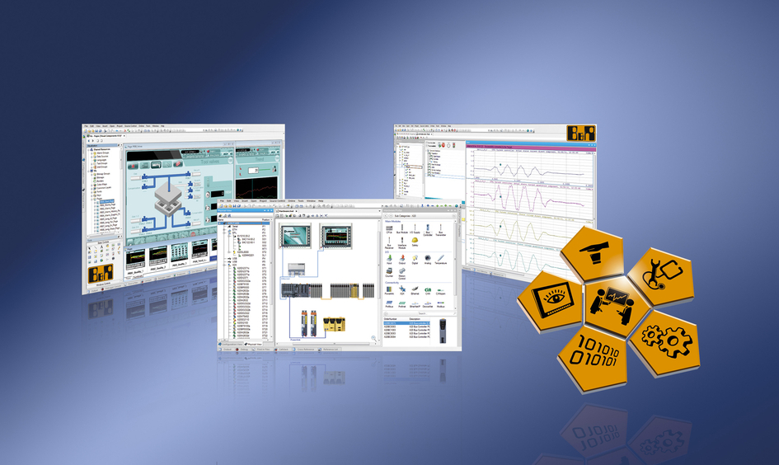
Smart Engineering makes it possible to minimize time to market and still maintain low development costs, even in the face of steadily increasing product complexity.

B&R Hakkında
ABB Grubunun bir bölümü olan B&R, merkezi Avusturya'da bulunan endüstriyel otomasyon alanında global bir liderdir. B&R, neredeyse her sektördeki müşterilere makine ve fabrika otomasyonu, hareket kontrolü, HMI ve entegre güvenlik teknolojisi için eksiksiz çözümler sunmak üzere en son teknolojiyi ileri mühendislikle birleştiriyor. OPC UA, POWERLINK ve openSAFETY gibi Endüstriyel IoT iletişim standartlarının yanı sıra Automation Studio yazılımıyla B&R, otomasyon mühendisliğinin geleceğini sürekli olarak yeniden tanımlıyor. B&R'ı endüstriyel otomasyonun ön saflarında tutan yenilikçi ruh, süreçleri basitleştirme ve müşteri beklentilerini aşma taahhüdünden kaynaklanmaktadır.
Daha fazla bilgi için www.br-automation.com adresini ziyaret edin.

