KHS and B&R take the "iF gold award"
An intuitive operating concept with clearly arranged symbols – this approach of keeping the focus on the user is what allowed a new KHS operator panel to win over the jury for the "iF communication design award 2011". Developed in close cooperation with B&R and based on advanced Power Panel technology, this innovative machine operator panel can handle all of the requirements of the foodstuffs and packaging industries. By seamlessly linking ergonomics, navigation and design, complex processes can be depicted in a way that is easy for the user to understand and manage. From among 900 products, this newly designed HMI system was able to rise above the crowd to win the coveted "iF gold award".
New standards in machine operation
With its modern flatscreen design, this state-of-the-art operator panel is able to meet the strict hygienic requirements of the foodstuffs and packaging industries. A high level of operating comfort for personnel is provided by the 4:3 resistive touch screen as well as the B&R illuminated ring keys with multi-color LEDs. Its colorful imagery, icons and interactive operating instructions make it extremely easy to enter and modify parameters. Also part of the system is an integrated RFID transponder that handles user management by only providing access to the detailed views and operating levels that are actually needed by each operator.
Another decisive advantage of this new HMI system is that it consolidates the user interfaces of machines on a production line that used to be handled separately. As a central operating and control unit, the B&R Panel PC combines control, visualization and drive technology into a single device, making it possible to control and monitor individual machines and complete production lines from a single interface.
HMI system wins the "red dot design award"
The operator panel designed by KHS and B&R didn't just stop at the iF award, however. Its modern design also took it to the top at a ceremony held at the red dot design museum in Essen, Germany, taking home the "red dot: best of the best" award. Of 6,000 registrants from 44 countries, just over 1% were bestowed with this honor. And as if winning several awards in 2011 weren't enough, the operator panel has already been nominated for "Germany's Design Prize of 2012" as well.

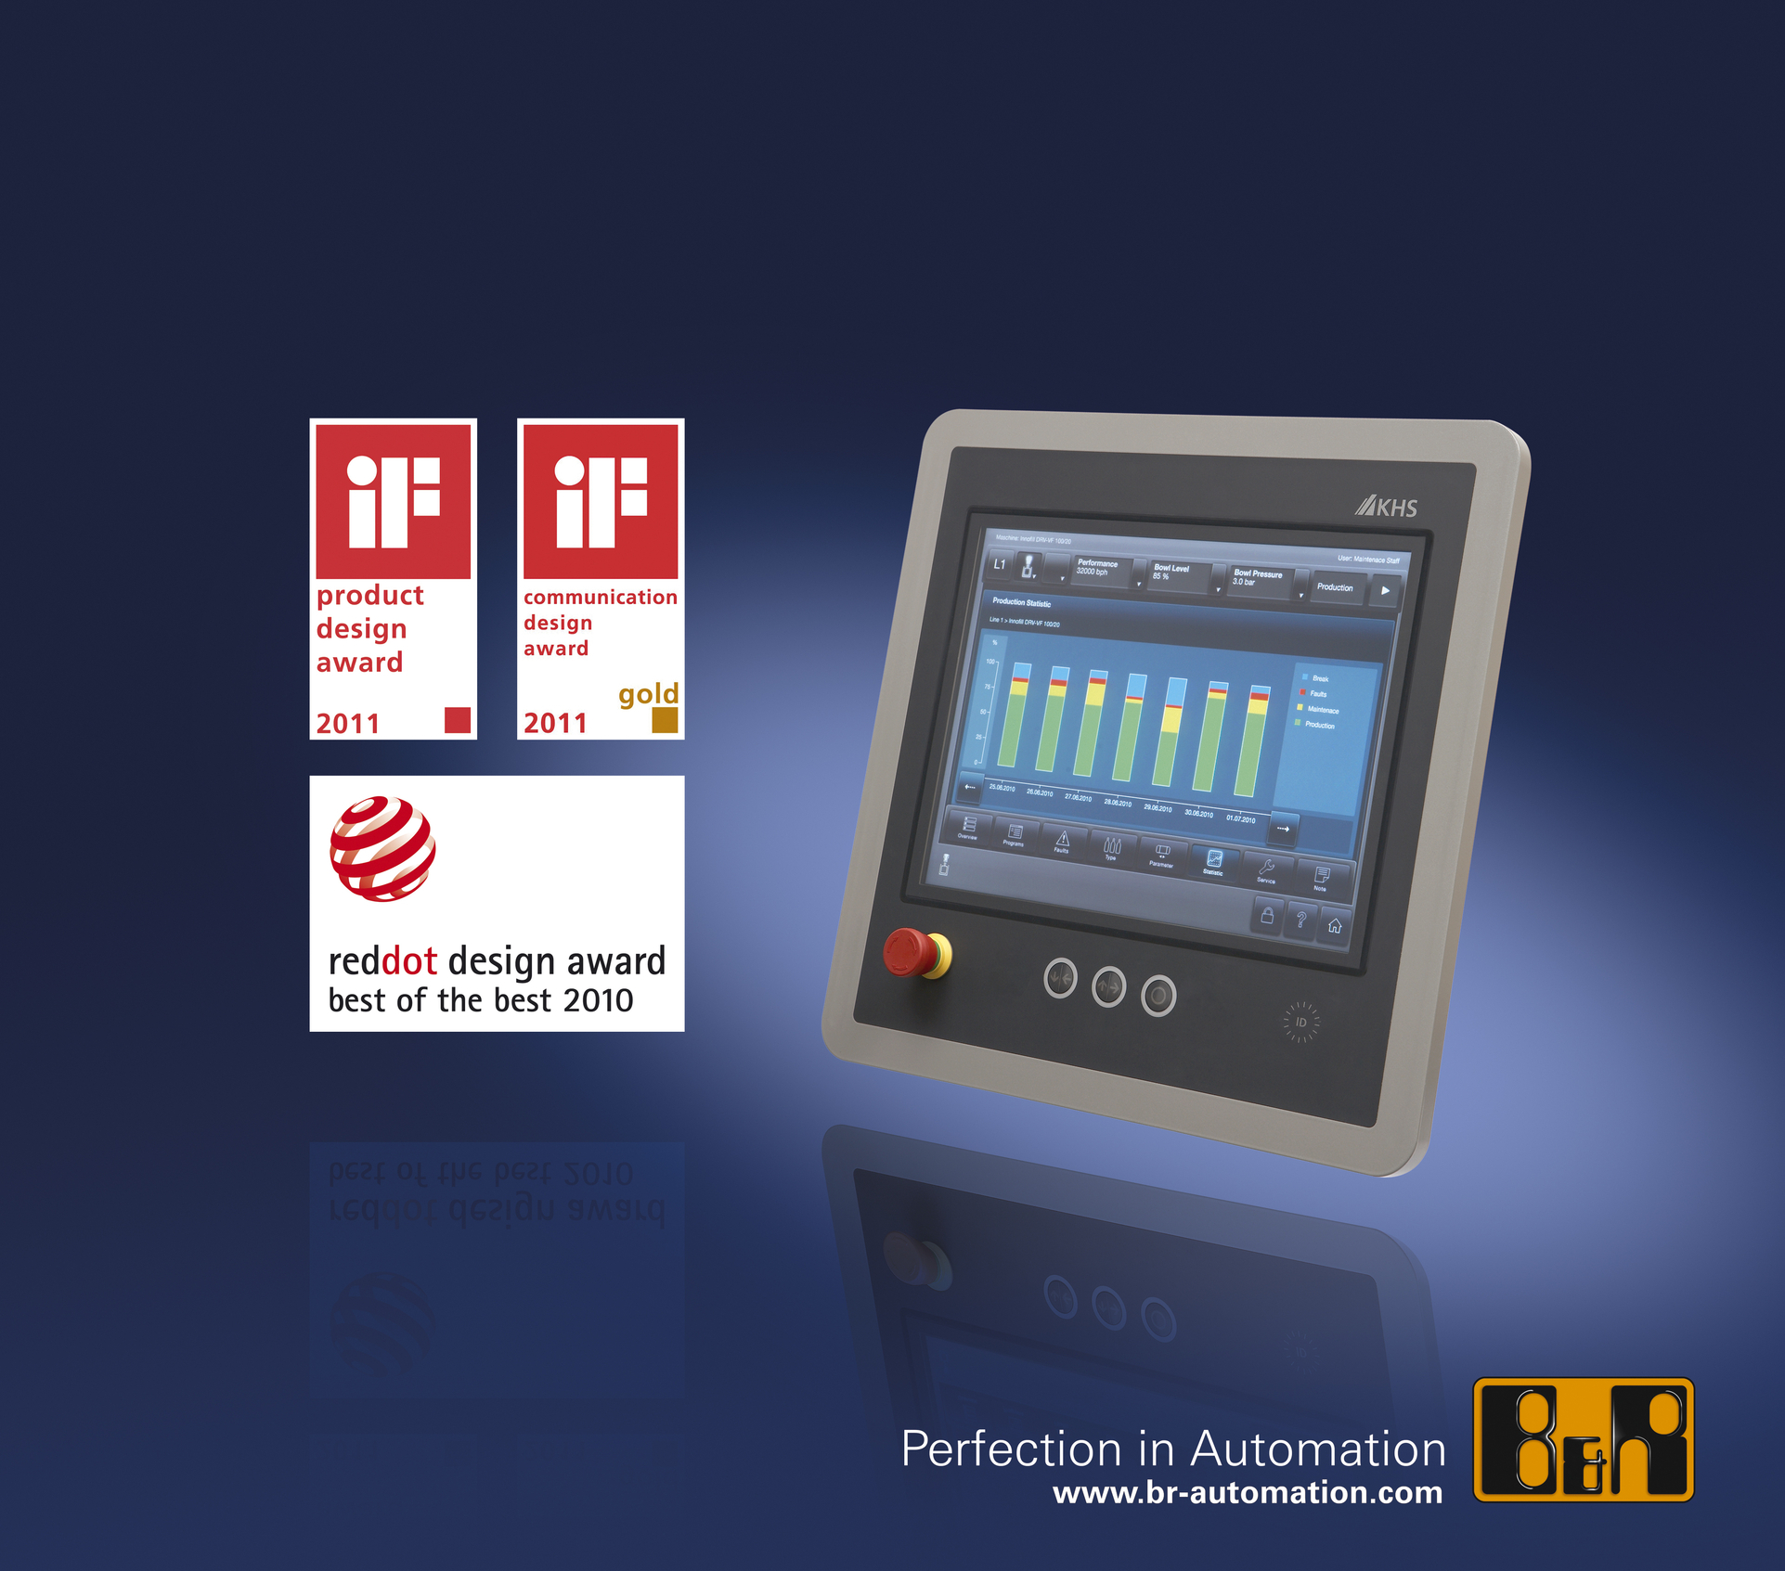
By seamlessly combining ergonomics, navigation and design, the KHS panel fulfills all the requirements of intuitive operation.

B&R Hakkında
ABB Grubunun bir bölümü olan B&R, merkezi Avusturya'da bulunan endüstriyel otomasyon alanında global bir liderdir. B&R, neredeyse her sektördeki müşterilere makine ve fabrika otomasyonu, hareket kontrolü, HMI ve entegre güvenlik teknolojisi için eksiksiz çözümler sunmak üzere en son teknolojiyi ileri mühendislikle birleştiriyor. OPC UA, POWERLINK ve openSAFETY gibi Endüstriyel IoT iletişim standartlarının yanı sıra Automation Studio yazılımıyla B&R, otomasyon mühendisliğinin geleceğini sürekli olarak yeniden tanımlıyor. B&R'ı endüstriyel otomasyonun ön saflarında tutan yenilikçi ruh, süreçleri basitleştirme ve müşteri beklentilerini aşma taahhüdünden kaynaklanmaktadır.
Daha fazla bilgi için www.br-automation.com adresini ziyaret edin.

