Taking precision and robustness to a whole new level
Efficient winder technology for printing on ultra-thin plastic film
One the of the latest technological innovations at B&R is a high-precision, robust software library for controlling winder processes. It can handle open-loop tension control using a set torque value or closed-loop tension control with the aid of measurement value feedback or a dancer.
The benefits are impressive: Tension can be stabilized even in the acceleration and deceleration phases by automatically adjusting both the speed control parameters of the drive and the feed-forward controls for speed and acceleration. Together with a precise calculation of the winder diameter, these features take precision and robustness to a whole new level. High-quality printing on ultra-thin highly elastic film demands this type of advanced technology, which can boost the efficiency of these machines.
The range of functions is not limited solely to printing machines, however; it includes all winding processes such as those involving wire saws, sheet metal, textiles, and much more.

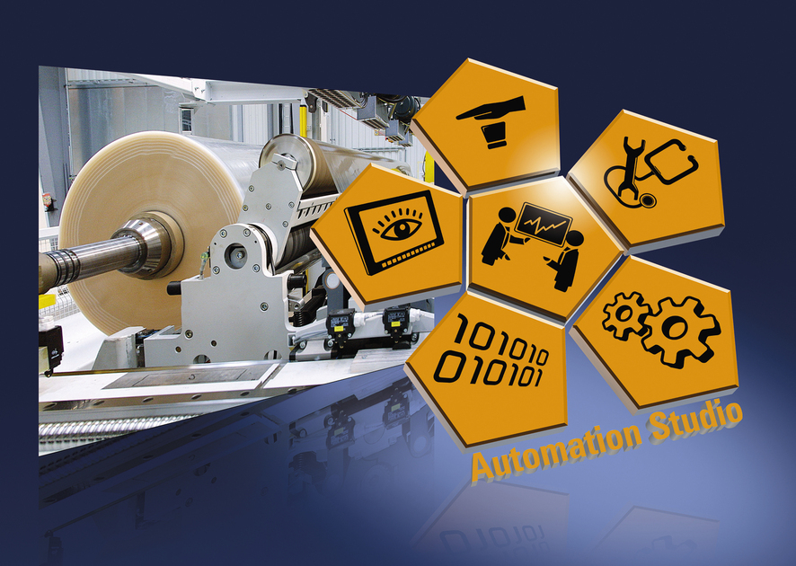
Users profit from high-precision, robust control of winding processes with this new software library from B&R.

About B&R
B&R, a division of ABB Group, is a global leader in industrial automation headquartered in Austria. B&R combines state-of-the-art technology with advanced engineering to provide customers in virtually every industry with complete solutions for machine and factory automation, motion control, HMI and integrated safety technology. With Industrial IoT communication standards including OPC UA, POWERLINK and openSAFETY as well as its Automation Studio software, B&R is constantly redefining the future of automation engineering. The innovative spirit that keeps B&R at the forefront of industrial automation is driven by a commitment to simplifying processes and exceeding customer expectations.
For more information, visit www.br-automation.com.

