The future is mechatronic
Developing with B&R Automation Studio and EPLAN Electric P8
Eggelsberg/Monheim - The lines separating mechanical, electrical and software engineering are becoming increasingly blurred. Clearly, the development tools used in these fields need to work as closely together as the engineers themselves. B&R and EPLAN are taking a proactive role in shaping this trend by developing a seamless interface between B&R Automation Studio and EPLAN Electric P8. The simple goal: to make these tools even more valuable for the users.
Seamless interface streamlines engineering
"Our users can easily carry over hardware configurations and I/O mapping tables from B&R Automation Studio, reducing the time and cost of development by avoiding unnecessary input repetitions and redundant workflow," explains Rainer Burgard, Key Account Manager at EPLAN, in the German town of Monheim. B&R hardware contained in an EPLAN Electric P8 project can be integrated into the hardware tree of an Automation Studio project at the push of a button. An intelligent side-by-side comparison tool provides a clear overview of which components the two projects already have in common and where changes have been made.
Round-trip synchronization
Intelligent import and export mechanisms streamline day-to-day workflow when using multiple software tools. Yet B&R and EPLAN take it even a step further: The electrical plan and automation project are synchronized using "round-trip engineering" features.
These features ensure that the two projects are always aligned and up-to-date. This has clear advantages: "Automated data exchange prevents errors that might otherwise occur in the course of interdisciplinary communication, thereby improving the quality of the end product. This contributes to reduced maintenance costs later in a system's life cycle," explains Heinz Fürnschuss, the B&R Technical Manager who is responsible for developing the EPLAN interface. "Modifications can be made more quickly, more easily and more inexpensively, since the system documentation and software are always current and synchronized."

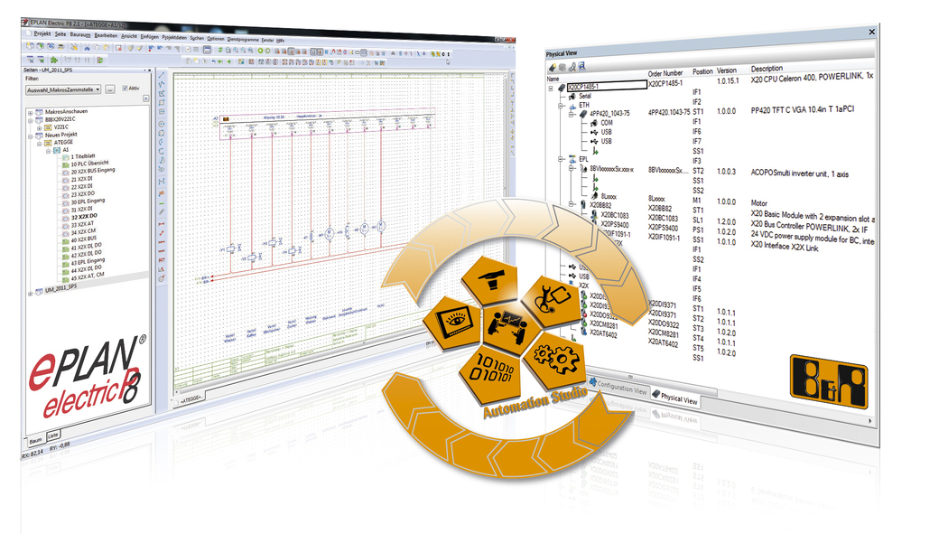
The close cooperation between B&R and EPLAN ensures optimal integration in Automation Studio, a clear and comprehensive workflow and enduring support for the user.

About B&R
B&R, a division of ABB Group, is a global leader in industrial automation headquartered in Austria. B&R combines state-of-the-art technology with advanced engineering to provide customers in virtually every industry with complete solutions for machine and factory automation, motion control, HMI and integrated safety technology. With Industrial IoT communication standards including OPC UA, POWERLINK and openSAFETY as well as its Automation Studio software, B&R is constantly redefining the future of automation engineering. The innovative spirit that keeps B&R at the forefront of industrial automation is driven by a commitment to simplifying processes and exceeding customer expectations.
For more information, visit www.br-automation.com.

