The future is mechatronic
Developing with B&R Automation Studio and EPLAN Electric P8
Eggelsberg/Monheim - The lines separating mechanical, electrical and software engineering are becoming increasingly blurred. Clearly, the development tools used in these fields need to work as closely together as the engineers themselves. B&R and EPLAN are taking a proactive role in shaping this trend by developing a seamless interface between B&R Automation Studio and EPLAN Electric P8. The simple goal: to make these tools even more valuable for the users.
Seamless interface streamlines engineering
"Our users can easily carry over hardware configurations and I/O mapping tables from B&R Automation Studio, reducing the time and cost of development by avoiding unnecessary input repetitions and redundant workflow," explains Rainer Burgard, Key Account Manager at EPLAN, in the German town of Monheim. B&R hardware contained in an EPLAN Electric P8 project can be integrated into the hardware tree of an Automation Studio project at the push of a button. An intelligent side-by-side comparison tool provides a clear overview of which components the two projects already have in common and where changes have been made.
Round-trip synchronization
Intelligent import and export mechanisms streamline day-to-day workflow when using multiple software tools. Yet B&R and EPLAN take it even a step further: The electrical plan and automation project are synchronized using "round-trip engineering" features.
These features ensure that the two projects are always aligned and up-to-date. This has clear advantages: "Automated data exchange prevents errors that might otherwise occur in the course of interdisciplinary communication, thereby improving the quality of the end product. This contributes to reduced maintenance costs later in a system's life cycle," explains Heinz Fürnschuss, the B&R Technical Manager who is responsible for developing the EPLAN interface. "Modifications can be made more quickly, more easily and more inexpensively, since the system documentation and software are always current and synchronized."

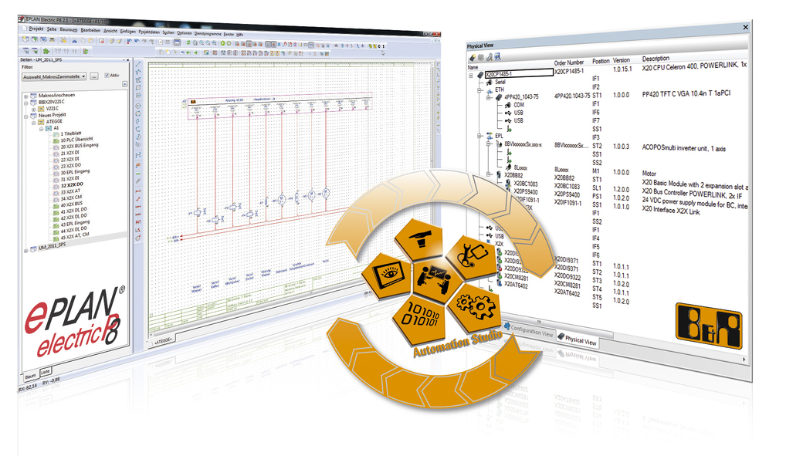
The close cooperation between B&R and EPLAN ensures optimal integration in Automation Studio, a clear and comprehensive workflow and enduring support for the user.

关于贝加莱
贝加莱是一家总部位于奥地利并在全球拥有分公司的创新型自动化企业。2017年7月，贝加莱成为ABB集团的机械自动化事业部。作为工业自动化领域的全球领导者，贝加莱将前沿技术与领先工程相结合，为几乎每个行业的客户提供面向机器与工厂自动化、运动控制、HMI和集成安全技术的完整解决方案。借助于OPC UA、POWERLINK、openSAFETY等工业物联网通信标准，以及强大的Automation Studio软件开发平台，贝加莱不断重新定义自动化工程的未来。受简化流程和超出客户预期的承诺驱动，贝加莱始终保持创新精神并处于工业自动化领域的前沿。
获取更多信息，请访问www.br-automation.com。

