B&R at the Intelligent Engineering benchmark forum in Munich
Engineering software tools are becoming more and more important in machine manufacturing. In light of this fact, the company ITQ and the trade magazine Computer&AUTOMATION sent out invitations to the first ever "Intelligent Engineering" benchmark forum.
This event is aimed at industrial leaders looking for a comprehensive overview of the development tools currently being used in the field of industrial automation. B&R is represented here by Dr.-Ing. Hans Egermeier and Dipl.-Ing. Philipp Wallner, who are responsible for B&R's engineering software tool – Automation Studio. The Benchmark Forum takes place on Mar 21, 2012 from 9 AM to 7 PM at the Novotel trade fair in Munich. On Mar 22, interested parties can take part in a live workshop from 11:30 AM to 1:30 PM and find out more about Automation Studio.
Additional information: www.intelligentes-engineering.de

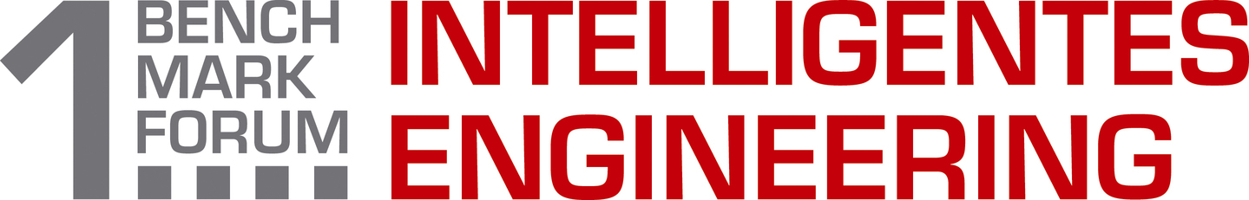
The first Intelligent Engineering benchmark forum provided a comprehensive overview of the industrial automation engineering tools available on the market.

About B&R
B&R, a division of ABB Group, is a global leader in industrial automation headquartered in Austria. B&R combines state-of-the-art technology with advanced engineering to provide customers in virtually every industry with complete solutions for machine and factory automation, motion control, HMI and integrated safety technology. With Industrial IoT communication standards including OPC UA, POWERLINK and openSAFETY as well as its Automation Studio software, B&R is constantly redefining the future of automation engineering. The innovative spirit that keeps B&R at the forefront of industrial automation is driven by a commitment to simplifying processes and exceeding customer expectations.
For more information, visit www.br-automation.com.

