A clear overview of voltage, current and frequency - B&R introduces the X20AP energy metering module
Eggelsberg – The first step to improving energy efficiency is being able to measure and evaluate the amount of power actually being consumed. Any deviations from normal values can be used to identify the condition of the machine and evaluated through the use of monitoring systems such as the EnMon energy monitoring package included in B&R's APROL process control system.
The new X20AP energy metering module from B&R is able to do just that: measure voltages, currents, frequencies and reactive components on all phases. Current and voltage measurements up to the 31st harmonic elevate the module to the highest level of precision while its extreme sensitivity and fourth channel make it perfectly suited for measuring leakage currents on the neutral line.
Higher performance through integrated intelligence
By preprocessing signals and providing measurements together with calculated effective performance values as sets of digital variables, this newest member of the compact B&R X20 family takes some of the load off the CPU. Measurement value curves recorded by the module can help in many ways, such as providing the basis for optimizing traverse paths within a machine, in turn contributing to further energy efficiency.
The three variants of this B&R energy metering module for connecting 20 mA, 1 A and 5 A transformers are available as of April 2012.

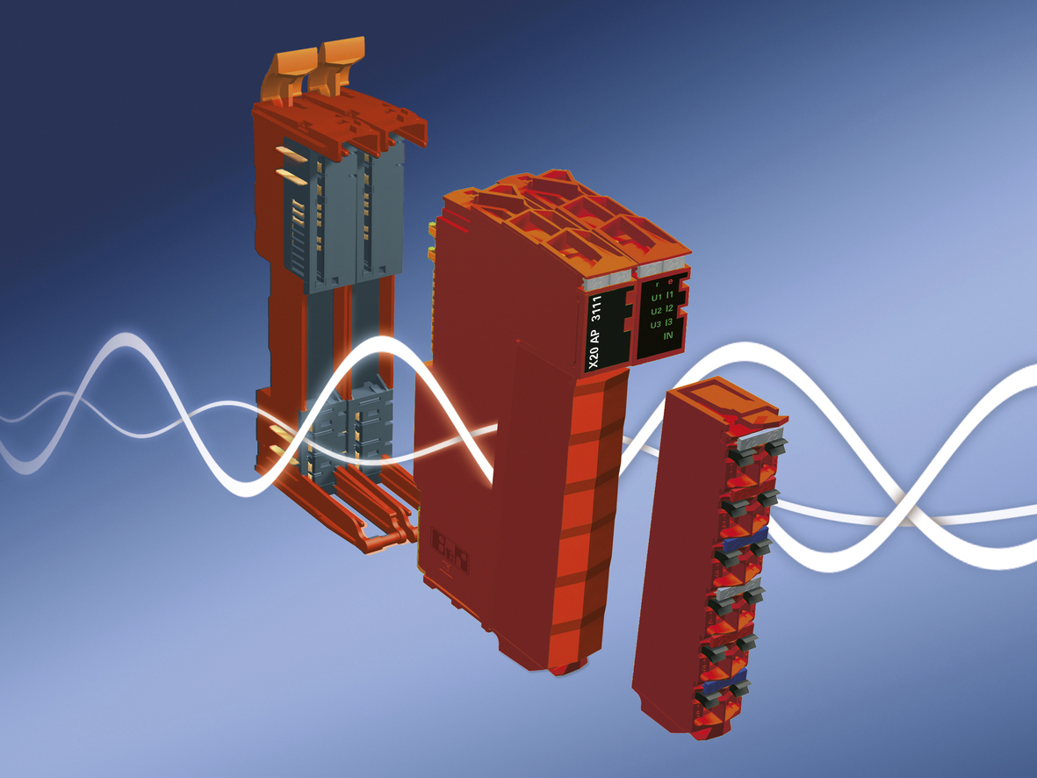
The X20AP energy measurement module from B&R contributes to better energy efficiency and easier condition monitoring.

About B&R
B&R, a division of ABB Group, is a global leader in industrial automation headquartered in Austria. B&R combines state-of-the-art technology with advanced engineering to provide customers in virtually every industry with complete solutions for machine and factory automation, motion control, HMI and integrated safety technology. With Industrial IoT communication standards including OPC UA, POWERLINK and openSAFETY as well as its Automation Studio software, B&R is constantly redefining the future of automation engineering. The innovative spirit that keeps B&R at the forefront of industrial automation is driven by a commitment to simplifying processes and exceeding customer expectations.
For more information, visit www.br-automation.com.

