A clear overview of voltage, current and frequency - B&R introduces the X20AP energy measurement module
Eggelsberg – The first step to improving energy efficiency is being able to measure and evaluate the amount of power actually being consumed. Any deviations from normal values can be used to identify the condition of the machine and evaluated through the use of monitoring systems such as the EnMon energy monitoring package included in B&R's APROL process control system.
The new X20AP energy measurement module from B&R is able to do just that: measure voltages, currents, frequencies and reactive components on all phases. Current and voltage measurements up to the 31st harmonic elevate the module to the highest level of precision while its extreme sensitivity and fourth channel make it perfectly suited for measuring leakage currents on the neutral line.
Higher performance through integrated intelligence
By preprocessing signals and providing measurements together with calculated effective performance values as sets of digital variables, this newest member of the compact B&R X20 family takes some of the load off the CPU. Measurement value curves recorded by the module can help in many ways, such as providing the basis for optimizing traverse paths within a machine, in turn contributing to further energy efficiency.
The three variants of this B&R energy measurement module for connecting 20 mA, 1 A and 5 A transformers are available as of April 2012.

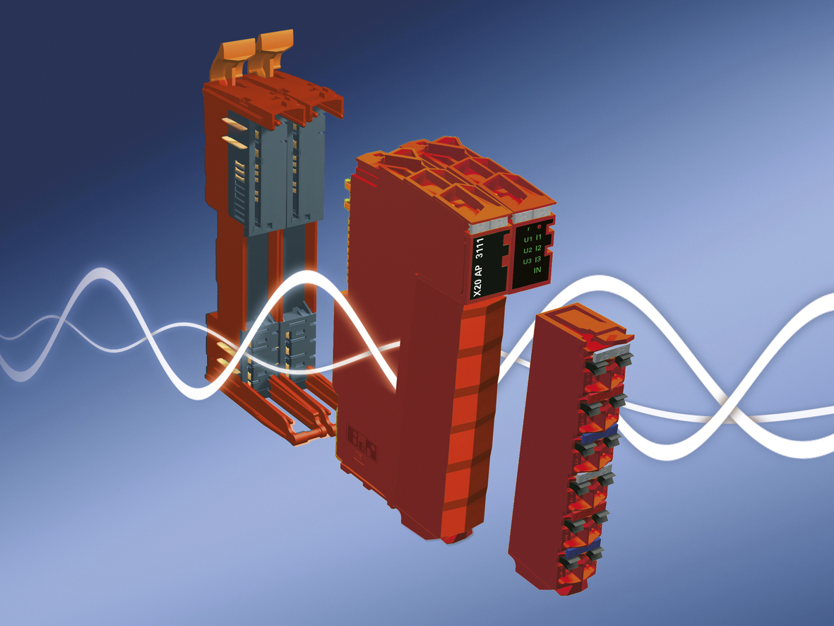
The X20AP energy measurement module from B&R contributes to better energy efficiency and easier condition monitoring.

关于贝加莱
贝加莱是一家总部位于奥地利并在全球拥有分公司的创新型自动化企业。2017年7月，贝加莱成为ABB集团的机械自动化事业部。作为工业自动化领域的全球领导者，贝加莱将前沿技术与领先工程相结合，为几乎每个行业的客户提供面向机器与工厂自动化、运动控制、HMI和集成安全技术的完整解决方案。借助于OPC UA、POWERLINK、openSAFETY等工业物联网通信标准，以及强大的Automation Studio软件开发平台，贝加莱不断重新定义自动化工程的未来。受简化流程和超出客户预期的承诺驱动，贝加莱始终保持创新精神并处于工业自动化领域的前沿。
获取更多信息，请访问www.br-automation.com。

