B&R APROL process technology expanding to new horizons Many new features being presented at the ACHEMA 2012
Eggelsberg – The 30th annual ACHEMA fair, the international forum for the process industry and leading trade fair for chemical engineering, environmental protection and biotechnology, is being held in Frankfurt, Germany from June 18-22, 2012. B&R is taking advantage of this leading industrial event to showcase the unrivaled versatility of the APROL process control system in everything from project configuration all the way down to the field level.
New features at the process control level include "Advanced Process Control", which includes a library of model predictive control functions for process modeling, and programming with the Sequential Function Chart language. For critical processes, newly developed controller redundancy ensures a switch to redundant systems in a matter of milliseconds.
Power monitoring and the associated increase in energy efficiency for industrial plants is provided by the comprehensive EnMon energy monitoring solution. This feature is an integral part of APROL and makes it easier to comply with ISO 50001, the new standard replacing EN 16001. Its functions are ready to go right from the start and perfect for evaluating signals from the new X20AP energy metering module used to measure voltages, currents, frequencies and reactive components on all phases.
Cost savings through synergy
This device belongs to B&R's X20 family of modules, whose large quantities make it attractive for machine manufacturing and whose compact modularity and cost efficiency are appreciated by system manufacturers as well. Of particular interest to process engineering specialists are the HART modules from this product line, which feature both analog inputs and outputs, as well as a newly developed condition monitoring module for autonomous vibration evaluation.
X20 modules with safe analog inputs have also been added to the range of products for the fieldbus-independent, safety-oriented transfer protocol openSAFETY. This protocol, based on the international IEC 61784-3 FSCP 13 standard, continues to gain more and more ground in the field of process automation.
B&R's booth at the ACHEMA trade fair is located in Hall 11.1 A63.

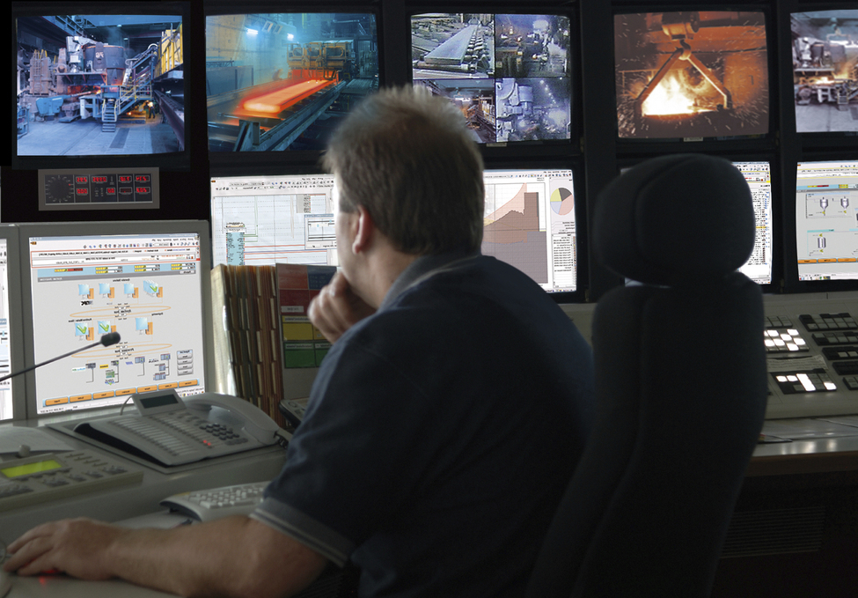
State-of-the-art control station for monitoring and control of processes.

About B&R
B&R, a division of ABB Group, is a global leader in industrial automation headquartered in Austria. B&R combines state-of-the-art technology with advanced engineering to provide customers in virtually every industry with complete solutions for machine and factory automation, motion control, HMI and integrated safety technology. With Industrial IoT communication standards including OPC UA, POWERLINK and openSAFETY as well as its Automation Studio software, B&R is constantly redefining the future of automation engineering. The innovative spirit that keeps B&R at the forefront of industrial automation is driven by a commitment to simplifying processes and exceeding customer expectations.
For more information, visit www.br-automation.com.

