B&R demonstrates "Perfection in Automation" – Appearance at the HMI with many technological innovations
B&R's presence was strongly felt at this year's HMI trade fair, which took place from April 23-27 in Hanover, Germany. B&R presented their wide range of products spanning all areas of automation at this leading international trade fair for process and production automation. "We are very satisfied with this year's HMI trade fair," explains Werner Gropp, manager of global marketing at B&R. He continues, "Many visitors sought out our booth to find out what we have to offer and to learn about the latest technological developments. After all, we offer a total package from a single source – from drives and controllers to visualization devices and control panels."
Automated demo projects were one way for visitors to see how well the various components and software systems work in action. B&R showcased touch screen based visualization products and solutions for smooth process control as well as I/O systems, CPUs, industrial PCs, drives and safety technology.
Mobile Automation that meets market demands
At this year's event, the newest company division – Mobile Automation – was also spotlighted. Because of market developments in recent years, B&R has been offering customized solutions for vehicles and outdoor applications since 2011. "Covering this area was the logical next step in expanding our existing product portfolio," states Gropp concerning the new strategy. A customized combination of different products is essential to ensuring that the requirements for automating mobile machines are being met. "This is a modular system that can be individually assembled as needed," explains the marketing manager . These types of automation solutions are used in commercial vehicles or construction machinery that has particularly higher standards for the integrated technology. Factors such as extreme temperatures, shock resistance and durability must be considered so that the system is able to function in extreme situations. Satisfied customers already include fire truck manufacturers, attracted by the performance offered by B&R solutions: In this particular case, operating and monitoring devices are controlled via a decentralized CPU and I/O modules. The experts also provide control computers whose extremely high performance is matched only by the performance of the firefighters themselves. MA120 and MA170 control nodes ensure the necessary high level of functionality. In combination with POWERLINK, this establishes a communication channel for a wide range of capabilities without the need for extensive cabling. All of the components needed to implement this solution come straight from the B&R product portfolio, another example of staying true to the company motto – "Complete solutions from a single source" – even in demanding areas such as this.

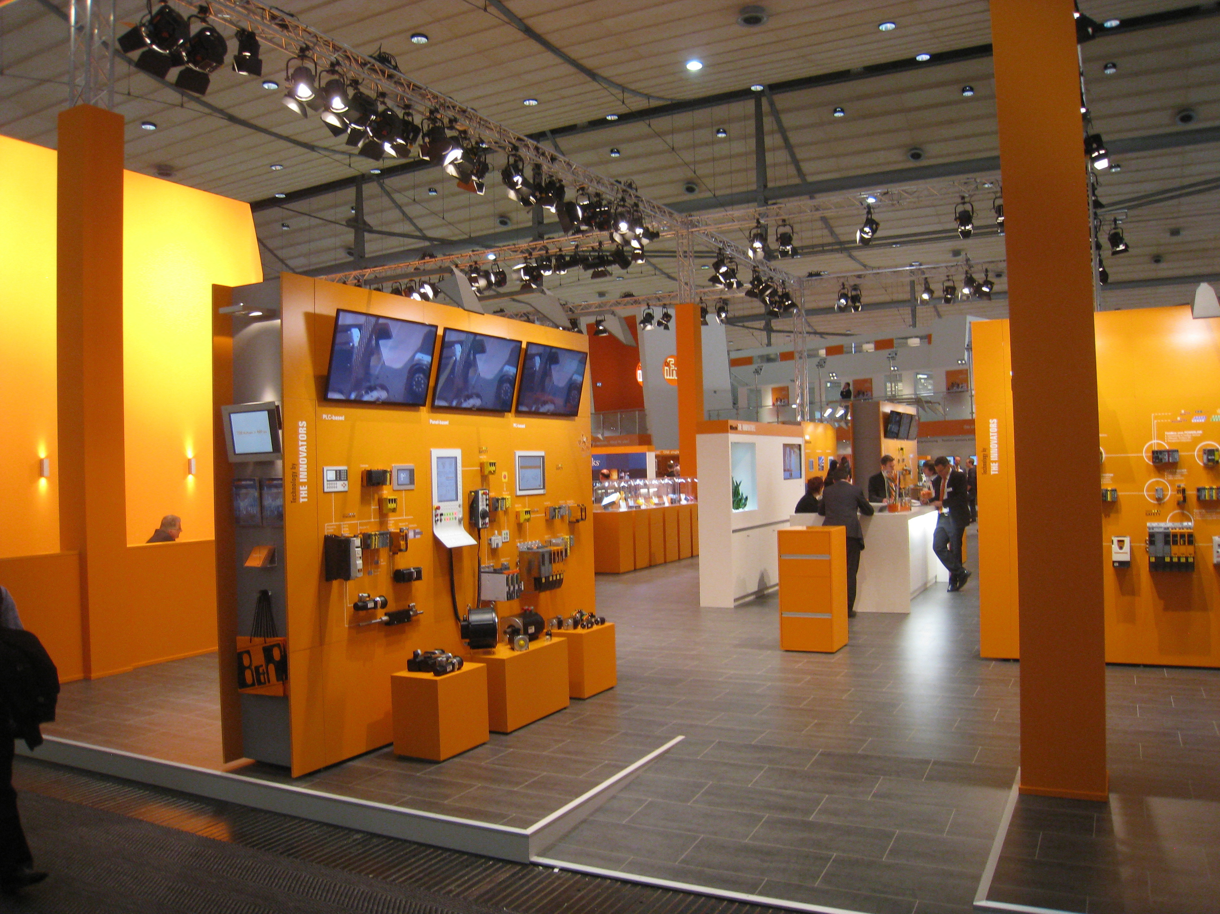
B&R at the HMI 2012

B&R Hakkında
ABB Grubunun bir bölümü olan B&R, merkezi Avusturya'da bulunan endüstriyel otomasyon alanında global bir liderdir. B&R, neredeyse her sektördeki müşterilere makine ve fabrika otomasyonu, hareket kontrolü, HMI ve entegre güvenlik teknolojisi için eksiksiz çözümler sunmak üzere en son teknolojiyi ileri mühendislikle birleştiriyor. OPC UA, POWERLINK ve openSAFETY gibi Endüstriyel IoT iletişim standartlarının yanı sıra Automation Studio yazılımıyla B&R, otomasyon mühendisliğinin geleceğini sürekli olarak yeniden tanımlıyor. B&R'ı endüstriyel otomasyonun ön saflarında tutan yenilikçi ruh, süreçleri basitleştirme ve müşteri beklentilerini aşma taahhüdünden kaynaklanmaktadır.
Daha fazla bilgi için www.br-automation.com adresini ziyaret edin.

