B&R demonstrates "Perfection in Automation" – Appearance at the HMI with many technological innovations
B&R's presence was strongly felt at this year's HMI trade fair, which took place from April 23-27 in Hanover, Germany.B&R presented their wide range of products spanning all areas of automation at this leading international trade fair for process and production automation."We are very satisfied with this year's HMI trade fair," explains Werner Gropp, manager of global marketing at B&R. He continues,"Many visitors sought out our booth to find out what we have to offer and to learn about the latest technological developments.After all, we offer a total package from a single source – from drives and controllers to visualization devices and control panels."
Automated demo projects were one way for visitors to see how well the various components and software systems work in action. B&R showcased touch screen based visualization products and solutions for smooth process control as well as I/O systems, CPUs, industrial PCs, drives and safety technology.
Mobile Automation that meets market demands
At this year's event, the newest company division – Mobile Automation – was also spotlighted. Because of market developments in recent years, B&R has been offering customized solutions for vehicles and outdoor applications since 2011. "Covering this area was the logical next step in expanding our existing product portfolio," states Gropp concerning the new strategy. A customized combination of different products is essential to ensuring that the requirements for automating mobile machines are being met. "This is a modular system that can be individually assembled as needed," explains the marketing manager . These types of automation solutions are used in commercial vehicles or construction machinery that has particularly higher standards for the integrated technology. Factors such as extreme temperatures, shock resistance and durability must be considered so that the system is able to function in extreme situations. Satisfied customers already include fire truck manufacturers, attracted by the performance offered by B&R solutions: In this particular case, operating and monitoring devices are controlled via a decentralized CPU and I/O modules. The experts also provide control computers whose extremely high performance is matched only by the performance of the firefighters themselves. MA120 and MA170 control nodes ensure the necessary high level of functionality. In combination with POWERLINK, this establishes a communication channel for a wide range of capabilities without the need for extensive cabling. All of the components needed to implement this solution come straight from the B&R product portfolio, another example of staying true to the company motto – "Complete solutions from a single source" – even in demanding areas such as this.

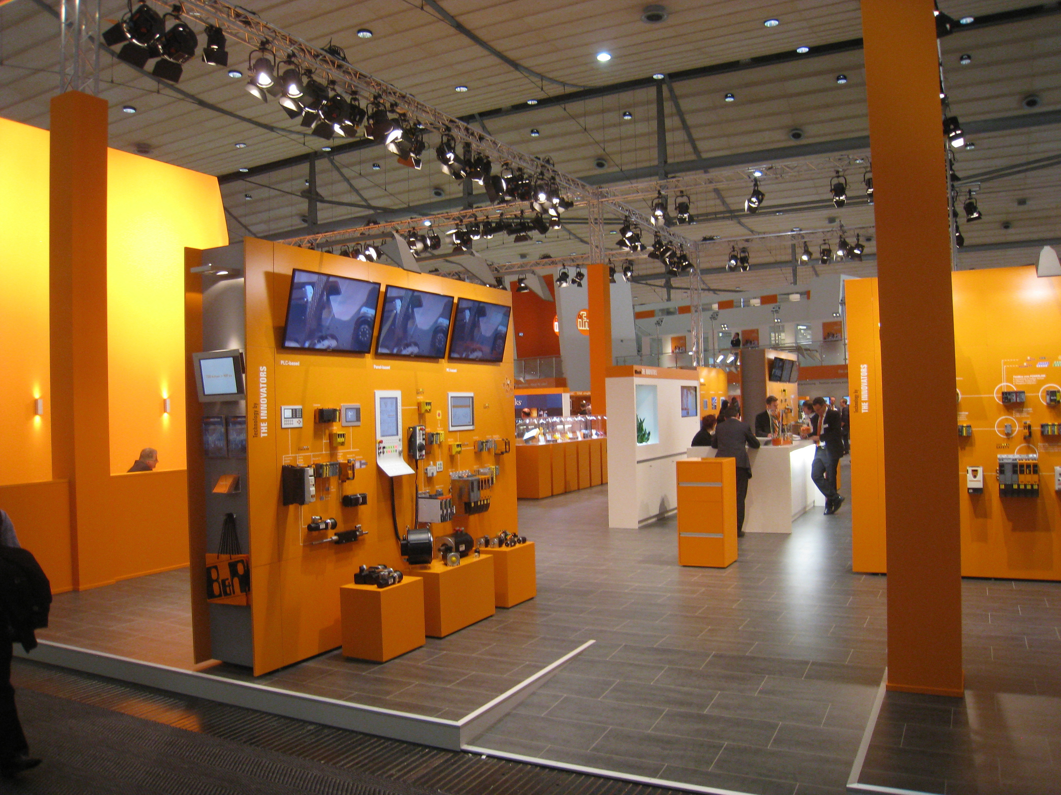
B&R at the HMI 2012

关于贝加莱
贝加莱是一家总部位于奥地利并在全球拥有分公司的创新型自动化企业。2017年7月，贝加莱成为ABB集团的机械自动化事业部。作为工业自动化领域的全球领导者，贝加莱将前沿技术与领先工程相结合，为几乎每个行业的客户提供面向机器与工厂自动化、运动控制、HMI和集成安全技术的完整解决方案。借助于OPC UA、POWERLINK、openSAFETY等工业物联网通信标准，以及强大的Automation Studio软件开发平台，贝加莱不断重新定义自动化工程的未来。受简化流程和超出客户预期的承诺驱动，贝加莱始终保持创新精神并处于工业自动化领域的前沿。
获取更多信息，请访问www.br-automation.com。

