B&R impresses with innovative safety technology
Safety Roadshow on tour in over twenty German cities
The company visited a total of 26 cities. Beginning in February, numerous visitors from a wide range of industries took the opportunity to check out the absolute latest in state-of-the-art safety solutions. "Intelligent, decentralized and integrated safety technology means that totally new safety concepts are now possible for machines," explains Markus Sandhöfner, a member of the B&R Germany management team. At the same time, he continues, these types of solutions must be easy to manage and achieve extremely short response times.
Visitors to the Safety Roadshow were able to learn quite a bit about the subject of safety, for example regarding 2006/42/EC machine guidelines that have been valid since the end of 2009 and the open safety protocol openSAFETY. Guests were also treated to a comprehensive look at safety technology in the form of actual customer applications. These real-world applications impressed audiences and demonstrated some of the practical applications of safety technology – one example of this was the configuration of a printing machine. B&R's Smart Safe Reaction technology allows machine manufacturers to first build their standard modules and corresponding control cabinet and then to configure them – along with the safety technology – on a computer screen to handle their respective tasks after commissioning has been successfully completed. The time this saves for programming, configuring, delivering and commissioning the machine is more than considerable.
B&R technology is also being successfully implemented in the area of press manufacturing. Here, the integrated Smart Safe Reaction safety concept and integrated Safe Motion Control drive technology accelerate the entire setup process, making it possible for machine builders to develop more flexible and energy-saving solutions. "With demonstrations from these and other industries – packaging, textile engineering or metalworking, for example – B&R continues to prove their ability to innovate in all areas of machine manufacturing," says Sandhöfner.
The Safety Roadshow clearly highlighted the advantages of this type of technology over conventional solutions. B&R's safety solutions not only exhibit faster response times, reduce engineering and wiring effort to a minimum and increase system availability, they also reduce costs throughout an entire project while ensuring effective service.

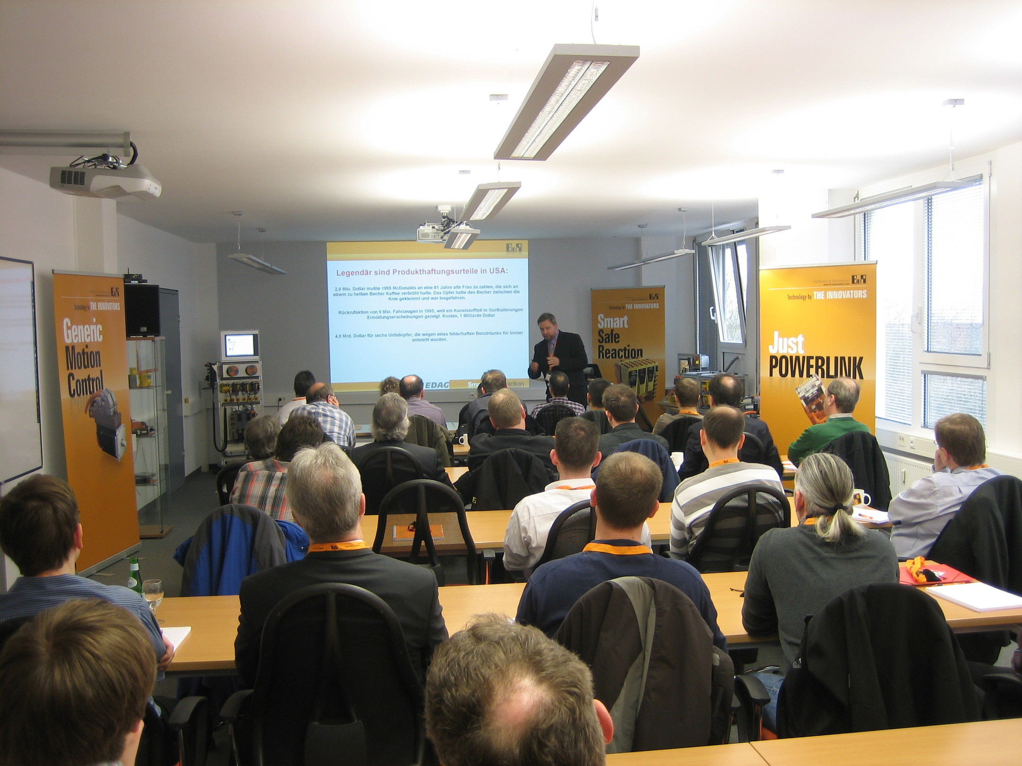

B&R Hakkında
ABB Grubunun bir bölümü olan B&R, merkezi Avusturya'da bulunan endüstriyel otomasyon alanında global bir liderdir. B&R, neredeyse her sektördeki müşterilere makine ve fabrika otomasyonu, hareket kontrolü, HMI ve entegre güvenlik teknolojisi için eksiksiz çözümler sunmak üzere en son teknolojiyi ileri mühendislikle birleştiriyor. OPC UA, POWERLINK ve openSAFETY gibi Endüstriyel IoT iletişim standartlarının yanı sıra Automation Studio yazılımıyla B&R, otomasyon mühendisliğinin geleceğini sürekli olarak yeniden tanımlıyor. B&R'ı endüstriyel otomasyonun ön saflarında tutan yenilikçi ruh, süreçleri basitleştirme ve müşteri beklentilerini aşma taahhüdünden kaynaklanmaktadır.
Daha fazla bilgi için www.br-automation.com adresini ziyaret edin.

