The new B&R keypad module
Intuitive operation right where you need it
Ergonomic design and robust construction for tough industrial environments – the new B&R keypad module with integrated illuminated ring keys perfectly combines these characteristics. With the compact dimensions of a mobile phone and IP65 washdown protection, this new control device can be used wherever it's needed on the machine. Its special hygienic design ensures a maximum degree of cleanliness even in sensitive working environments such as those found in the foodstuffs and pharmaceutical industries.
The keys can be illuminated in yellow, green, red and white and labeled as needed using slide-in labels. Fully homogeneous illumination of the ring keys ensures an ideal signal effect. Tactile feedback provides another layer of operating comfort. And with three different designs, users can choose the one that best fits to the application's requirements.
Install, connect and you're ready to go
This new keypad module offers extremely communicative features while providing a flexible connection to open fieldbus systems. With its compact dimensions, this new control device from B&R also helps save valuable installation space. This is achieved by encapsulating the electronics on the back of the device, thereby eliminating the need for an additional protective housing. Single-screw mounting ensures quick and easy attachment, while standard M8 and M12 connections sink overall costs even further.

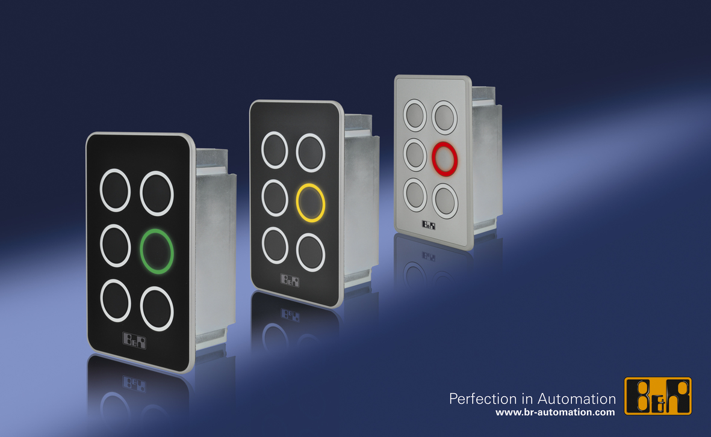
The new B&R keypad module: Cool design, robust enough for industrial environments.

About B&R
B&R, a division of ABB Group, is a global leader in industrial automation headquartered in Austria. B&R combines state-of-the-art technology with advanced engineering to provide customers in virtually every industry with complete solutions for machine and factory automation, motion control, HMI and integrated safety technology. With Industrial IoT communication standards including OPC UA, POWERLINK and openSAFETY as well as its Automation Studio software, B&R is constantly redefining the future of automation engineering. The innovative spirit that keeps B&R at the forefront of industrial automation is driven by a commitment to simplifying processes and exceeding customer expectations.
For more information, visit www.br-automation.com.

