The new B&R keypad module
Intuitive operation right where you need it
Ergonomic design and robust construction for tough industrial environments – the new B&R keypad module with integrated illuminated ring keys perfectly combines these characteristics. With the compact dimensions of a mobile phone and IP65 washdown protection, this new control device can be used wherever it's needed on the machine. Its special hygienic design ensures a maximum degree of cleanliness even in sensitive working environments such as those found in the foodstuffs and pharmaceutical industries.
The keys can be illuminated in yellow, green, red and white and labeled as needed using legend strips. Fully homogeneous ring key illumination ensures a perfect signal effect, while tactile feedback provides an additional layer of operating comfort. And with three different designs, users can choose the one that best fits to the application's requirements.
Install and connect – that's all there is to it
This new keypad module offers extremely communicative features while providing a flexible connection to open fieldbus systems. With its compact dimensions, this new control device from B&R also helps save valuable installation space. This is achieved by encapsulating the electronics on the back of the device, thereby eliminating the need for an additional protective housing. Single-screw mounting ensures quick and easy attachment, while standard M8 and M12 connections sink overall costs even further.

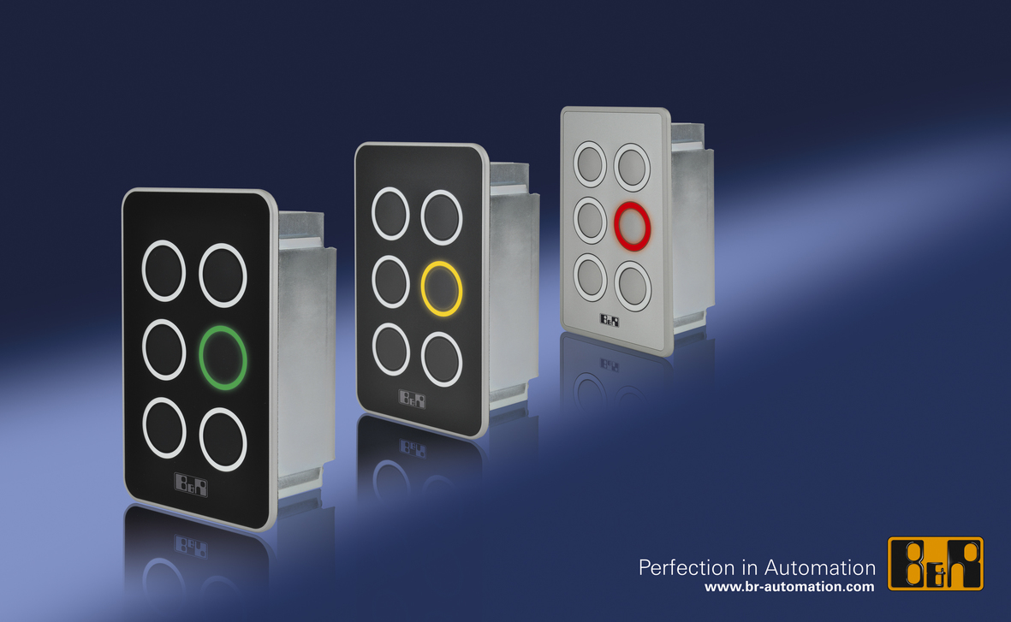
The new B&R keypad module: Cool design, robust enough for industrial environments.

关于贝加莱
贝加莱是一家总部位于奥地利并在全球拥有分公司的创新型自动化企业。2017年7月，贝加莱成为ABB集团的机械自动化事业部。作为工业自动化领域的全球领导者，贝加莱将前沿技术与领先工程相结合，为几乎每个行业的客户提供面向机器与工厂自动化、运动控制、HMI和集成安全技术的完整解决方案。借助于OPC UA、POWERLINK、openSAFETY等工业物联网通信标准，以及强大的Automation Studio软件开发平台，贝加莱不断重新定义自动化工程的未来。受简化流程和超出客户预期的承诺驱动，贝加莱始终保持创新精神并处于工业自动化领域的前沿。
获取更多信息，请访问www.br-automation.com。

