New motors in B&R's portfolio
B&R and Baumüller establish long-term framework supply contract
Eggelsberg – On May 21st, Baumüller and B&R signed a framework contract to solidify the cooperation established by Hans Wimmer and Peter Schuch from B&R and Norbert Scholz and Ralf Dietrich from Baumüller. Customers will now profit from the combined expertise of the two system suppliers. In the future, B&R will take advantage of Baumüller's comprehensive selection of motors, drawing from their DSC, DSD and DS series. "The Baumüller motors will expand our performance range up to 140 kW," says B&R's managing director Hans Wimmer. "This cooperation says a great deal about the quality and performance of the Baumüller products. This is a classic Win-Win situation for both companies," says Baumüller's general manager Ralf Dietrich.

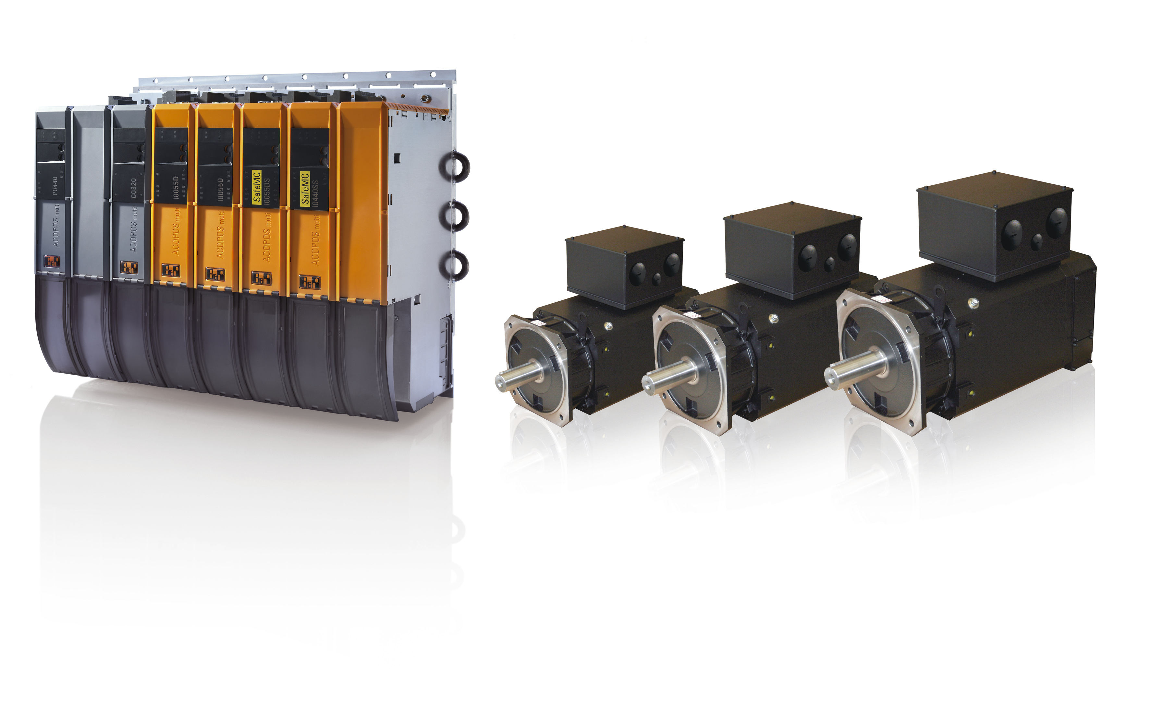
Cooperation: Baumüller and B&R have signed a long-term framework supply contract – expanding B&R's portfolio of motors with power ratings up to 140 kW.

About B&R
B&R, a division of ABB Group, is a global leader in industrial automation headquartered in Austria. B&R combines state-of-the-art technology with advanced engineering to provide customers in virtually every industry with complete solutions for machine and factory automation, motion control, HMI and integrated safety technology. With Industrial IoT communication standards including OPC UA, POWERLINK and openSAFETY as well as its Automation Studio software, B&R is constantly redefining the future of automation engineering. The innovative spirit that keeps B&R at the forefront of industrial automation is driven by a commitment to simplifying processes and exceeding customer expectations.
For more information, visit www.br-automation.com.

