New motors in B&R's portfolio
B&R and Baumüller establish long-term framework supply contract
Eggelsberg – On May 21st, Baumüller and B&R signed a framework contract to solidify the cooperation established by Hans Wimmer and Peter Schuch from B&R and Norbert Scholz and Ralf Dietrich from Baumüller. Customers will now profit from the combined expertise of the two system suppliers. In the future, B&R will take advantage of Baumüller's comprehensive selection of motors, drawing from their DSC, DSD and DS series. "The Baumüller motors will expand our performance range up to 140 kW," says B&R's managing director Hans Wimmer. "This cooperation says a great deal about the quality and performance of the Baumüller products. This is a classic Win-Win situation for both companies," says Baumüller's general manager Ralf Dietrich.

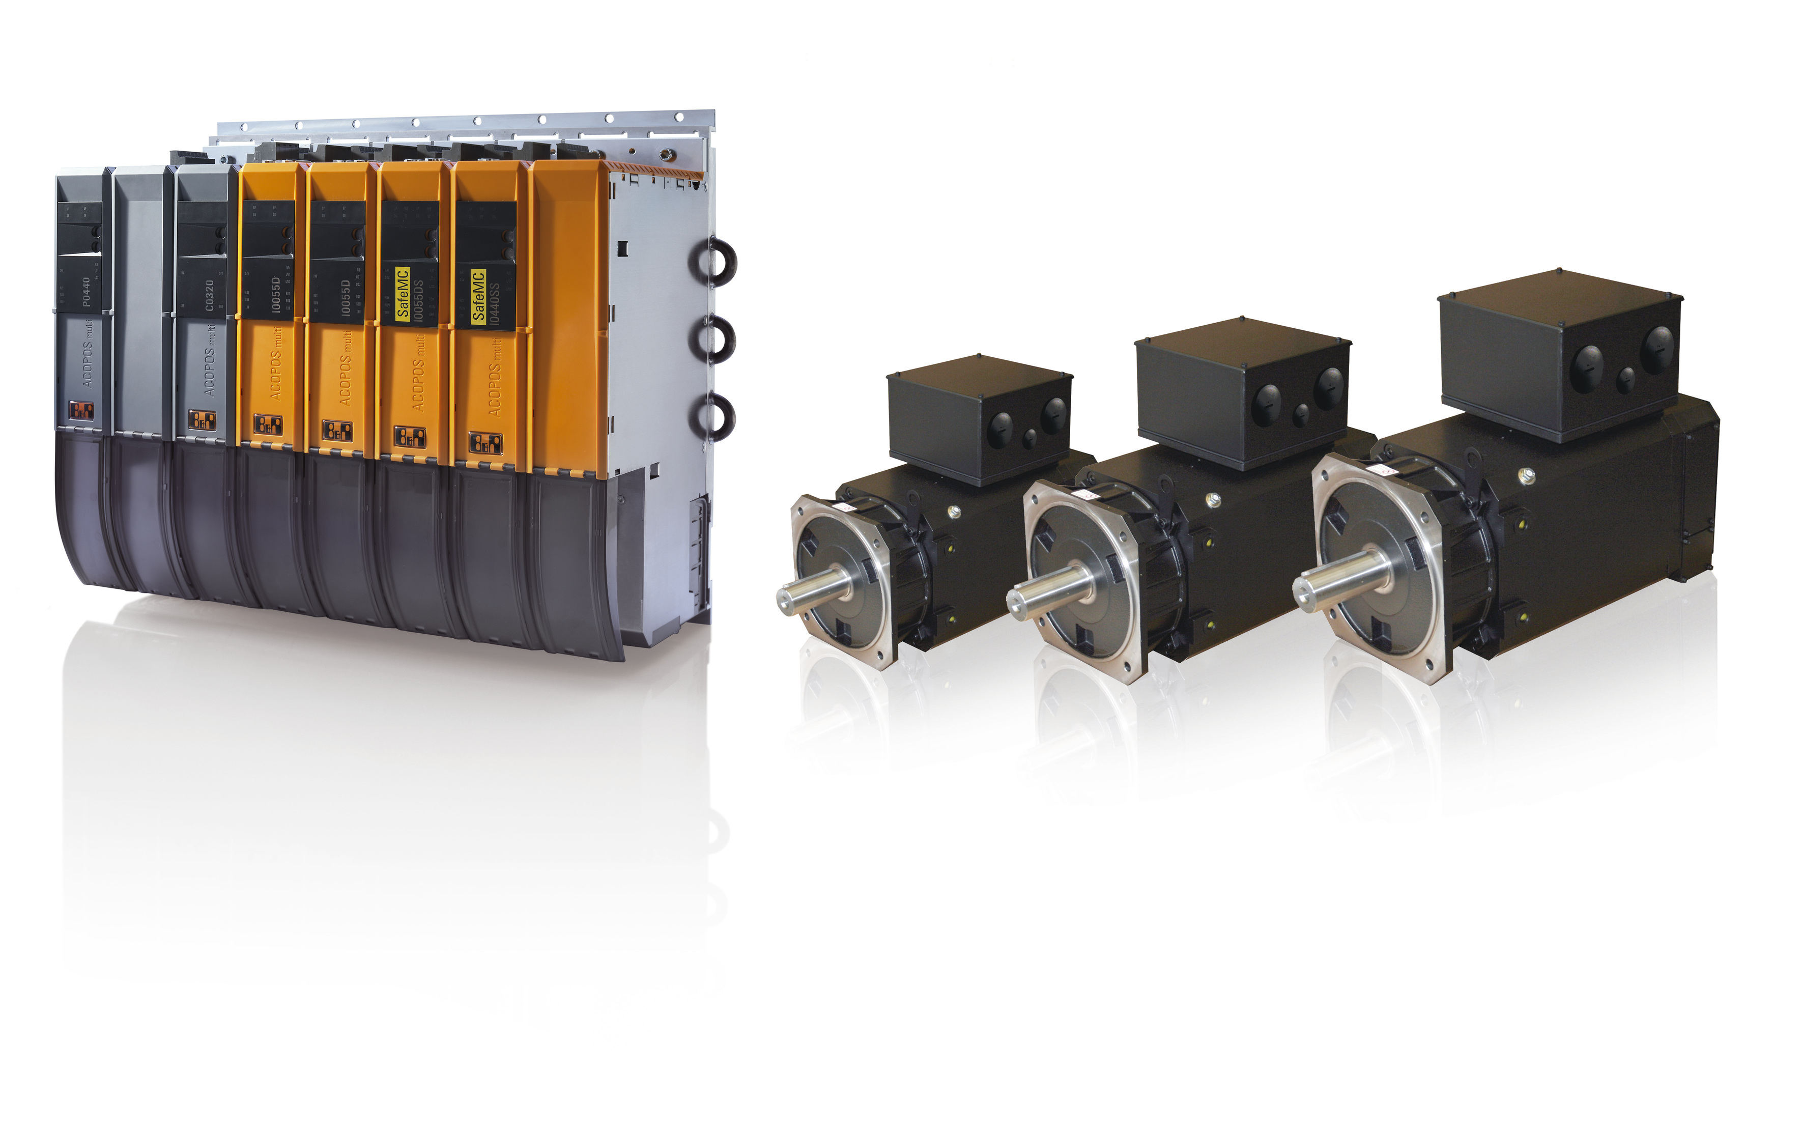
Cooperation: Baumüller and B&R have signed a long-term framework supply contract – expanding B&R's portfolio of motors with power ratings up to 140 kW.

关于贝加莱
贝加莱是一家总部位于奥地利并在全球拥有分公司的创新型自动化企业。2017年7月，贝加莱成为ABB集团的机械自动化事业部。作为工业自动化领域的全球领导者，贝加莱将前沿技术与领先工程相结合，为几乎每个行业的客户提供面向机器与工厂自动化、运动控制、HMI和集成安全技术的完整解决方案。借助于OPC UA、POWERLINK、openSAFETY等工业物联网通信标准，以及强大的Automation Studio软件开发平台，贝加莱不断重新定义自动化工程的未来。受简化流程和超出客户预期的承诺驱动，贝加莱始终保持创新精神并处于工业自动化领域的前沿。
获取更多信息，请访问www.br-automation.com。

