New Box PC from B&R with third generation Intel Core™ i-series processors
The Automation PC 910 adapts perfectly to each customer's unique requirements
(Eggelsberg, Aug 16, 2012) Robust and reliable with long-term availability – these are the excellent characteristics provided by B&R's new Box PC, the Automation PC 910. At the heart of this powerful industrial PC you'll find the latest 3rd generation Intel® Core™ i technology. Core™ i3, Core™ i5 and Core™ i7 CPUs with up to four cores, combined with the new QM77 Express chipset provide the most performance currently available for industrial PCs.
As with previous Automation PC models, users can select the exact combination of CPU performance and main unit size that meets their needs. For example a quadcore CPU can be used in a single-slot housing or a single core Celeron can be used in a five-slot housing. This gives users a lot of freedom as well as price advantages. The rest of the PC infrastructure has also been streamlined for maximum computing performance and optimal data throughput. For example, a serial ATA-based CFast card has replaced the CompactFlash used previously in the Automation PC 910. This B&R Industrial PC uses the proven approach of combining compact removable media based on CFast with standard PC solid state drives and hard disks. These devices are also well-equipped when it comes to interface options. Two Gigabit Ethernet ports, one serial and one modular serial port such as RS485 or CAN together with USB 3.0 interfaces round off the extensive capabilities of the Automation PC 910.

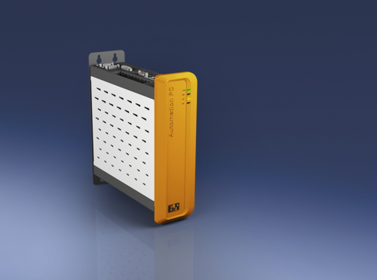
B&R's Automation PC 910 is a robust and reliable industrial PC with long-term availability.

About B&R
B&R, a division of ABB Group, is a global leader in industrial automation headquartered in Austria. B&R combines state-of-the-art technology with advanced engineering to provide customers in virtually every industry with complete solutions for machine and factory automation, motion control, HMI and integrated safety technology. With Industrial IoT communication standards including OPC UA, POWERLINK and openSAFETY as well as its Automation Studio software, B&R is constantly redefining the future of automation engineering. The innovative spirit that keeps B&R at the forefront of industrial automation is driven by a commitment to simplifying processes and exceeding customer expectations.
For more information, visit www.br-automation.com.

