Technology trends meet practical expertise
This year's B&R User Meeting was focused on one key topic: generating competitive advantage.
Salzburg – Some 270 machine and systems manufacturers took advantage of an opportunity to learn about the latest innovative solutions in the field of automation technology. More than 20 guest speakers, including experts and researchers from across the industry, shared their practical experience and thought-provoking insights.
The pursuit of competitive advantage is no new concept for machine and systems manufacturers. The main question on the agenda at the B&R User Meeting in Salzburg was "How can machine and systems manufacturers best position themselves to be competitive into the future?" Hermann Obermair, Sales Manager, B&R Austria, summed up the core requirements. The primary objective is to increase production output. In doing so, products and manufacturing processes must remain stable and reproducible.
At the same time, downtime must be minimized and maintenance costs reduced. Machines need to be flexible and multi-functional to provide rapid changeover. B&R offers its machine and systems manufacturer partners complete solutions that meet all of these requirements.
Innovative products and solutions
The agenda also included numerous new developments, including the new version of B&R's development environment, Automation Studio 4, as well as the decentralized servo actuator, ACOPOSmotor. In July B&R is also launching a new high-end industrial PC, the Automation PC 910, equipped with the third generation of Intel® CoreTM i5/i7 processors.
The fourth quarter of 2012 will see the introduction of APROL R3.8, which uses a multi-runtime server to enable decentralized automation within a project. A powerful new redundant control solution further increases availability across the entire system.
Forward-thinking products and solutions are essential to the worldwide success of machine and systems manufacturers – while quality and robustness have a direct impact on day-to-day operation. Across the board, innovations from B&R hold immense potential for generating competitive advantage.
Poised for success
In positioning themselves for long-term success on the global market, machine and systems manufacturers face particular challenges when it comes to product development. At the User Meeting, Dr. Rainer Stetter from ITQ addressed the need for more seamless interaction between the individual engineering disciplines – mechanical, electrical and software.
Mechanical engineers can no longer serve as the sole driving force in development, Stetter pointed out, and software engineers need to be called on much earlier in the game. Interdisciplinary collaboration is the recipe for success. At the moment, however, few machine and systems manufacturers have made the shift in this direction. Instead, many remain entrenched in traditional development structures.
Yet only when manufacturers commit to modularity and interdisciplinary exchange will they be in a position to stand out amidst growing competition – especially with formerly import countries such as China and India rapidly developing into export countries. The market's demands are developing quickly and dramatically; machine and systems manufacturers need agile development strategies to react effectively, according to Stetter, who concludes with some words of caution: "It's tougher to stay at the top than it is to actually get there."
Hot topics
Feedback from B&R User Meeting participants was overwhelmingly positive. Yet smart engineering was not the only highlight. Topics presented by the other guest speakers were met with equal resonance. These included issues such as usability, EMC as well as condition and energy monitoring. Once again, the B&R User Meeting distinguished itself as a forum for innovative ideas as well as cutting-edge products and solutions.

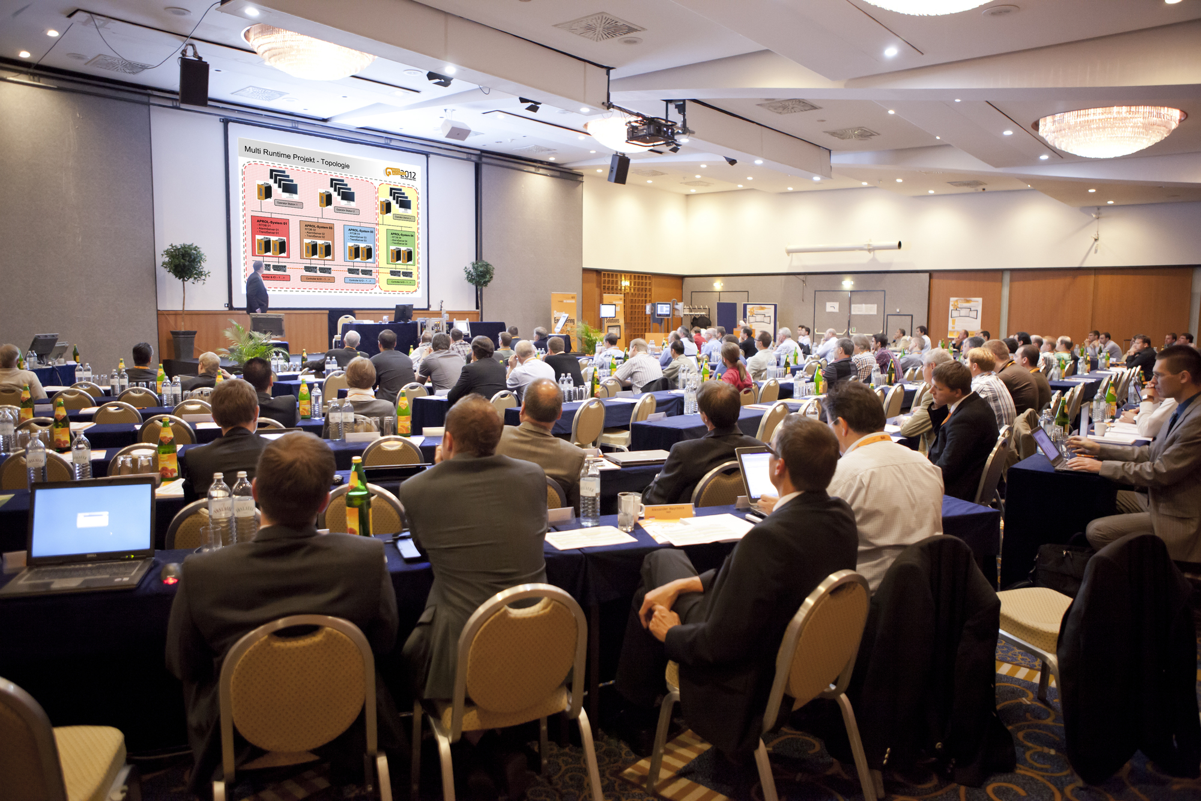
Participants at the User Meeting heard from 20 guest speakers, including experts and researchers from across the industry, who discussed the latest trends and significant technology topics. They also got a glimpse at the latest exciting innovations coming from B&R.

About B&R
B&R, a division of ABB Group, is a global leader in industrial automation headquartered in Austria. B&R combines state-of-the-art technology with advanced engineering to provide customers in virtually every industry with complete solutions for machine and factory automation, motion control, HMI and integrated safety technology. With Industrial IoT communication standards including OPC UA, POWERLINK and openSAFETY as well as its Automation Studio software, B&R is constantly redefining the future of automation engineering. The innovative spirit that keeps B&R at the forefront of industrial automation is driven by a commitment to simplifying processes and exceeding customer expectations.
For more information, visit www.br-automation.com.

