B&R presents impressive new solutions at the ACHEMA 2012
Extended functionality with the APROL process control system
(Bad Homburg, June 21, 2012) – At this year's ACHEMA in Frankfurt am Main, B&R once again demonstrated their strength as a supplier of complete process control systems and PLC technology. In addition to products more common in the field of industrial automation, they also presented their newest developments in the area of process automation. Two things set the APROL process control system apart from the competition: its unique features and and its ability to handle a wide variety of applications and industrial environments. "This complete system covers everything from system manufacturing to plant automation and can easily handle complex process control system applications", says Stefan Lau, sales manager for process automation in Bad Homburg.
With new process control functions, B&R increases their range of products and services in the area of process automation. One of these functions involves powerful controller redundancy systems that back up critical processes within milliseconds. In addition, the upgraded "Advanced Process Control" process library enables the application of complex control algorithms using predictive controllers. The Sequential Function Chart programming language that is now implemented further advances the batch processing possibilities of the APROL process control system.
An extensive energy monitoring solution has also been developed that supports conformity to the ISO 50001 energy management standard. The newly designed X20AP energy metering module is also available for power monitoring and mains network analysis. With APROL Energy Monitoring (EnMon), B&R offers users an application that can be immediately put to use to easily record and evaluate energy data.
"We are very happy that so many visitors showed interest in our solutions," says Martin Reichinger, business manager for process automation in Eggelsberg, commenting on the success at the ACHEMA 2012 trade fair. The audience was especially impressed by three things that characterized all of these B&R solutions: their versatility, their openness and their scalability.

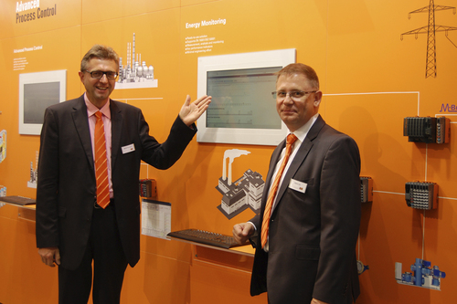
APROL's new energy monitoring solution – EnMon – was just one of the innovations presented by B&R's Martin Reichinger (left) and Stefan Lau at the ACHEMA.

About B&R
B&R, a division of ABB Group, is a global leader in industrial automation headquartered in Austria. B&R combines state-of-the-art technology with advanced engineering to provide customers in virtually every industry with complete solutions for machine and factory automation, motion control, HMI and integrated safety technology. With Industrial IoT communication standards including OPC UA, POWERLINK and openSAFETY as well as its Automation Studio software, B&R is constantly redefining the future of automation engineering. The innovative spirit that keeps B&R at the forefront of industrial automation is driven by a commitment to simplifying processes and exceeding customer expectations.
For more information, visit www.br-automation.com.

