B&R presents impressive new solutions at the ACHEMA 2012
Extended functionality with the APROL process control system
In addition to products more common in the field of industrial automation, they also presented their newest developments in the area of process automation. Two things set the APROL process control system apart from the competition: its unique features and and its ability to handle a wide variety of applications and industrial environments. "This complete system covers everything from system manufacturing to plant automation and can easily handle complex process control system applications", says Stefan Lau, sales manager for process automation in Bad Homburg.
With new process control functions, B&R increases their range of products and services in the area of process automation. One of these functions involves powerful controller redundancy systems that back up critical processes within milliseconds. In addition, the upgraded "Advanced Process Control" process library enables the application of complex control algorithms using predictive controllers. The Sequential Function Chart programming language that is now implemented further advances the batch processing possibilities of the APROL process control system.
An extensive energy monitoring solution has also been developed that supports conformity to the ISO 50001 energy management standard. The newly designed X20AP energy metering module is also available for power monitoring and mains network analysis. With APROL Energy Monitoring (EnMon), B&R offers users an application that can be immediately put to use to easily record and evaluate energy data.
"We are very happy that so many visitors showed interest in our solutions," says Martin Reichinger, business manager for process automation in Eggelsberg, commenting on the success at the ACHEMA 2012 trade fair. The audience was especially impressed by three things that characterized all of these B&R solutions: their versatility, their openness and their scalability.

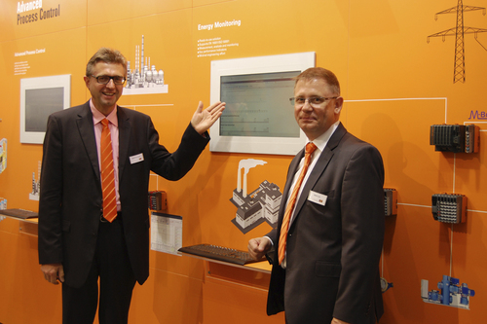
APROL's new energy monitoring solution – EnMon – was just one of the innovations presented by B&R's Martin Reichinger (left) and Stefan Lau at the ACHEMA.

B&R Hakkında
ABB Grubunun bir bölümü olan B&R, merkezi Avusturya'da bulunan endüstriyel otomasyon alanında global bir liderdir. B&R, neredeyse her sektördeki müşterilere makine ve fabrika otomasyonu, hareket kontrolü, HMI ve entegre güvenlik teknolojisi için eksiksiz çözümler sunmak üzere en son teknolojiyi ileri mühendislikle birleştiriyor. OPC UA, POWERLINK ve openSAFETY gibi Endüstriyel IoT iletişim standartlarının yanı sıra Automation Studio yazılımıyla B&R, otomasyon mühendisliğinin geleceğini sürekli olarak yeniden tanımlıyor. B&R'ı endüstriyel otomasyonun ön saflarında tutan yenilikçi ruh, süreçleri basitleştirme ve müşteri beklentilerini aşma taahhüdünden kaynaklanmaktadır.
Daha fazla bilgi için www.br-automation.com adresini ziyaret edin.

