B&R presents impressive new solutions at the ACHEMA 2012
Extended functionality with the APROL process control system
(Bad Homburg, June 21, 2012) – At this year's ACHEMA in Frankfurt am Main, B&R once again demonstrated their strength as a supplier of complete process control systems and PLC technology. In addition to products more common in the field of industrial automation, they also presented their newest developments in the area of process automation. Two things set the APROL process control system apart from the competition: its unique features and and its ability to handle a wide variety of applications and industrial environments. "This complete system covers everything from system manufacturing to plant automation and can easily handle complex process control system applications", says Stefan Lau, sales manager for process automation in Bad Homburg.
With new process control functions, B&R increases their range of products and services in the area of process automation. One of these functions involves powerful controller redundancy systems that back up critical processes within milliseconds. In addition, the upgraded "Advanced Process Control" process library enables the application of complex control algorithms using predictive controllers. The Sequential Function Chart programming language that is now implemented further advances the batch processing possibilities of the APROL process control system.
An extensive energy monitoring solution has also been developed that supports conformity to the ISO 50001 energy management standard. The newly designed X20AP energy measurement module is also available for power monitoring and mains network analysis. With APROL Energy Monitoring (EnMon), B&R offers users an application that can be immediately put to use to easily record and evaluate energy data.
"We are very happy that so many visitors showed interest in our solutions," says Martin Reichinger, business manager for process automation in Eggelsberg, commenting on the success at the ACHEMA 2012 trade fair. The audience was especially impressed by three things that characterized all of these B&R solutions: their versatility, their openness and their scalability.

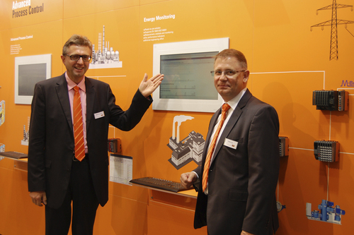
APROL's new energy monitoring solution – EnMon – was just one of the innovations presented by B&R's Martin Reichinger (left) and Stefan Lau at the ACHEMA.

关于贝加莱
贝加莱是一家总部位于奥地利并在全球拥有分公司的创新型自动化企业。2017年7月，贝加莱成为ABB集团的机械自动化事业部。作为工业自动化领域的全球领导者，贝加莱将前沿技术与领先工程相结合，为几乎每个行业的客户提供面向机器与工厂自动化、运动控制、HMI和集成安全技术的完整解决方案。借助于OPC UA、POWERLINK、openSAFETY等工业物联网通信标准，以及强大的Automation Studio软件开发平台，贝加莱不断重新定义自动化工程的未来。受简化流程和超出客户预期的承诺驱动，贝加莱始终保持创新精神并处于工业自动化领域的前沿。
获取更多信息，请访问www.br-automation.com。

