Integrated Safety Technology for wind turbines
B&R setting new trends at the HUSUM WindEnergy trade fair
This new solution can be seamlessly integrated into standard controllers and offers not just digital inputs and outputs, but also analog and temperature interfaces as well as safe speed measurement functionality that meets both SIL3 and Performance Level e requirements. Fully compliant GL2010 function blocks are thus able to be completely integrated into the main controller regardless of the control topology in use – efficiently and inexpensively.
An additional trade fair highlight on display will be the robust design of the X20 controller system. It is the perfect solution for mastering the extreme conditions associated with offshore wind turbines. This system can handle the measurement and monitoring of key parameters such as voltage, frequency and phasing of the power mains while also calculating the amount of energy output by the wind turbine. In addition, B&R's intelligent condition monitoring solution is easy to use and makes it possible to coordinate maintenance more effectively and avoid machine downtime. A wide range of redundancy solutions – for the main controller, the safety system and the real-time Ethernet POWERLINK fieldbus – maximize the availability of the system. Time-consuming and costly re-engineering is therefore unnecessary.
B&R offers comprehensive automation solutions for the wind power industry, particularly when it comes to increasing safety and reducing costs. For example, automatic code generation for MATLAB/Simulink makes it possible to transfer sophisticated control algorithms to B&R systems that maximize energy yield while minimizing the load on machine components. This is but one way of meeting the challenges presented by wind turbines, a crucial technology as we move into the future. At the HUSUM WindEnergy trade fair, B&R expert automation solution specialists will once again be placing the focus squarely where it belongs – on quality, availability and overall safety.

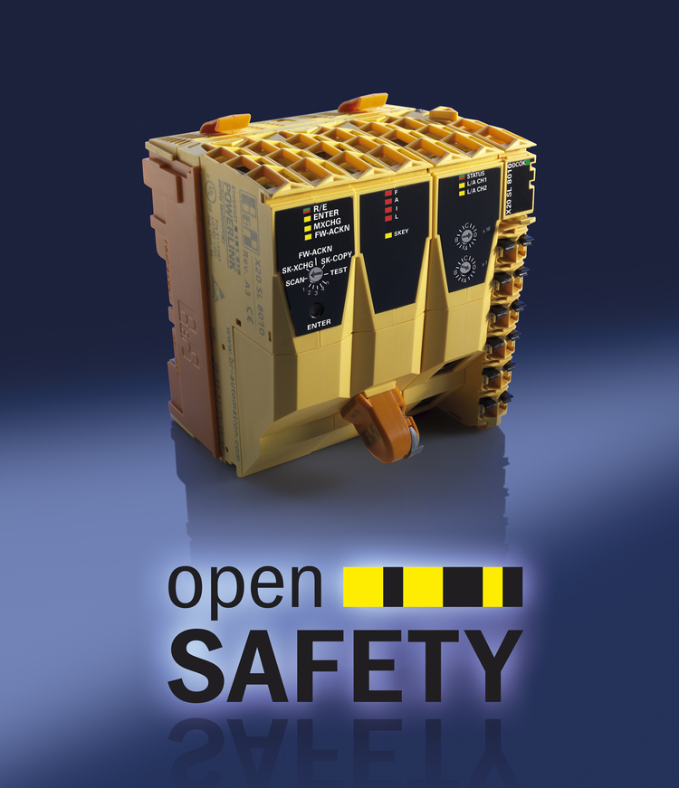
The integrated approach from B&R is setting new trends in the wind power industry. One aspect of this is the SafeLOGIC safety controller, which can be seamlessly integrated into standard controller systems.

B&R Hakkında
ABB Grubunun bir bölümü olan B&R, merkezi Avusturya'da bulunan endüstriyel otomasyon alanında global bir liderdir. B&R, neredeyse her sektördeki müşterilere makine ve fabrika otomasyonu, hareket kontrolü, HMI ve entegre güvenlik teknolojisi için eksiksiz çözümler sunmak üzere en son teknolojiyi ileri mühendislikle birleştiriyor. OPC UA, POWERLINK ve openSAFETY gibi Endüstriyel IoT iletişim standartlarının yanı sıra Automation Studio yazılımıyla B&R, otomasyon mühendisliğinin geleceğini sürekli olarak yeniden tanımlıyor. B&R'ı endüstriyel otomasyonun ön saflarında tutan yenilikçi ruh, süreçleri basitleştirme ve müşteri beklentilerini aşma taahhüdünden kaynaklanmaktadır.
Daha fazla bilgi için www.br-automation.com adresini ziyaret edin.

