Integrated Safety Technology for wind turbines
B&R setting new trends at the HUSUM WindEnergytrade fair
Eggelsberg, August 29, 2012 - B&R, the driving force behind Integrated Safety Technology, will be taking advantage of their presence at this year's HUSUM WindEnergy trade fair (Hall 1, Booth E08) on September 18–22 to demonstrate their innovative approach to integrated safety – an approach that has already created quite a buzz throughout the wind power industry. This new solution can be seamlessly integrated into standard controllers and offers not just digital inputs and outputs, but also analog and temperature interfaces as well as safe speed measurement functionality that meets both SIL3 and Performance Level e requirements. Fully compliant GL2010 function blocks are thus able to be completely integrated into the main controller regardless of the control topology in use – efficiently and inexpensively.
An additional trade fair highlight on display will be the robust design of the X20 controller system. It is the perfect solution for mastering the extreme conditions associated with offshore wind turbines. This system can handle the measurement and monitoring of key parameters such as voltage, frequency and phasing of the power mains while also calculating the amount of energy output by the wind turbine. In addition, B&R's intelligent condition monitoring solution is easy to use and makes it possible to coordinate maintenance more effectively and avoid machine downtime. A wide range of redundancy solutions – for the main controller, the safety system and the real-time Ethernet POWERLINK fieldbus – maximize the availability of the system. Time-consuming and costly re-engineering is therefore unnecessary.
B&R offers comprehensive automation solutions for the wind power industry, particularly when it comes to increasing safety and reducing costs. For example, automatic code generation for MATLAB/Simulink makes it possible to transfer sophisticated control algorithms to B&R systems that maximize energy yield while minimizing the load on machine components. This is but one way of meeting the challenges presented by wind turbines, a crucial technology as we move into the future. At the HUSUM WindEnergy trade fair, B&R expert automation solution specialists will once again be placing the focus squarely where it belongs – on quality, availability and overall safety.

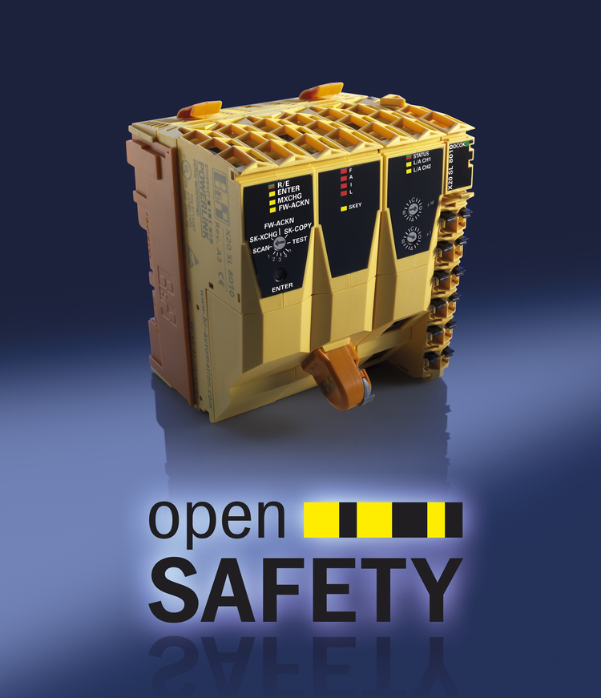
The integrated approach from B&R is setting new trends in the wind power industry. One aspect of this is the SafeLOGIC safety controller, which can be seamlessly integrated into standard controller systems.

关于贝加莱
贝加莱是一家总部位于奥地利并在全球拥有分公司的创新型自动化企业。2017年7月，贝加莱成为ABB集团的机械自动化事业部。作为工业自动化领域的全球领导者，贝加莱将前沿技术与领先工程相结合，为几乎每个行业的客户提供面向机器与工厂自动化、运动控制、HMI和集成安全技术的完整解决方案。借助于OPC UA、POWERLINK、openSAFETY等工业物联网通信标准，以及强大的Automation Studio软件开发平台，贝加莱不断重新定义自动化工程的未来。受简化流程和超出客户预期的承诺驱动，贝加莱始终保持创新精神并处于工业自动化领域的前沿。
获取更多信息，请访问www.br-automation.com。

