New technology trends at the 2012 Motek trade fair
B&R will be presenting simple and efficient automation solutions for key challenges currently facing the industry
Eggelsberg – In Hall 7, Booth 7101 at the Motek trade fair, which is taking place from the 8th to the 11th of October 2012 in Stuttgart, B&R will be presenting new solutions for two key challenges currently facing the industry – energy monitoring and condition monitoring – in addition to their motor-mounted motion control system product range. They facilitate optimum configuration of machines and systems and are the perfect complement to a modular drive solution for maximum performance and flexibility. In particular; the ACOPOSremote and ACOPOSmotor inverters with IP65 protection are effective products for creating modular architectures and greatly simplifying commissioning. Both the ACOPOSremote and ACOPOSmotor are equipped with a POWERLINK interface. These two inverters also provide software compatibility to the complete B&R drive family. This makes it possible to utilize all of the tools and features available in B&R Automation Studio as well as applications created therein.
Another important topic at the trade fair will be Integrated Safety Technology. B&R's safety system can be seamlessly integrated in the standard control system, i.e. the main controller, and the integration of both systems – standard and safe – reduces wiring to a minimum. Here, B&R relies on the open standard openSAFETY. Modular machines benefit particularly from this network-based wiring approach, since the ready-to-use machine components can simply be connected as a single unit, safe drives and all. In such a system, the integrated safety technology includes all safety-related hardware and software components.

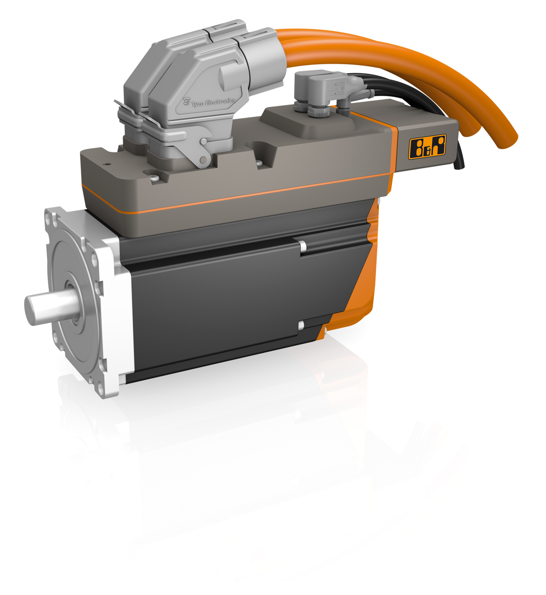
One of B&R's product highlights at the 2012 MOTEK trade fair in Stuttgart will be the ACOPOSmotor motor-mounted servo drive.

About B&R
B&R, a division of ABB Group, is a global leader in industrial automation headquartered in Austria. B&R combines state-of-the-art technology with advanced engineering to provide customers in virtually every industry with complete solutions for machine and factory automation, motion control, HMI and integrated safety technology. With Industrial IoT communication standards including OPC UA, POWERLINK and openSAFETY as well as its Automation Studio software, B&R is constantly redefining the future of automation engineering. The innovative spirit that keeps B&R at the forefront of industrial automation is driven by a commitment to simplifying processes and exceeding customer expectations.
For more information, visit www.br-automation.com.

