New technology trends at the 2012 Motek trade fair
B&R will be presenting simple and efficient automation solutions for key challenges currently facing the industry
Eggelsberg – In Hall 7, Booth 7101 at the Motek trade fair, which is taking place from the 8th to the 11th of October 2012 in Stuttgart, B&R will be presenting new solutions for two key challenges currently facing the industry – energy monitoring and condition monitoring – in addition to their motor-mounted motion control system product range. They facilitate optimum configuration of machines and systems and are the perfect complement to a modular drive solution for maximum performance and flexibility. In particular; the ACOPOSremote and ACOPOSmotor inverters with IP65 protection are effective products for creating modular architectures and greatly simplifying commissioning. Both the ACOPOSremote and the ACOPOSmotor are equipped with a POWERLINK interface. These two inverters also provide software compatibility to the complete B&R drive family. This makes it possible to utilize all of the tools and features available in B&R Automation Studio as well as applications created therein.
Another important topic at the trade fair will be Integrated Safety Technology. B&R's safety system can be seamlessly integrated in the standard control system, i.e. the main controller, and the integration of both systems – standard and safe – reduces wiring to a minimum. Here, B&R relies on the open standard openSAFETY. Máquinas modulares se pueden beneficiar del sistema basado en una red, ya que cada uno de sus módulos pueden ser conectados como si se tratase de una simple unidad, independientemente de si se trata de una parada de emergencia o de un servoaccionamiento con funciones de seguridad. In such a system, the integrated safety technology includes all safety-related hardware and software components.

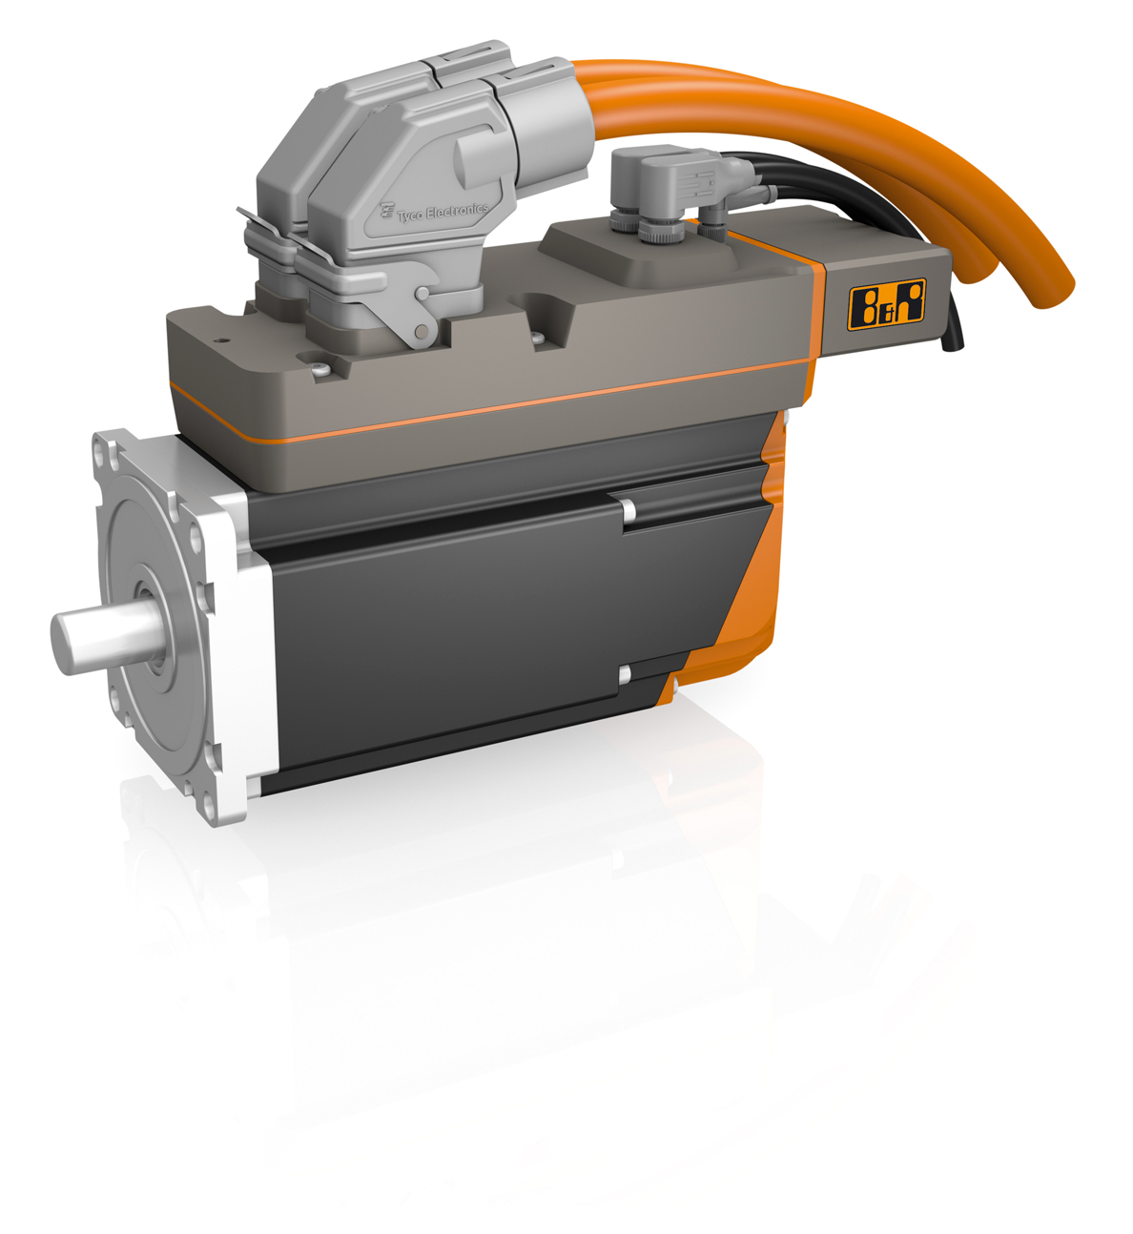
One of B&R's product highlights at the 2012 MOTEK trade fair in Stuttgart will be the ACOPOSmotor motor-mounted servo drive.

Acerca de B&R
B&R, empresa perteneciente al Grupo ABB y con sede en Austria, es líder mundial en automatización industrial. B&R combina tecnología de vanguardia con ingeniería avanzada para proporcionar a usuarios de todos los sectores soluciones completas para la automatización de máquinas y fábricas, Motion Control, HMI y tecnología de seguridad integrada. El catálogo de productos se completa con estándares de comunicación de IoT industrial que incluyen OPC UA, POWERLINK y openSAFETY. Gracias a su única herramienta de software Automation Studio, B&R redefine constantemente el futuro de la ingeniería de automatización. El espíritu innovador que mantiene a B&R a la vanguardia de la automatización industrial está impulsado por el compromiso de simplificar los procesos y superar las expectativas de los clientes.Para más información, visite www.br-automation.com.
Para más información, visite www.br-automation.com.

