New technology trends at the 2012 Motek trade fair
B&R will be presenting simple and efficient automation solutions for key challenges currently facing the industry
Eggelsberg – In Hall 7, Booth 7101 at the Motek trade fair, which is taking place from the 8th to the 11th of October 2012 in Stuttgart, B&R will be presenting new solutions for two key challenges currently facing the industry – energy monitoring and condition monitoring – in addition to their motor-mounted motion control system product range. They facilitate optimum configuration of machines and systems and are the perfect complement to a modular drive solution for maximum performance and flexibility. In particular; the ACOPOSremote and ACOPOSmotor inverters with IP65 protection are effective products for creating modular architectures and greatly simplifying commissioning. Both the ACOPOSremote and the ACOPOSmotor are equipped with a POWERLINK interface. These two inverters also provide software compatibility to the complete B&R drive family. This makes it possible to utilize all of the tools and features available in B&R Automation Studio as well as applications created therein.
Another important topic at the trade fair will be Integrated Safety Technology. B&R's safety system can be seamlessly integrated in the standard control system, i.e. the main controller, and the integration of both systems – standard and safe – reduces wiring to a minimum. Here, B&R relies on the open standard openSAFETY. Modular machines benefit particularly from this network-based wiring approach, since the ready-to-use machine components can simply be connected as a single unit, safe drives and all. In such a system, the integrated safety technology includes all safety-related hardware and software components.

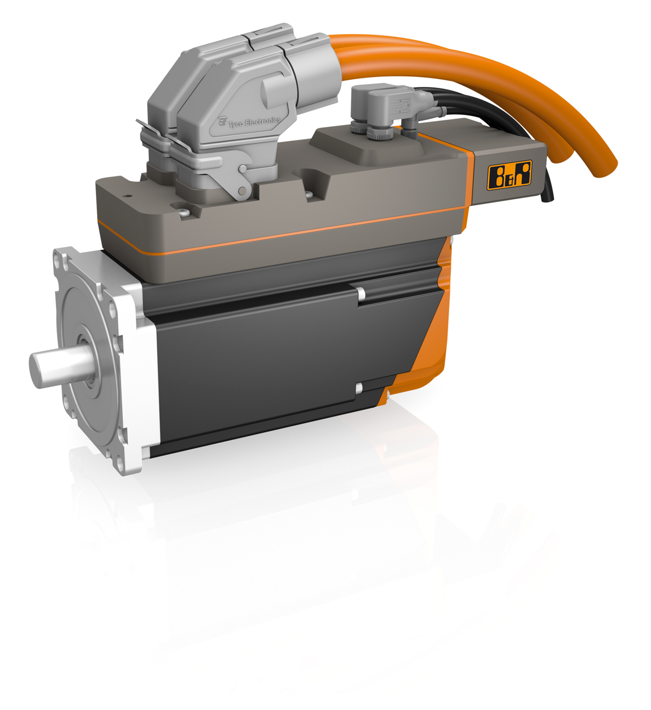
One of B&R's product highlights at the 2012 MOTEK trade fair in Stuttgart will be the ACOPOSmotor motor-mounted servo drive.

关于贝加莱
贝加莱是一家总部位于奥地利并在全球拥有分公司的创新型自动化企业。2017年7月，贝加莱成为ABB集团的机械自动化事业部。作为工业自动化领域的全球领导者，贝加莱将前沿技术与领先工程相结合，为几乎每个行业的客户提供面向机器与工厂自动化、运动控制、HMI和集成安全技术的完整解决方案。借助于OPC UA、POWERLINK、openSAFETY等工业物联网通信标准，以及强大的Automation Studio软件开发平台，贝加莱不断重新定义自动化工程的未来。受简化流程和超出客户预期的承诺驱动，贝加莱始终保持创新精神并处于工业自动化领域的前沿。
获取更多信息，请访问www.br-automation.com。

