2012 Vienna-Tec trade fair – B&R will be presenting sophisticated solutions for increasing efficiency
(Eggelsberg) In Hall D, Booth D0117 at the 2012 Vienna-Tec trade fair, which will be taking place from the 9th to the 12th of October at the exhibition center in Vienna, B&R will be presenting highlights concerning key topics in the field of automation. This will include sophisticated concepts to increase engineering efficiency. How companies can gain a competitive edge using an optimal engineering workflow will be demonstrated at the B&R booth on a live networked system in Automation Studio. Seamless integration of project configuration and programming in the automation system gives machine and system manufacturers a decisive advantage.
Two other key topics will be prevalent at B&R's exhibition booth at the Vienna-Tec trade fair: condition monitoring for machines and systems and energy monitoring. "These topics are becoming more and more important for manufacturing companies as well as OEMs,", says Hermann Obermair, Manager of Sales in Austria. Pre-configured solution packages from B&R for energy monitoring and condition monitoring are an indication of the possibilities available for integration in existing automation solutions. Everything used for a process – such as power, air pressure, steam or water – can be monitored and optimized. In addition, critical system information such as bearing damage or sluggishness, can be processed online. B&R solutions therefore provide possibilities to implement efficient and economical condition monitoring for machine and system maintenance concepts.

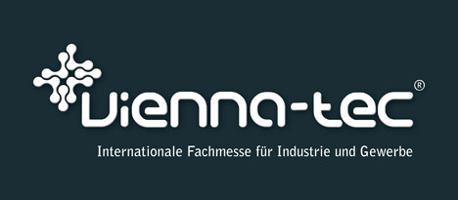

B&R Hakkında
ABB Grubunun bir bölümü olan B&R, merkezi Avusturya'da bulunan endüstriyel otomasyon alanında global bir liderdir. B&R, neredeyse her sektördeki müşterilere makine ve fabrika otomasyonu, hareket kontrolü, HMI ve entegre güvenlik teknolojisi için eksiksiz çözümler sunmak üzere en son teknolojiyi ileri mühendislikle birleştiriyor. OPC UA, POWERLINK ve openSAFETY gibi Endüstriyel IoT iletişim standartlarının yanı sıra Automation Studio yazılımıyla B&R, otomasyon mühendisliğinin geleceğini sürekli olarak yeniden tanımlıyor. B&R'ı endüstriyel otomasyonun ön saflarında tutan yenilikçi ruh, süreçleri basitleştirme ve müşteri beklentilerini aşma taahhüdünden kaynaklanmaktadır.
Daha fazla bilgi için www.br-automation.com adresini ziyaret edin.

