B&R Showcases New Automation Technologies at PACK EXPO 2012
B&R Industrial Automation will present its latest packaging solutions at the industry’s premier event, PACK EXPO International 2012 (booth 4337). In addition to the B&R products featured at its own booth, several OEMs at the show will exhibit packaging machines using B&R technology. B&R specializes in standards-based, scalable and modular control systems integrating logic, motion, robotics, human-machine interface (HMI), safety, I/O and data acquisition in a unified software development environment.
New products
New product introductions at PACK EXPO will include the latest Automation Panel HMI with multi-touch functionality developed specifically for industrial environments. The ergonomically designed, 21.5” full HD touch screen device resembles an oversized iPad®. The innovative multi-touch technology can make machine operation more intuitive, faster, and safer.
B&R complements its line of distributed, machine-mountable IP65 rated servo and stepper drives with the new ACPOSmuilti65m, a new family of integrated servo motor/drives that feature flexible mounting and cabling options, onboard I/O and advanced safe motion functions. Distributed drive technology saves valuable control cabinet space, reduces installation cost through quick-connect cables, and promotes modular machine design with easy expansion.
Networked & integrated safety
In contrast to hardwired safety PLCs and circuits, B&R’s integrated safety solution runs on the same Ethernet Powerlink network and integrates with B&R controllers and I/O. contributes to productivity with diagnostics, safe motion, safe robotics and zoning, without requiring full machine shut downs. B&R safety devices monitor, prevent, and react to machine faults to help increase efficiency and reduce energy consumption and downtime.
Other B&R highlights at PACK EXPO include an energy management module that contributes to better energy efficiency and easier monitoring, and a new IP65 rated keypad module that has the compact dimensions of a mobile phone.
Powered by B&R
Exhibitors from North America, Europe and developing markets will feature B&R powered packaging machinery at PACK EXPO covering the full range of primary, secondary and end-of-line packaging processes.
B&R supports education
This year’s PACK EXPO Student Packaging Solutions Contest will be sponsored by B&R Industrial Automation’s Packaging Solutions Group for the second year in a row. Student teams will be challenged to implement innovative packaging controls into their design for a weighing, filling and case-packing system for snack maker Jackson Snack Foods Company.

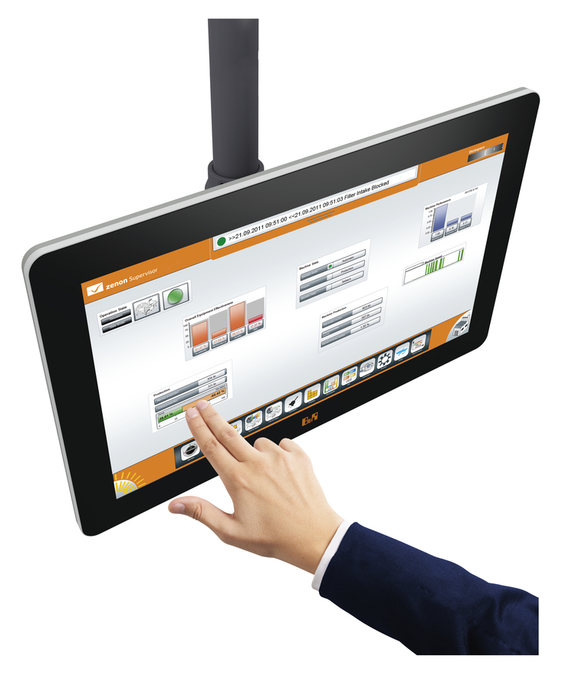
The ergonomically designed, 21.5” full HD touch screen device resembles anoversized iPad®

About B&R
B&R, a division of ABB Group, is a global leader in industrial automation headquartered in Austria. B&R combines state-of-the-art technology with advanced engineering to provide customers in virtually every industry with complete solutions for machine and factory automation, motion control, HMI and integrated safety technology. With Industrial IoT communication standards including OPC UA, POWERLINK and openSAFETY as well as its Automation Studio software, B&R is constantly redefining the future of automation engineering. The innovative spirit that keeps B&R at the forefront of industrial automation is driven by a commitment to simplifying processes and exceeding customer expectations.
For more information, visit www.br-automation.com.

