B&R Showcases New Automation Technologies at PACK EXPO 2012
B&R Industrial Automation will present its latest packaging solutions at the industry’s premier event, PACK EXPO International 2012 (booth 4337). In addition to the B&R products featured at its own booth, several OEMs at the show will exhibit packaging machines using B&R technology. B&R specializes in standards-based, scalable and modular control systems integrating logic, motion, robotics, human-machine interface (HMI), safety, I/O and data acquisition in a unified software development environment.
New products
New product introductions at PACK EXPO will include the latest Automation Panel HMI with multi-touch functionality developed specifically for industrial environments. The ergonomically designed, 21.5” full HD touch screen device resembles an oversized iPad®. The innovative multi-touch technology can make machine operation more intuitive, faster, and safer.
B&R complements its line of distributed, machine-mountable IP65 rated servo and stepper drives with the new ACPOSmuilti65m, a new family of integrated servo motor/drives that feature flexible mounting and cabling options, onboard I/O and advanced safe motion functions. Distributed drive technology saves valuable control cabinet space, reduces installation cost through quick-connect cables, and promotes modular machine design with easy expansion.
Networked & integrated safety
In contrast to hardwired safety PLCs and circuits, B&R’s integrated safety solution runs on the same Ethernet Powerlink network and integrates with B&R controllers and I/O. contributes to productivity with diagnostics, safe motion, safe robotics and zoning, without requiring full machine shut downs. B&R safety devices monitor, prevent, and react to machine faults to help increase efficiency and reduce energy consumption and downtime.
Other B&R highlights at PACK EXPO include an energy management module that contributes to better energy efficiency and easier monitoring, and a new IP65 rated keypad module that has the compact dimensions of a mobile phone.
Powered by B&R
Exhibitors from North America, Europe and developing markets will feature B&R powered packaging machinery at PACK EXPO covering the full range of primary, secondary and end-of-line packaging processes.
B&R supports education
This year’s PACK EXPO Student Packaging Solutions Contest will be sponsored by B&R Industrial Automation’s Packaging Solutions Group for the second year in a row. Student teams will be challenged to implement innovative packaging controls into their design for a weighing, filling and case-packing system for snack maker Jackson Snack Foods Company.

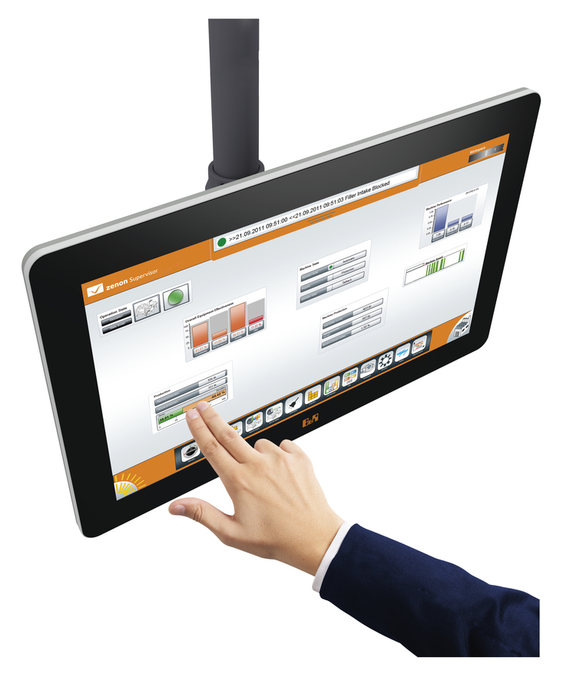
The ergonomically designed, 21.5” full HD touch screen device resembles anoversized iPad®

Acerca de B&R
B&R, empresa perteneciente al Grupo ABB y con sede en Austria, es líder mundial en automatización industrial. B&R combina tecnología de vanguardia con ingeniería avanzada para proporcionar a usuarios de todos los sectores soluciones completas para la automatización de máquinas y fábricas, Motion Control, HMI y tecnología de seguridad integrada. El catálogo de productos se completa con estándares de comunicación de IoT industrial que incluyen OPC UA, POWERLINK y openSAFETY. Gracias a su única herramienta de software Automation Studio, B&R redefine constantemente el futuro de la ingeniería de automatización. El espíritu innovador que mantiene a B&R a la vanguardia de la automatización industrial está impulsado por el compromiso de simplificar los procesos y superar las expectativas de los clientes.Para más información, visite www.br-automation.com.
Para más información, visite www.br-automation.com.

