B&R Showcases New Automation Technologies at PACK EXPO 2012
B&R Industrial Automation will present its latest packaging solutions at the industry’s premier event, PACK EXPO International 2012 (booth 4337). In addition to the B&R products featured at its own booth, several OEMs at the show will exhibit packaging machines using B&R technology. B&R specializes in standards-based, scalable and modular control systems integrating logic, motion, robotics, human-machine interface (HMI), safety, I/O and data acquisition in a unified software development environment.
New products
New product introductions at PACK EXPO will include the latest Automation Panel HMI with multi-touch functionality developed specifically for industrial environments. The ergonomically designed, 21.5” full HD touch screen device resembles an oversized iPad®. The innovative multi-touch technology can make machine operation more intuitive, faster, and safer.
B&R complements its line of distributed, machine-mountable IP65 rated servo and stepper drives with the new ACPOSmuilti65m, a new family of integrated servo motor/drives that feature flexible mounting and cabling options, onboard I/O and advanced safe motion functions. Distributed drive technology saves valuable control cabinet space, reduces installation cost through quick-connect cables, and promotes modular machine design with easy expansion.
Networked & integrated safety
In contrast to hardwired safety PLCs and circuits, B&R’s integrated safety solution runs on the same Ethernet Powerlink network and integrates with B&R controllers and I/O. contributes to productivity with diagnostics, safe motion, safe robotics and zoning, without requiring full machine shut downs. B&R safety devices monitor, prevent, and react to machine faults to help increase efficiency and reduce energy consumption and downtime.
Other B&R highlights at PACK EXPO include an energy management module that contributes to better energy efficiency and easier monitoring, and a new IP65 rated keypad module that has the compact dimensions of a mobile phone.
Powered by B&R
Exhibitors from North America, Europe and developing markets will feature B&R powered packaging machinery at PACK EXPO covering the full range of primary, secondary and end-of-line packaging processes.
B&R supports education
This year’s PACK EXPO Student Packaging Solutions Contest will be sponsored by B&R Industrial Automation’s Packaging Solutions Group for the second year in a row. Student teams will be challenged to implement innovative packaging controls into their design for a weighing, filling and case-packing system for snack maker Jackson Snack Foods Company.

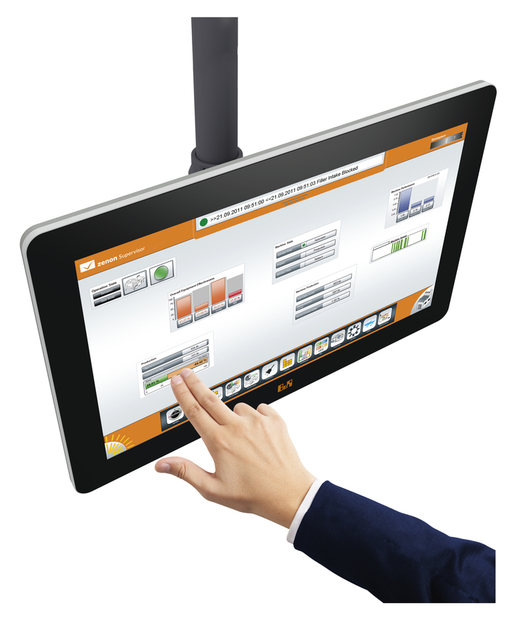
The ergonomically designed, 21.5” full HD touch screen device resembles anoversized iPad®

关于贝加莱
贝加莱是一家总部位于奥地利并在全球拥有分公司的创新型自动化企业。2017年7月，贝加莱成为ABB集团的机械自动化事业部。作为工业自动化领域的全球领导者，贝加莱将前沿技术与领先工程相结合，为几乎每个行业的客户提供面向机器与工厂自动化、运动控制、HMI和集成安全技术的完整解决方案。借助于OPC UA、POWERLINK、openSAFETY等工业物联网通信标准，以及强大的Automation Studio软件开发平台，贝加莱不断重新定义自动化工程的未来。受简化流程和超出客户预期的承诺驱动，贝加莱始终保持创新精神并处于工业自动化领域的前沿。
获取更多信息，请访问www.br-automation.com。

