Innovative solutions for the metal industry
B&R at EuroBLECH 2012 in Hanover
(Eggelsberg) – From October 23rd to the 27th, the largest trade fair for the metal processing industry will be held for the 22nd time. At EuroBLECH, B&R will be found at Hall 12, Booth F26 presenting its full range of products and services, as well as custom solutions tailored specifically to the metal industry. The focus will be on the revolutionary building block system, which allows for modular machines with automation technology perfectly suited to the customer's unique requirements. In the past, standard solutions were able to cover all the needs of the metal industry," explains Wolfgang Rabl, International Sales Manager and metal industry specialist at B&R, "but the situation has undergone a fundamental shift." Automation technology from B&R is tailored to the needs of its customers, which in turn allows them to design custom machines for theirs. And the integrated design of all B&R components and systems allows them to be mixed and matched in perfect harmony. In the end, this means a considerable boost in efficiency, with up to 80 percent energy savings. All the components needed to implement overall solution come straight from the B&R portfolio – in line with B&R's philosophy of serving as a single source supplier.
With its completely open CNC system, B&R offers machine manufacturers a very simple way to implement technology functions. These functions represent the core of the machine's know-how. B&R's CNC system also offers a simple interface to CAD/CAM systems. The CNC functions can be implemented on a single hardware platform together with the standard control, robotics and safety technology systems. This results in a significant increase in performance and decrease in costs.
Its newly developed condition monitoring solution enables B&R to guarantee even greater system availability. The reason? Data providing valuable insight into the physical condition of the machine is measured and evaluated continuously. Potential equipment failure or required maintenance are detected far in advance, allowing downtime to be planned efficiently.
At EuroBLECH B&R will also be exhibiting its Integrated Safety Technology, a trend-setting solution for machine manufacturing that integrates safety seamlessly into the standard control system and eliminates the need for extra wiring. B&R implements its safety system using the open standard openSAFETY. Modular machines benefit particularly from this network-based wiring approach, since the ready-to-use machine components can simply be connected as a single unit, safe drives and all.

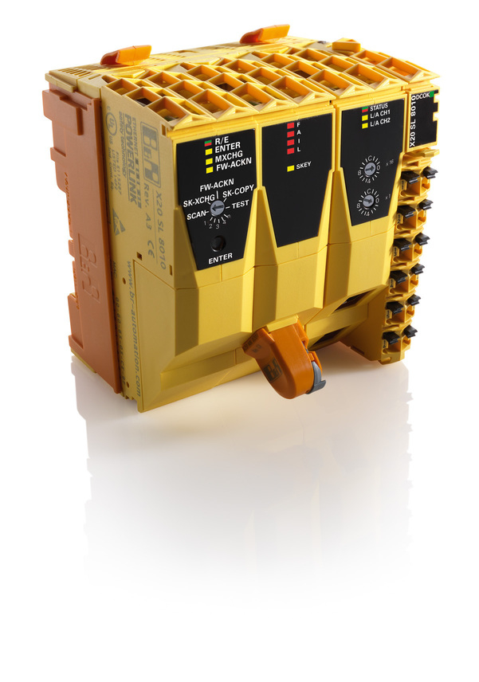
B&R Integrated Safety Technology is an innovative safety solution: Safety components such as the SafeLOGIC controllers are fully and easily integrated into the standard control system – with no extra wiring.

About B&R
B&R, a division of ABB Group, is a global leader in industrial automation headquartered in Austria. B&R combines state-of-the-art technology with advanced engineering to provide customers in virtually every industry with complete solutions for machine and factory automation, motion control, HMI and integrated safety technology. With Industrial IoT communication standards including OPC UA, POWERLINK and openSAFETY as well as its Automation Studio software, B&R is constantly redefining the future of automation engineering. The innovative spirit that keeps B&R at the forefront of industrial automation is driven by a commitment to simplifying processes and exceeding customer expectations.
For more information, visit www.br-automation.com.

