Safe programming in Automation Studio
Graphical project comparison with SafeDESIGNER Version 2.90
Eggelsberg – New and improved SafeDESIGNER Version 2.90 is now available from B&R. As an integral component of the Automation Studio development environment, SafeDESIGNER ensures safety and reliability when programming sensitive functions for the protection of equipment and personnel. All modifications to safety systems are completely protected by a restrictive change process. In this new release of SafeDESIGNER, a helpful graphical view has been added to the comparison function. Users now have a clear and comprehensive overview of all modifications to the safety system. The effects of changes to safety functionality can now be localized even faster and more effectively.
The project comparison in SafeDESIGNER 2.90 makes it possible to determine which verification and validation procedures are required based on well-founded information and to analyze differences between machine generations. Projects don't need to be compiled before they can be compared, either. SafeDESIGNER 2.90 lets users compare even unknown or temporary uncompiled software versions.
SafeDESIGNER draws some of its components from the open technology platform of the Safety Alliance. "The Safety Alliance is an association of leading automation manufacturers, service providers and users of safety technology – including B&R – who benefit from the synergy of their various areas of expertise," explains Peter Fuchs, spokesman of the Safety Alliance. Its mission is to promote the marketing and continuous development of an open technology platform for functional safety based on the market standard from KW-Software. The manufacturer-independent certified technology components are already being used in solutions from countless leading automation suppliers. The platform's open, modular and scalable architecture greatly simplifies the development, integration and application of functional safety technology. For more information, visit www.safety-alliance.de.

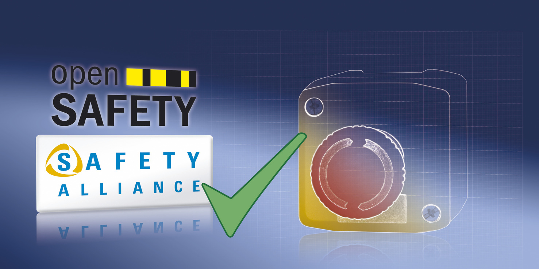
SafeDESIGNER 2.90 gives users a clear and comprehensive overview of all modifications to a project.

About B&R
B&R, a division of ABB Group, is a global leader in industrial automation headquartered in Austria. B&R combines state-of-the-art technology with advanced engineering to provide customers in virtually every industry with complete solutions for machine and factory automation, motion control, HMI and integrated safety technology. With Industrial IoT communication standards including OPC UA, POWERLINK and openSAFETY as well as its Automation Studio software, B&R is constantly redefining the future of automation engineering. The innovative spirit that keeps B&R at the forefront of industrial automation is driven by a commitment to simplifying processes and exceeding customer expectations.
For more information, visit www.br-automation.com.

