Safe programming in Automation Studio
Graphical project comparison with SafeDESIGNER Version 2.90
Eggelsberg – New and improved SafeDESIGNER Version 2.90 is now available from B&R. As an integral component of the Automation Studio development environment, SafeDESIGNER ensures safety and reliability when programming sensitive functions for the protection of equipment and personnel. All modifications to safety systems are completely protected by a restrictive change process. In this new release of SafeDESIGNER, a helpful graphical view has been added to the comparison function. Users now have a clear and comprehensive overview of all modifications to the safety system. The effects of changes to safety functionality can now be localized even faster and more effectively.
The project comparison in SafeDESIGNER 2.90 makes it possible to determine which verification and validation procedures are required based on well-founded information and to analyze differences between machine generations. Projects don't need to be compiled before they can be compared, either. SafeDESIGNER 2.90 lets users compare even unknown or temporary uncompiled software versions.
SafeDESIGNER draws some of its components from the open technology platform of the Safety Alliance. "The Safety Alliance is an association of leading automation manufacturers, service providers and users of safety technology – including B&R – who benefit from the synergy of their various areas of expertise," explains Peter Fuchs, Spokesman of the Safety Alliance. Its mission is to promote the marketing and continuous development of an open technology platform for functional safety based on the market standard from KW-Software. The manufacturer-independent certified technology components are already being used in solutions from countless leading automation suppliers. The platform's open, modular and scalable architecture greatly simplifies the development, integration and application of functional safety technology. Para más información, visite www.br-automation.com

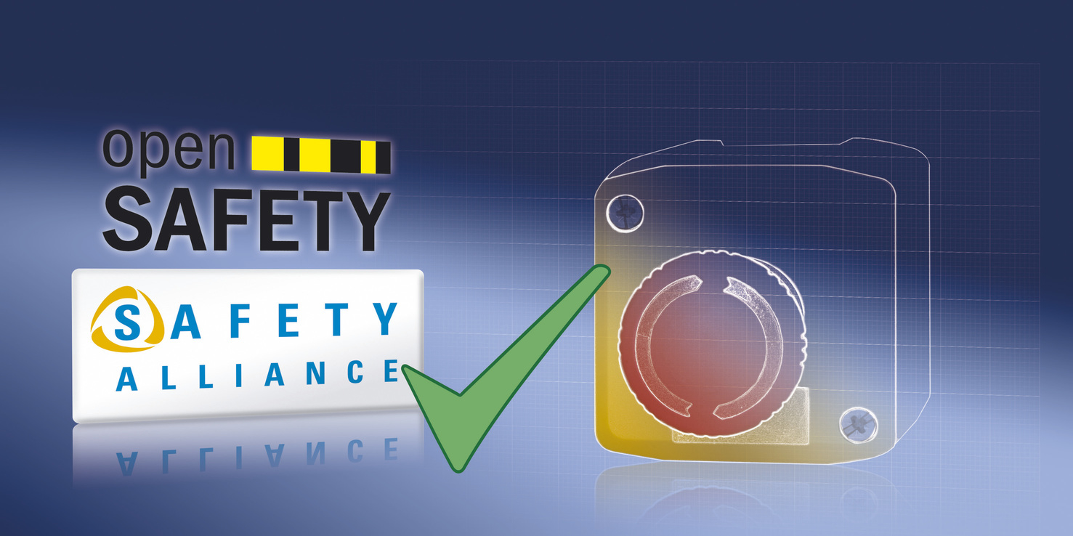
SafeDESIGNER 2.90 gives users a clear and comprehensive overview of all modifications to a project.

Acerca de B&R
B&R, empresa perteneciente al Grupo ABB y con sede en Austria, es líder mundial en automatización industrial. B&R combina tecnología de vanguardia con ingeniería avanzada para proporcionar a usuarios de todos los sectores soluciones completas para la automatización de máquinas y fábricas, Motion Control, HMI y tecnología de seguridad integrada. El catálogo de productos se completa con estándares de comunicación de IoT industrial que incluyen OPC UA, POWERLINK y openSAFETY. Gracias a su única herramienta de software Automation Studio, B&R redefine constantemente el futuro de la ingeniería de automatización. El espíritu innovador que mantiene a B&R a la vanguardia de la automatización industrial está impulsado por el compromiso de simplificar los procesos y superar las expectativas de los clientes.Para más información, visite www.br-automation.com.
Para más información, visite www.br-automation.com.

