Safe programming in Automation Studio
Graphical project comparison with SafeDESIGNER Version 2.90
Eggelsberg – New and improved SafeDESIGNER Version 2.90 is now available from B&R. As an integral component of the Automation Studio development environment, SafeDESIGNER ensures safety and reliability when programming sensitive functions for the protection of equipment and personnel. All modifications to safety systems are completely protected by a restrictive change process. In this new release of SafeDESIGNER, a helpful graphical view has been added to the comparison function. Users now have a clear and comprehensive overview of all modifications to the safety system. The effects of changes to safety functionality can now be localized even faster and more effectively.
The project comparison in SafeDESIGNER 2.90 makes it possible to determine which verification and validation procedures are required based on well-founded information and to analyze differences between machine generations. Projects don't need to be compiled before they can be compared, either. SafeDESIGNER 2.90 lets users compare even unknown or temporary uncompiled software versions.
SafeDESIGNER draws some of its components from the open technology platform of the Safety Alliance. "The Safety Alliance is an association of leading automation manufacturers, service providers and users of safety technology – including B&R – who benefit from the synergy of their various areas of expertise," explains Peter Fuchs, Spokesman of the Safety Alliance. Its mission is to promote the marketing and continuous development of an open technology platform for functional safety based on the market standard from KW-Software. The manufacturer-independent certified technology components are already being used in solutions from countless leading automation suppliers. The platform's open, modular and scalable architecture greatly simplifies the development, integration and application of functional safety technology. For more information, visit www.safety-alliance.de.

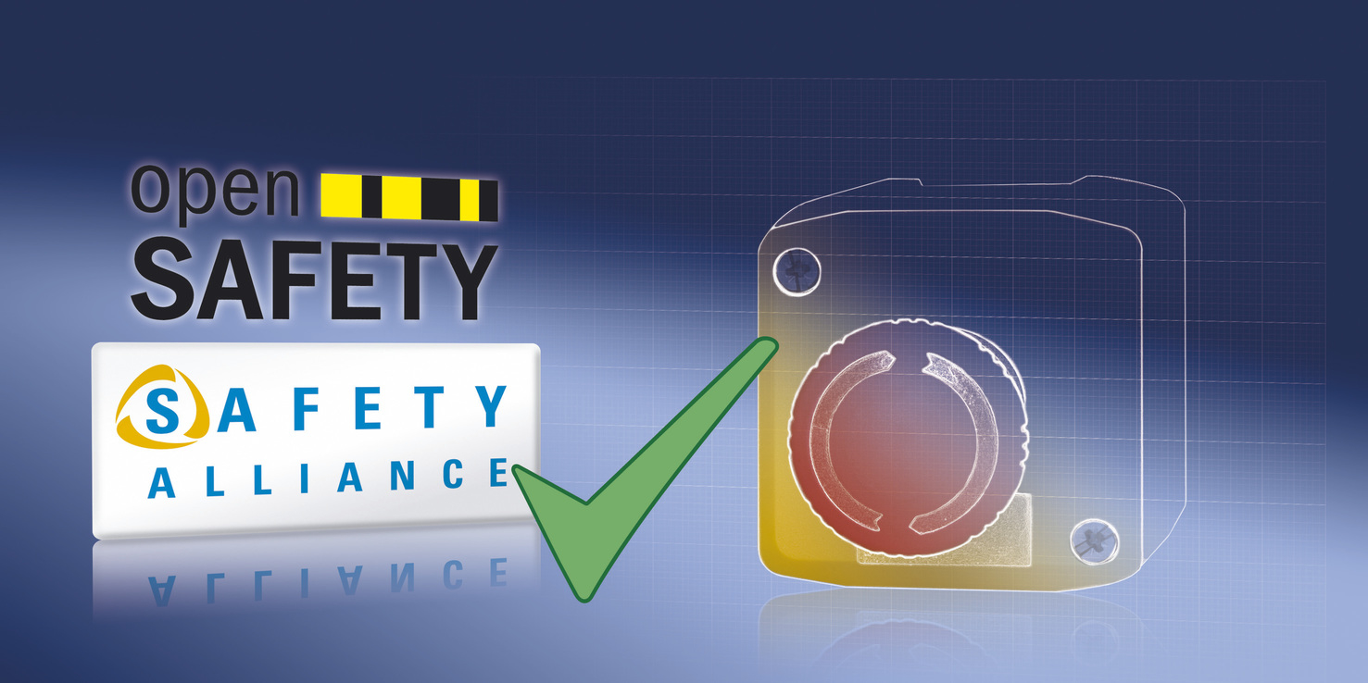
SafeDESIGNER 2.90 gives users a clear and comprehensive overview of all modifications to a project.

关于贝加莱
贝加莱是一家总部位于奥地利并在全球拥有分公司的创新型自动化企业。2017年7月，贝加莱成为ABB集团的机械自动化事业部。作为工业自动化领域的全球领导者，贝加莱将前沿技术与领先工程相结合，为几乎每个行业的客户提供面向机器与工厂自动化、运动控制、HMI和集成安全技术的完整解决方案。借助于OPC UA、POWERLINK、openSAFETY等工业物联网通信标准，以及强大的Automation Studio软件开发平台，贝加莱不断重新定义自动化工程的未来。受简化流程和超出客户预期的承诺驱动，贝加莱始终保持创新精神并处于工业自动化领域的前沿。
获取更多信息，请访问www.br-automation.com。

