Groundbreaking innovations in automation
B&R at the 2012 SPS IPC Drives in Nuremberg
This year's SPS IPC Drives will be taking place from the 27th to the 29th of November 2012 in Nuremberg. At this leading trade fair for industrial automation systems and components, B&R's entire product range will be on display at their nearly 1000 m² booth (Hall 7, Booth 206). The spotlight will be on the latest developments from this highly innovative global leader in the field of automation technology. These innovations will open up new opportunities for machine and system manufacturers to build and strengthen their competitive edge.
New B&R Box PC with 3rd generation Intel® Core™ i technology
Users can expect extreme versatility and cost advantages from B&R's robust and reliable line of industrial PCs, including the new Automation PC 910. At the heart of this powerful industrial PC you'll find the latest 3rd generation Intel® Core™ i technology. Core™ i3, Core™ i5 and Core™ i7 CPUs with up to four cores, paired with the newly released QM77 Express chipset, provide the ultimate in state-of-the-art industrial computing performance.
APROL EnMon optimizes energy efficiency
B&R has introduced an all-new energy monitoring solution – APROL EnMon. Helping users implement ISO 50001, this new innovation also provides improved energy efficiency, which means reduced costs and increased competitiveness. In stand-alone operation or integrated in an existing APROL process control system, this solution supports a process of continual improvement by measuring and evaluating all relevant energy consumption data.
Automation Studio 4 supercharges development with sustainable efficiency
In spite of ever increasing product complexity, "Smart Engineering" with Automation Studio 4 helps cut development costs and accelerate time-to-market. The next generation of B&R's development environment provides decisive advantages. For one, it allows you to develop automation solutions with unprecedented efficiency.
Automation Studio 4 is also equipped with revolutionary new features that support optimum development and series production of modular machines in varying configurations. These include complete software modularization, a graphical hardware configuration tool and communication via OPC-UA as well as open interfaces between Automation Studio 4 and various design and simulation software.
In addition, Automation Runtime provides optimal multi-core utilization and supports simultaneous use of multiple operating systems (MultiOS) on a single hardware platform.
CPU redundancy from B&R – Absolutely reliable and cost-efficient
In the past, a failsafe system with redundant processors was a cost-prohibitive solution for many applications. With processor redundancy provided by the B&R X20 System and integrated in the Automation Studio 4 development environment, high availability systems are now a cost-effective option even for smaller applications in the classic areas of machine automation. The communication protocol used for B&R's redundancy solution is the high-performance POWERLINK real-time fieldbus.
Decentralized drive technology from B&R for optimum use of available space
The ACOPOSmulti65m motor-mounted servo drive with IP65 protection is an innovative addition to B&R's modular ACOPOSmulti drive system. It melds with the motor to form a configurable and easy-to-connect mechatronic servo drive unit with integrated safe motion functions and openSAFETY to deliver power right where it is needed on the machine. This saves valuable space in the control cabinet and, even more importantly, advances the development of decentralized machine architectures.
New milestone in integrated safety
At the 2012 SPS IPC Drives, B&R will be presenting a further milestone for integrated safety technology.
These outstanding highlights will be featured at the B&R booth in a comprehensive exhibition of notable innovations spanning all areas of automation – including brand new developments for operation and HMI as well as robust components and systems for mobile automation.

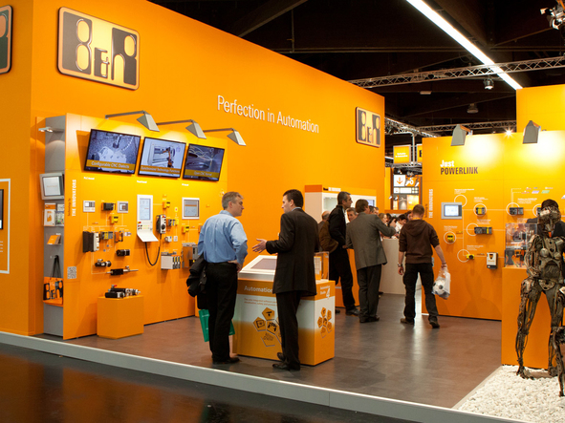
C'est sur le Stand 206, Hall 7, du salon SPS IPC Drives 2012, que B&R présentera ses innovations révolutionnaires pour tous les domaines de l'automatisation industrielle.

A propos de B&R
B&R est une société d'automatismes innovante dont le siège social est basé en Autriche et qui dispose d'agences partout dans le monde. Le 6 juillet 2017, B&R est devenue une business unit du groupe ABB. Comptant parmi les leaders de l’automatisation industrielle, B&R allie technologies avancées et ingénierie de haut niveau pour fournir à ses clients, dans la quasi-totalité des industries, des solutions complètes pour l’automatisation de machines et de lignes, le contrôle de mouvements, la visualisation et la sécurité intégrée. En s’appuyant sur des standards de communication IoT Industriel comme OPC UA, POWERLINK et openSAFETY, et sur le puissant environnement de développement logiciel Automation Studio, B&R façonne l'avenir de l'ingénierie des automatismes. Forte de son leadership technologique, la société puise sa capacité d'innovation dans sa volonté de simplifier les processus et d'aller au-delà des attentes des clients.
Pour plus d'informations : www.br-automation.com

