Groundbreaking innovations in automation
B&R at the 2012 SPS IPC Drives trade fair in Nuremberg
This year's SPS IPC Drives will be taking place from the 27th to the 29th of November 2012 in Nuremberg. At this leading trade fair for industrial automation systems and components, B&R's entire product range will be on display at their nearly 1000 m² booth (Hall 7, Booth 206). The spotlight will be on the latest developments from this highly innovative global leader in the field of automation technology. These innovations will open up new opportunities for machine and system manufacturers to build and strengthen their competitive edge.
New B&R box PC with third-generation Intel® Core™ i technology
Users can expect extreme versatility and cost advantages from B&R's robust and reliable line of industrial PCs, including the new Automation PC 910. At the heart of this powerful industrial PC you'll find the latest 3rd generation Intel® Core™ i technology. Core™ i3, Core™ i5 and Core™ i7 CPUs with up to four cores, combined with the new QM77 Express chipset provide the most performance currently available for industrial PCs.
APROL EnMon increases energy efficiency
B&R has introduced an all-new energy monitoring solution – APROL EnMon. Helping users implement ISO 50001, this new innovation also provides improved energy efficiency, which means reduced costs and increased competitiveness. In standalone operation or integrated in an existing APROL process control system, this solution supports a process of continual improvement by measuring and evaluating all relevant energy consumption data.
Automation Studio 4 increases development efficiency
In spite of ever increasing product complexity, "Smart Engineering" with Automation Studio 4 helps cut development costs and accelerate time-to-market. The next generation of B&R's development environment provides decisive advantages. thus significantly increasing efficiency in development.
Automation Studio 4 is also equipped with revolutionary new features that support optimum development and series production of modular machines in varying configurations. What makes this possible is consistent software modularization, a fully visual hardware configuration and communication via OPC UA, as well as open interfaces to design and simulation software.
In addition, Automation Runtime provides optimal multi-core utilization and supports simultaneous use of multiple operating systems (MultiOS) on a single hardware platform.
CPU redundancy from B&R – Absolutely reliable and cost-efficient
In the past, a failsafe system with redundant processors was a cost-prohibitive solution for many applications. With processor redundancy provided by the B&R X20 system and integrated in the Automation Studio 4 development environment, high availability systems are now a cost-effective option even for smaller applications in the classic areas of machine automation. The communication protocol used for B&R's redundancy solution is the high-performance POWERLINK real-time fieldbus.
Distributed actuator technology from B&R provides flexibility
The ACOPOSmotor motor-mounted servo drive with IP65 protection is an innovative addition to B&R's modular ACOPOSmulti drive system. It melds with the motor to form a configurable and easy-to-connect mechatronic servo drive unit with integrated safe motion functions and openSAFETY to deliver power right where it is needed on the machine. This saves valuable space in the control cabinet and, even more importantly, advances the development of decentralized machine architectures.

At the 2012 SPS IPC Drives, B&R will be presenting a further milestone for integrated safety technology.
These outstanding highlights will be featured at the B&R booth in a comprehensive exhibition of notable innovations spanning all areas of automation – including brand new developments for operation and HMI as well as robust components and systems for mobile automation.

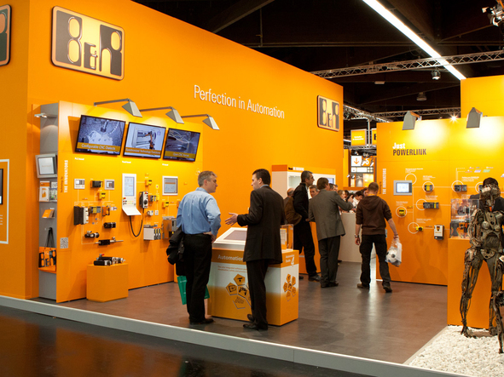
In Hall 7, Booth 206 at the 2012 SPS IPC Drives, B&R will be presenting groundbreaking innovations spanning all areas of industrial automation.

B&R Hakkında
ABB Grubunun bir bölümü olan B&R, merkezi Avusturya'da bulunan endüstriyel otomasyon alanında global bir liderdir. B&R, neredeyse her sektördeki müşterilere makine ve fabrika otomasyonu, hareket kontrolü, HMI ve entegre güvenlik teknolojisi için eksiksiz çözümler sunmak üzere en son teknolojiyi ileri mühendislikle birleştiriyor. OPC UA, POWERLINK ve openSAFETY gibi Endüstriyel IoT iletişim standartlarının yanı sıra Automation Studio yazılımıyla B&R, otomasyon mühendisliğinin geleceğini sürekli olarak yeniden tanımlıyor. B&R'ı endüstriyel otomasyonun ön saflarında tutan yenilikçi ruh, süreçleri basitleştirme ve müşteri beklentilerini aşma taahhüdünden kaynaklanmaktadır.
Daha fazla bilgi için www.br-automation.com adresini ziyaret edin.

