Groundbreaking innovations in automation
B&R at the 2012 SPS IPC Drives in Nuremberg
This year's SPS IPC Drives will be taking place from the 27th to the 29th of November 2012 in Nuremberg. At this leading trade fair for industrial automation systems and components, B&R's entire product range will be on display at their nearly 1000 m² booth (Hall 7, Booth 206). The spotlight will be on the latest developments from this highly innovative global leader in the field of automation technology. These innovations will open up new opportunities for machine and system manufacturers to build and strengthen their competitive edge.
New B&R Box PC with 3rd generation Intel® Core™ i technology
Users can expect extreme versatility and cost advantages from B&R's robust and reliable line of industrial PCs, including the new Automation PC 910. At the heart of this powerful industrial PC you'll find the latest 3rd generation Intel® Core™ i technology. Core™ i3, Core™ i5 and Core™ i7 CPUs with up to four cores, paired with the newly released QM77 Express chipset, provide the ultimate in state-of-the-art industrial computing performance.
APROL EnMon optimizes energy efficiency
B&R has introduced an all-new energy monitoring solution – APROL EnMon. Helping users implement ISO 50001, this new innovation also provides improved energy efficiency, which means reduced costs and increased competitiveness. In stand-alone operation or integrated in an existing APROL process control system, this solution supports a process of continual improvement by measuring and evaluating all relevant energy consumption data.
Automation Studio 4 supercharges development with sustainable efficiency
In spite of ever increasing product complexity, "Smart Engineering" with Automation Studio 4 helps cut development costs and accelerate time-to-market. The next generation of B&R's development environment provides decisive advantages. For one, it allows you to develop automation solutions with unprecedented efficiency.
Automation Studio 4 is also equipped with revolutionary new features that support optimum development and series production of modular machines in varying configurations. These include complete software modularization, a graphical hardware configuration tool and communication via OPC-UA as well as open interfaces between Automation Studio 4 and various design and simulation software.
In addition, Automation Runtime provides optimal multi-core utilization and supports simultaneous use of multiple operating systems (MultiOS) on a single hardware platform.
CPU redundancy from B&R – Absolutely reliable and cost-efficient
In the past, a failsafe system with redundant processors was a cost-prohibitive solution for many applications. 通过贝加莱X20系统提供并集成在Automation Studio 4开发环境中的处理器冗余，即使机器自动化传统领域中较小的应用现在也可以选用具有成本效益的高可用性系统。The communication protocol used for B&R's redundancy solution is the high-performance POWERLINK real-time fieldbus.
Decentralized drive technology from B&R for optimum use of available space
The ACOPOSmulti65m motor-mounted servo drive with IP65 protection is an innovative addition to B&R's modular ACOPOSmulti drive system. It melds with the motor to form a configurable and easy-to-connect mechatronic servo drive unit with integrated safe motion functions and openSAFETY to deliver power right where it is needed on the machine. This saves valuable space in the control cabinet and, even more importantly, advances the development of decentralized machine architectures.
New milestone in integrated safety
At the 2012 SPS IPC Drives, B&R will be presenting a further milestone for integrated safety technology.
These outstanding highlights will be featured at the B&R booth in a comprehensive exhibition of notable innovations spanning all areas of automation – including brand new developments for operation and HMI as well as robust components and systems for mobile automation.

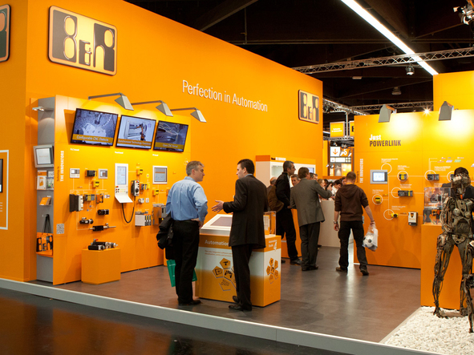

关于贝加莱
贝加莱是一家总部位于奥地利并在全球拥有分公司的创新型自动化企业。2017年7月，贝加莱成为ABB集团的机械自动化事业部。作为工业自动化领域的全球领导者，贝加莱将前沿技术与领先工程相结合，为几乎每个行业的客户提供面向机器与工厂自动化、运动控制、HMI和集成安全技术的完整解决方案。借助于OPC UA、POWERLINK、openSAFETY等工业物联网通信标准，以及强大的Automation Studio软件开发平台，贝加莱不断重新定义自动化工程的未来。受简化流程和超出客户预期的承诺驱动，贝加莱始终保持创新精神并处于工业自动化领域的前沿。
获取更多信息，请访问www.br-automation.com。

