MA170 – New control and I/O concept
A modular system architecture for mobile automation
With their MA170 modular control and I/O systems, B&R is continuing to set new standards in mobile automation. For the first time, achievements made in the field of industrial automation have made their way into commercial equipment. The modular approach that industrial automation users have already come to know and appreciate makes it possible for manufacturers of special-purpose vehicles such as excavators and firetrucks to tailor control and I/O systems to their individual requirements. And because these MA170 devices are fully integrated into the B&R product range, they can receive all of the benefits of integrated safety solutions such as B&R's Integrated Safety Technology.
High flexibility for customized needs
Customers can put together modules as their requirements demand. This doesn't just mean the number of I/O channels or the CPU to be used; engineers can also choose between the CAN bus and Ethernet POWERLINK communication protocols. All of the programming is handled in the advanced Automation Studio software development environment, which all but guarantees the elimination of interface problems between hardware and software components.
MA170 devices have been specially developed for use in harsh conditions. An IP65 housing and coated circuit board allow these modules to withstand extreme temperatures from -40°C to +85°C without difficulties. Depending on customer requirements, the devices come equipped with up to either IP65 or IP67 protection, thereby ruling out short circuits caused by condensation. These new B&R modules are also shock and vibration resistant.
Each MA170 device allows 44 I/O channels to be set up as needed – if more channels are required, it's just a question of adding more modules. A wide range of interface modules – for handling remote maintenance, for example – allow devices to be flexibly adapted to the situation at hand. These devices can also be swapped out at a later time.

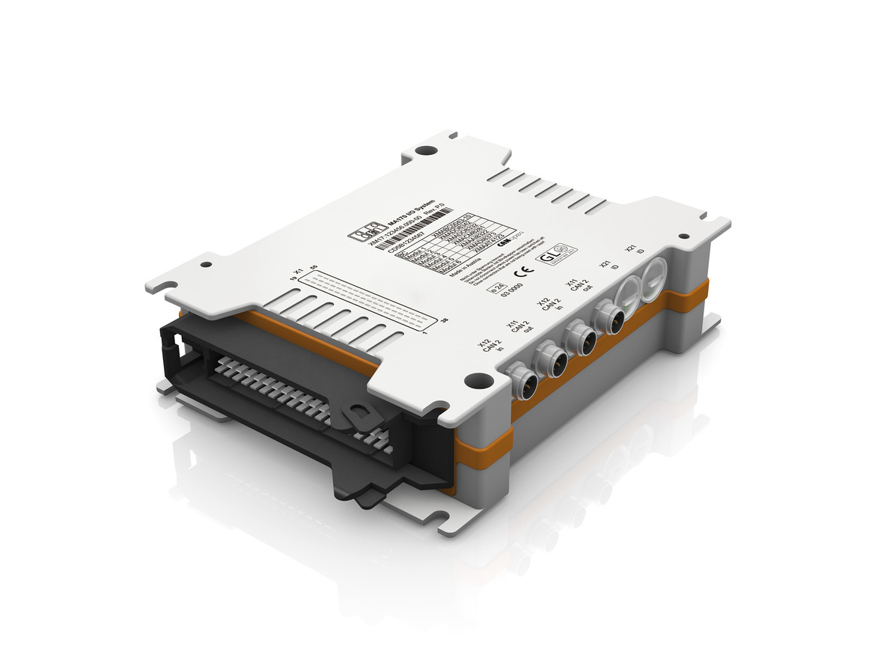
With the new MA170 modular control and I/O concept, commercial equipment manufacturers profit from B&R's industrial automation expertise.

B&R Hakkında
ABB Grubunun bir bölümü olan B&R, merkezi Avusturya'da bulunan endüstriyel otomasyon alanında global bir liderdir. B&R, neredeyse her sektördeki müşterilere makine ve fabrika otomasyonu, hareket kontrolü, HMI ve entegre güvenlik teknolojisi için eksiksiz çözümler sunmak üzere en son teknolojiyi ileri mühendislikle birleştiriyor. OPC UA, POWERLINK ve openSAFETY gibi Endüstriyel IoT iletişim standartlarının yanı sıra Automation Studio yazılımıyla B&R, otomasyon mühendisliğinin geleceğini sürekli olarak yeniden tanımlıyor. B&R'ı endüstriyel otomasyonun ön saflarında tutan yenilikçi ruh, süreçleri basitleştirme ve müşteri beklentilerini aşma taahhüdünden kaynaklanmaktadır.
Daha fazla bilgi için www.br-automation.com adresini ziyaret edin.

