Increasing machine availability with B&R
Integrated evaluation of vibration patterns with an intelligent X20 module
Eggelsberg – B&R's innovative X20 module with onboard intelligence for vibration analysis makes condition monitoring an integral standard feature in every machine. Until now, preventive maintenance based on data from permanent condition monitoring has been rarely practiced due to the high cost of conventional systems. The X20 module remedies this by maximizing machine availability while minimizing the time and money spent on maintenance, allowing significant reductions to the total cost of ownership of machines and systems. Preventive maintenance control based on the condition of the machinery can be planned more efficiently and performed during breaks in production.
Condition monitoring just got easier
With the X20CM4810 module, B&R is presenting the very first dedicated condition monitoring tool for machine builders and end users. "The innovative X20 module allows operators to permanently monitor the status of an entire system. The results are then used to determine exactly which parts of the machinery require maintenance," states Andreas Waldl, B&R. With a width of two slots, the module provides four input channels with an IEPE interface (integrated electronic piezoelectric) for querying acceleration sensors. This interface supplies the sensors with power, samples their signals and processes them internally to generate more than 70 condition parameters like configurable damage frequency values, which are then transferred directly to the CPU via POWERLINK or any other standard fieldbus system.
Compact solution with no service required
The integrated evaluation of vibration patterns sets the B&R X20 module apart from other tools on the market and completely eliminates the need to forward raw data to an external CPU for analysis. ¿El resultado? A reduced load on the fieldbus as well as the elimination of superfluous interfaces.
The condition parameters generated by this module not only provide operators with the information they need to optimize maintenance intervals, but are also available for use directly as input in the automation software. B&R Automation Studio makes it a snap to configure the X20CM4810 and program how the machine should respond to a status change, significantly reducing the amount of time and effort spent working with software. "The main criteria we focused on when developing these modules was that they needed to be easy to use as part of an overall automation solution – without requiring expertise in vibration mechanics," explains Waldl.

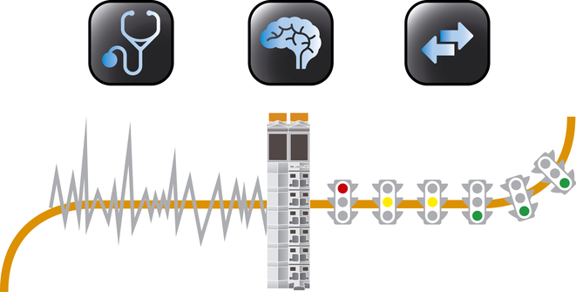
B&R's X20 module for condition monitoring is a snap to integrate into an overall automation solution – no expertise in vibration mechanics required!

Acerca de B&R
B&R, empresa perteneciente al Grupo ABB y con sede en Austria, es líder mundial en automatización industrial. B&R combina tecnología de vanguardia con ingeniería avanzada para proporcionar a usuarios de todos los sectores soluciones completas para la automatización de máquinas y fábricas, Motion Control, HMI y tecnología de seguridad integrada. El catálogo de productos se completa con estándares de comunicación de IoT industrial que incluyen OPC UA, POWERLINK y openSAFETY. Gracias a su única herramienta de software Automation Studio, B&R redefine constantemente el futuro de la ingeniería de automatización. El espíritu innovador que mantiene a B&R a la vanguardia de la automatización industrial está impulsado por el compromiso de simplificar los procesos y superar las expectativas de los clientes.Para más información, visite www.br-automation.com.
Para más información, visite www.br-automation.com.

