Increasing machine availability with B&R
Integrated evaluation of vibration patterns with an intelligent X20 module
Eggelsberg – B&R's innovative X20 module with onboard intelligence for vibration analysis makes condition monitoring an integral standard feature in every machine. Until now, preventive maintenance based on data from permanent condition monitoring has been rarely practiced due to the high cost of conventional systems. The X20 module remedies this by maximizing machine availability while minimizing the time and money spent on maintenance, allowing significant reductions to the total cost of ownership of machines and systems. Preventive maintenance control based on the condition of the machinery can be planned more efficiently and performed during breaks in production.
Condition monitoring just got easier
With the X20CM4810 module, B&R is presenting the very first dedicated condition monitoring tool for machine builders and end users. "The innovative X20 module allows operators to permanently monitor the status of an entire system. The results are then used to determine exactly which parts of the machinery require maintenance," states Andreas Waldl, B&R. With a width of two slots, the module provides four input channels with an IEPE interface (integrated electronic piezoelectric) for querying acceleration sensors. This interface supplies the sensors with power, samples their signals and processes them internally to generate more than 70 condition parameters like configurable damage frequency values, which are then transferred directly to the CPU via POWERLINK or any other standard fieldbus system.
Compact solution with no service required
The integrated evaluation of vibration patterns sets the B&R X20 module apart from other tools on the market and completely eliminates the need to forward raw data to an external CPU for analysis. The result? A reduced load on the fieldbus as well as the elimination of superfluous interfaces.
The condition parameters generated by this module not only provide operators with the information they need to optimize maintenance intervals, but are also available for use directly as input in the automation software. B&R Automation Studio makes it a snap to configure the X20CM4810 and program how the machine should respond to a status change, significantly reducing the amount of time and effort spent working with software. "The main criteria we focused on when developing these modules was that they needed to be easy to use as part of an overall automation solution – without requiring expertise in vibration mechanics," explains Waldl.

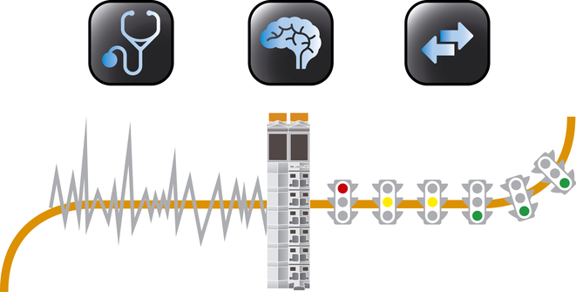
B&R's X20 module for condition monitoring is a snap to integrate into an overall automation solution – no expertise in vibration mechanics required!

B&R Hakkında
ABB Grubunun bir bölümü olan B&R, merkezi Avusturya'da bulunan endüstriyel otomasyon alanında global bir liderdir. B&R, neredeyse her sektördeki müşterilere makine ve fabrika otomasyonu, hareket kontrolü, HMI ve entegre güvenlik teknolojisi için eksiksiz çözümler sunmak üzere en son teknolojiyi ileri mühendislikle birleştiriyor. OPC UA, POWERLINK ve openSAFETY gibi Endüstriyel IoT iletişim standartlarının yanı sıra Automation Studio yazılımıyla B&R, otomasyon mühendisliğinin geleceğini sürekli olarak yeniden tanımlıyor. B&R'ı endüstriyel otomasyonun ön saflarında tutan yenilikçi ruh, süreçleri basitleştirme ve müşteri beklentilerini aşma taahhüdünden kaynaklanmaktadır.
Daha fazla bilgi için www.br-automation.com adresini ziyaret edin.

