EWEA 2013: B&R brings your visions to life
Reducing costs with innovative automation solutions
In Hall B, Booth H20 at the EWEA 2013 from February 4–7, 2013 in Vienna, B&R will be demonstrating how innovative automation solutions can significantly contribute to cost reductions. Optimizing mechanical components through the use of intelligent safety solutions is one way to considerably increase operational safety across the board. As a leader in integrated safety technology, B&R will be demonstrating how the new safety requirements for certification of wind power systems in the GL 2010 guideline can be implemented in an extremely efficient and economical manner.
openSAFETY: Safety technology declares its independence
The safety system is based on the open, fieldbus-independent safety standard openSAFETY and can be seamlessly integrated with all standard controllers. In addition to digital I/O, it also provides analog or temperature interfaces as well as safe speed measurement up to SIL3 and performance level e.
X20 control systems: The first choice for offshore wind parks
An additional trade fair highlight on display will be the highly successful X20 control system. Because the system is highly robust, it is the perfect solution for mastering the extreme conditions associated with offshore wind power systems. Modular redundancy solutions – for example for the main controller, the safety system and the real-time Ethernet POWERLINK fieldbus – maximize the availability of the system. Time-consuming and costly re-engineering is therefore unnecessary. In addition, B&R's intelligent condition monitoring solution is easy to use and makes it possible to coordinate maintenance more effectively to avoid system downtime.
APROL process control systems – The best solution for wind power systems
The scalable APROL process control system allows efficient manufacturer-independent management of entire wind parks – from just a few systems all the way up to large parks that include many thousands of systems with an additional higher level hierarchy. Integrated data management, reporting with unlimited configuration possibilities and Audit Trail – for certified logging of all interactions – are included as standard features. Several algorithms for things like park power management can also be easily implemented and executed on the process control system.
B&R systems for future proofing wind power systems
Code generation for MATLAB/Simulink makes it possible to transfer sophisticated control algorithms to B&R systems that maximize energy yield while minimizing the load on machine components with a simple click of the mouse. This is but one way of meeting the challenges presented by wind turbines, a crucial technology as we move into the future. At the 2013 EWEA trade fair, B&R expert automation solution specialists will once again be placing the focus squarely where it belongs – on quality, availability and overall safety.

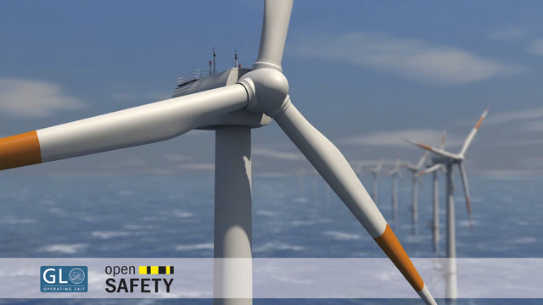

关于贝加莱
贝加莱是一家总部位于奥地利并在全球拥有分公司的创新型自动化企业。2017年7月，贝加莱成为ABB集团的机械自动化事业部。作为工业自动化领域的全球领导者，贝加莱将前沿技术与领先工程相结合，为几乎每个行业的客户提供面向机器与工厂自动化、运动控制、HMI和集成安全技术的完整解决方案。借助于OPC UA、POWERLINK、openSAFETY等工业物联网通信标准，以及强大的Automation Studio软件开发平台，贝加莱不断重新定义自动化工程的未来。受简化流程和超出客户预期的承诺驱动，贝加莱始终保持创新精神并处于工业自动化领域的前沿。
获取更多信息，请访问www.br-automation.com。

