B&R hosts OMAC Committee Meetings to develop universal packaging standards
Members of the OMAC Packaging Working Group’s PackML and PackSpec committees met December 4-5 at B&R Industrial Automation’s facility in Atlanta with the combined objectives to make PackML easier to implement and benefit from, and to develop a universal controls specification for packaging machinery based on OMAC Packaging Guidelines.
“Access to the universal specification alone, featuring best practices from world class companies, will be enough to justify the cost of OMAC corporate membership for packagers, integrators and machinery providers regardless of their revenue, industry and geographic footprint”, noted John Kowal, an OMAC and PMMI board member observing the workshops. Simplified PackML adds the benefit of making productivity-enhancing practices such as OEE more accessible to small and mid-market companies, while it will accelerate adoption and scale-up across Global 2000 enterprises. Of course, current OMAC members will gain the most, both the opportunity for input and first mover advantage.
Based on initial experiences using the PackML standard, the committees clarified and simplified ISA TR88.00.02 language and identified the most often used PackTags to let developers and users achieve the fastest returns on investment. The group’s intent is to present the changes for ratification at the annual OMAC meeting, held in conjunction with the ARC Automation Forum February 11-14, 2013 in Orlando, Florida. PackSpec harmonized its specification document with the PackML revisions, to beta test the specification with an end user and OEM, and to develop a test protocol. A future goal is to develop a software compliance tool for PackML.
Together, the teams outlined a five year plan to present to OMAC Packaging Workgroup leadership, covering TR88 revisions, education activities, a modular programming template and harmonization with the Weihenstephan protocol. “This was the most effective OMAC meeting I have attended. Having both groups in one meeting place helped facilitate cross functional activities and enabled us to get our goals accomplished”, commented Marc Wolf PackSpec Group Member and B&R Business Development Manager.
Committee workshop participants included new OMAC corporate members SMC and Patti Engineering, along with representatives from Bosch Rexroth, B&R, GE Intelligent Systems, Invensys, Lenze, Nestlé, Nestlé Purina, Omron, PepsiCo, Procter & Gamble, Rockwell Automation, Sidel and Siemens.

About B&R
B&R is a privately owned company with headquarters in Austria and offices all around the world. As a global leader in industrial automation, B&R combines state-of-the-art technology with advanced engineering to provide customers in virtually every industry with complete solutions for machine and process automation, motion control, HMI and integrated safety technology. With industrial fieldbus communication standards like POWERLINK and openSAFETY as well as the powerful Automation Studio software development environment, B&R is constantly redefining the future of automation engineering. The innovative spirit that keeps B&R at the forefront of industrial automation is driven by a commitment to simplifying processes and exceeding customer expectations.
For more information, visit www.br-automation.com
When reprinting this press release, please send a copy to:
B&R Industrial Automation Corp.
Attn: Yvonne Eich
1250 Northmeadow Parkway, S-100
Roswell, GA 30076

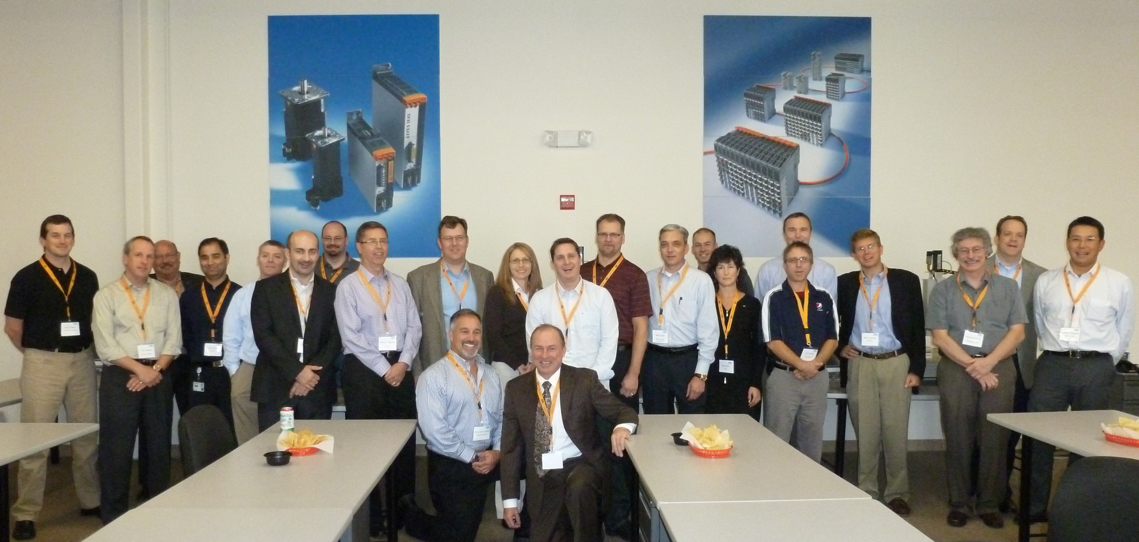
Members of the OMAC Packaging Working Group’s PackML and PackSpec committees met December 4-5 at B&R Industrial Automation’s facility in Atlanta with the combined objectives to make PackML easier to implement and benefit from, and to develop a universal controls specification for packaging machinery based on OMAC Packaging Guidelines.

About B&R
B&R, a division of ABB Group, is a global leader in industrial automation headquartered in Austria. B&R combines state-of-the-art technology with advanced engineering to provide customers in virtually every industry with complete solutions for machine and factory automation, motion control, HMI and integrated safety technology. With Industrial IoT communication standards including OPC UA, POWERLINK and openSAFETY as well as its Automation Studio software, B&R is constantly redefining the future of automation engineering. The innovative spirit that keeps B&R at the forefront of industrial automation is driven by a commitment to simplifying processes and exceeding customer expectations.
For more information, visit www.br-automation.com.

