B&R hosts OMAC Committee Meetings to develop universal packaging standards
Members of the OMAC Packaging Working Group’s PackML and PackSpec committees met December 4-5 at B&R Industrial Automation’s facility in Atlanta with the combined objectives to make PackML easier to implement and benefit from, and to develop a universal controls specification for packaging machinery based on OMAC Packaging Guidelines.
“Access to the universal specification alone, featuring best practices from world class companies, will be enough to justify the cost of OMAC corporate membership for packagers, integrators and machinery providers regardless of their revenue, industry and geographic footprint”, noted John Kowal, an OMAC and PMMI board member observing the workshops. Simplified PackML adds the benefit of making productivity-enhancing practices such as OEE more accessible to small and mid-market companies, while it will accelerate adoption and scale-up across Global 2000 enterprises. Of course, current OMAC members will gain the most, both the opportunity for input and first mover advantage.
Based on initial experiences using the PackML standard, the committees clarified and simplified ISA TR88.00.02 language and identified the most often used PackTags to let developers and users achieve the fastest returns on investment. The group’s intent is to present the changes for ratification at the annual OMAC meeting, held in conjunction with the ARC Automation Forum February 11-14, 2013 in Orlando, Florida. PackSpec harmonized its specification document with the PackML revisions, to beta test the specification with an end user and OEM, and to develop a test protocol. A future goal is to develop a software compliance tool for PackML.
Together, the teams outlined a five year plan to present to OMAC Packaging Workgroup leadership, covering TR88 revisions, education activities, a modular programming template and harmonization with the Weihenstephan protocol. “This was the most effective OMAC meeting I have attended. Having both groups in one meeting place helped facilitate cross functional activities and enabled us to get our goals accomplished”, commented Marc Wolf PackSpec Group Member and B&R Business Development Manager.
Committee workshop participants included new OMAC corporate members SMC and Patti Engineering, along with representatives from Bosch Rexroth, B&R, GE Intelligent Systems, Invensys, Lenze, Nestlé, Nestlé Purina, Omron, PepsiCo, Procter & Gamble, Rockwell Automation, Sidel and Siemens.

关于贝加莱
贝加莱是一家私有化公司，总部位于奥地利，并在世界各地设有办事处。作为工业自动化领域的全球领导者，贝加莱结合先进的工程技术经验，为广泛的行业客户提供机械与过程自动化，运动控制，HMI和集成安全技术的完整解决方案。凭借工业现场总线通信标准POWERLINK和openSAFETY以及强大的Automation Studio软件开发环境，贝加莱正在不断地重新定义未来的自动化工程。受简化流程并超越客户预期承诺驱使的创新精神确保贝加莱始终处于工业自动化前沿。
更多信息，请访问www.br-automation.com
在重印本新闻稿时，请发送副本至：
B&R Industrial Automation Corp.
Attn: Yvonne Eich
1250 Northmeadow Parkway, S-100
Roswell, GA 30076

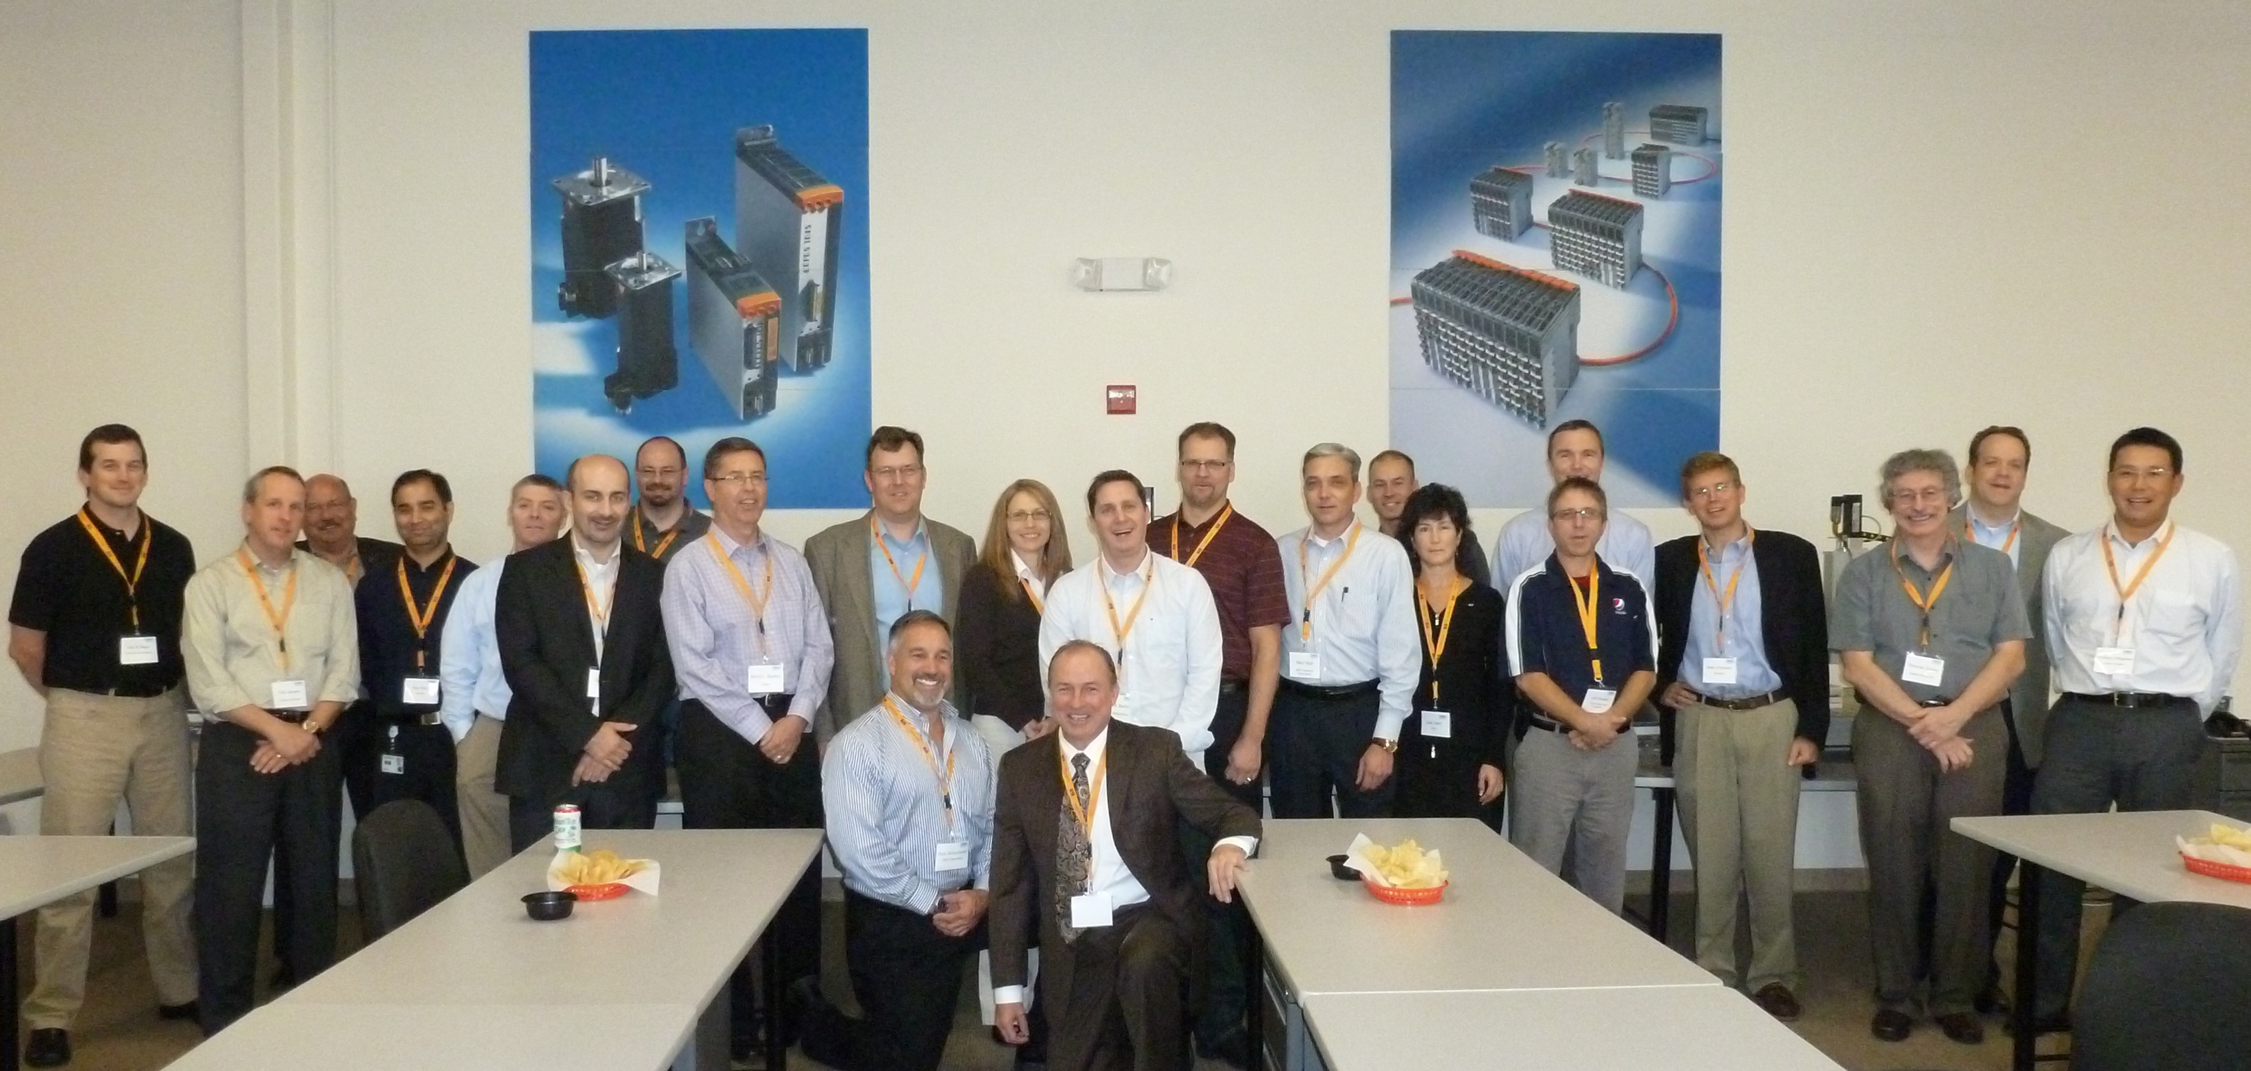
Members of the OMAC Packaging Working Group’s PackML and PackSpec committees met December 4-5 at B&R Industrial Automation’s facility in Atlanta with the combined objectives to make PackML easier to implement and benefit from, and to develop a universal controls specification for packaging machinery based on OMAC Packaging Guidelines.

关于贝加莱
贝加莱是一家总部位于奥地利并在全球拥有分公司的创新型自动化企业。2017年7月，贝加莱成为ABB集团的机械自动化事业部。作为工业自动化领域的全球领导者，贝加莱将前沿技术与领先工程相结合，为几乎每个行业的客户提供面向机器与工厂自动化、运动控制、HMI和集成安全技术的完整解决方案。借助于OPC UA、POWERLINK、openSAFETY等工业物联网通信标准，以及强大的Automation Studio软件开发平台，贝加莱不断重新定义自动化工程的未来。受简化流程和超出客户预期的承诺驱动，贝加莱始终保持创新精神并处于工业自动化领域的前沿。
获取更多信息，请访问www.br-automation.com。

