Efficient integration of development tools

Perfect interaction: Automation Studio 4 and EPLAN Electric P8
Efficient integration of Version 4 of B&R's Automation Studio engineering tool and EPLAN Electric P8 is now a reality. These two tools provide unparalleled support for the automated exchange and synchronization of hardware configurations, I/O mappings and process variables. This is made possible by an automated round-trip engineering feature. With an interface very different from conventional import/export interfaces, users are able to intervene in the process at any time – this is, however, something that is not often necessary.
Maximum transparency and ease of use
All types of development processes are supported. It makes no difference if a project is started with software development or electrical planning. It is even possible to handle projects in which extensive work is done in both of these disciplines at the same time, as is often the case with an efficient approach to project development. An intelligent comparison mechanism gives users a clear overview of differences between project versions at any time in addition to providing guidance when merging different project versions together. For projects large or small, the tight integration between Automation Studio and EPLAN Electric P8 offers maximum transparency and ease of use.
The key to successful development
Integrating various tools in the development process brings a wide range of benefits. In addition, working on different processes in parallel reduces development times and improves response times. Automated data manipulation increases quality by doing away with errors that can occur when making changes manually. The constant synchronization of project data makes subsequent service work easier, and reduces costs later on down the road. For B&R, it couldn't be clearer: The key to the successful development of future machine and system manufacturing projects lies in the efficient integration of the best development tools available.

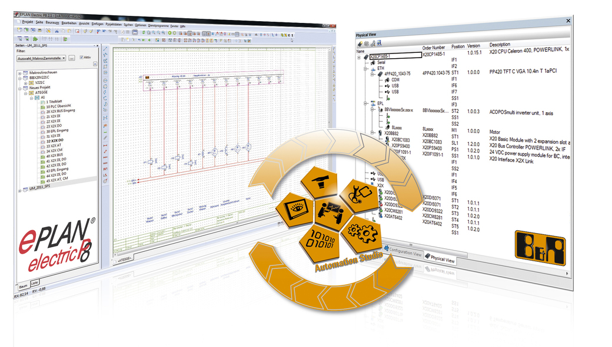
Round-trip-engineering: During the engineering process, users benefit from the efficient exchange of data between Automation Studio 4 and EPLAN Electric 8.

B&R Hakkında
ABB Grubunun bir bölümü olan B&R, merkezi Avusturya'da bulunan endüstriyel otomasyon alanında global bir liderdir. B&R, neredeyse her sektördeki müşterilere makine ve fabrika otomasyonu, hareket kontrolü, HMI ve entegre güvenlik teknolojisi için eksiksiz çözümler sunmak üzere en son teknolojiyi ileri mühendislikle birleştiriyor. OPC UA, POWERLINK ve openSAFETY gibi Endüstriyel IoT iletişim standartlarının yanı sıra Automation Studio yazılımıyla B&R, otomasyon mühendisliğinin geleceğini sürekli olarak yeniden tanımlıyor. B&R'ı endüstriyel otomasyonun ön saflarında tutan yenilikçi ruh, süreçleri basitleştirme ve müşteri beklentilerini aşma taahhüdünden kaynaklanmaktadır.
Daha fazla bilgi için www.br-automation.com adresini ziyaret edin.

