Efficient integration of development tools

Perfect interaction: Automation Studio 4 and EPLAN Electric P8
Efficient integration of Version 4 of B&R's Automation Studio engineering tool and EPLAN Electric P8 is now a reality. These two tools provide unparalleled support for the automated exchange and synchronization of hardware configurations, I/O mappings and process variables. This is made possible by an automated round-trip engineering feature. With an interface very different from conventional import/export interfaces, users are able to intervene in the process at any time – this is, however, something that is not often necessary.
Maximum transparency and ease of use
All types of development processes are supported. It makes no difference if a project is started with software development or electrical planning. It is even possible to handle projects in which extensive work is done in both of these disciplines at the same time, as is often the case with an efficient approach to project development. An intelligent comparison mechanism gives users a clear overview of differences between project versions at any time in addition to providing guidance when merging different project versions together. For projects large or small, the tight integration between Automation Studio and EPLAN Electric P8 offers maximum transparency and ease of use.
The key to successful development
Integrating various tools in the development process brings a wide range of benefits. In addition, working on different processes in parallel reduces development times and improves response times. Automated data manipulation increases quality by doing away with errors that can occur when making changes manually. The constant synchronization of project data makes subsequent service work easier, and reduces costs later on down the road. For B&R, it couldn't be clearer: The key to the successful development of future machine and system manufacturing projects lies in the efficient integration of the best development tools available.

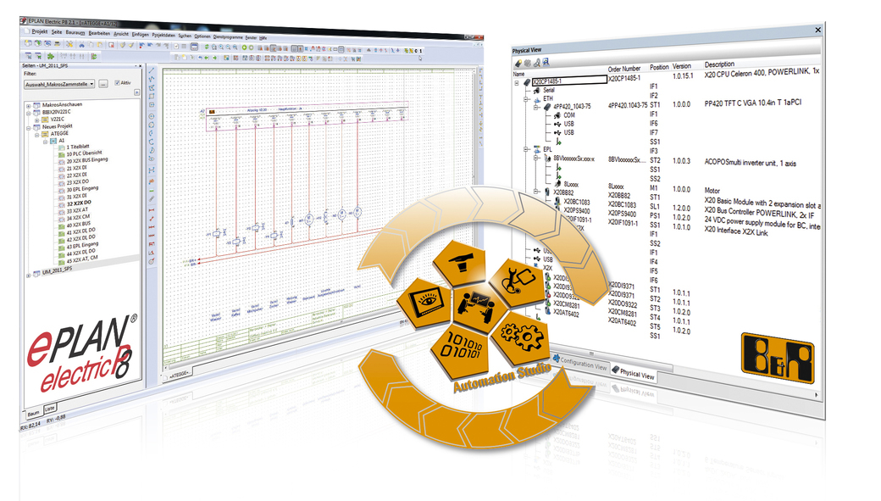
Round-trip-engineering: During the engineering process, users benefit from the efficient exchange of data between Automation Studio 4 and EPLAN Electric 8.

关于贝加莱
贝加莱是一家总部位于奥地利并在全球拥有分公司的创新型自动化企业。2017年7月，贝加莱成为ABB集团的机械自动化事业部。作为工业自动化领域的全球领导者，贝加莱将前沿技术与领先工程相结合，为几乎每个行业的客户提供面向机器与工厂自动化、运动控制、HMI和集成安全技术的完整解决方案。借助于OPC UA、POWERLINK、openSAFETY等工业物联网通信标准，以及强大的Automation Studio软件开发平台，贝加莱不断重新定义自动化工程的未来。受简化流程和超出客户预期的承诺驱动，贝加莱始终保持创新精神并处于工业自动化领域的前沿。
获取更多信息，请访问www.br-automation.com。

