B&R User Meeting - March 12-13, 2013 in Salzburg
- Agenda – User Meeting 2013
- Workshops
- Guest speakers
Experience automation highlights firsthand
At the 2013 B&R User Meeting, which is taking place March 12-13 in Salzburg, participants will once again have the chance to experience the latest highlights in industrial automation firsthand. Ad-free product information straight from the various development departments, application reports from users and the possibility to speak with both customers using B&R technology as well as experts from various industries – these are the aspects that give the B&R User Meeting its special flair.
For representatives from industrial automation and process control
During this two-day event, B&R will be offering an informative program for those interested in technical information related to machine and system manufacturing – from small machine controllers to complex process control systems. Specialists from B&R, industry experts and B&R customers will be on hand to discuss the following topics: Optimizing the engineering workflow, increasing overall efficiency using simulation, the advantages of integrated safety technology, the latest communication standards for automation industries and potential benefits of condition and energy monitoring.
In response to overwhelming requests, discussions with industry experts will be offered in groups at the User Meeting 2013 in addition to the main program. This mix of panel discussions and workgroups will be complemented by several practical tasks.
Firsthand product information
The User Meeting is also a great chance for participants to speak with industry experts during breaks. It's a perfect opportunity to check out B&R's wide range of hardware and software tools firsthand.
Participants will once again be invited to tour B&R headquarters in Eggelsberg, which is set to include a few new surprises this year.

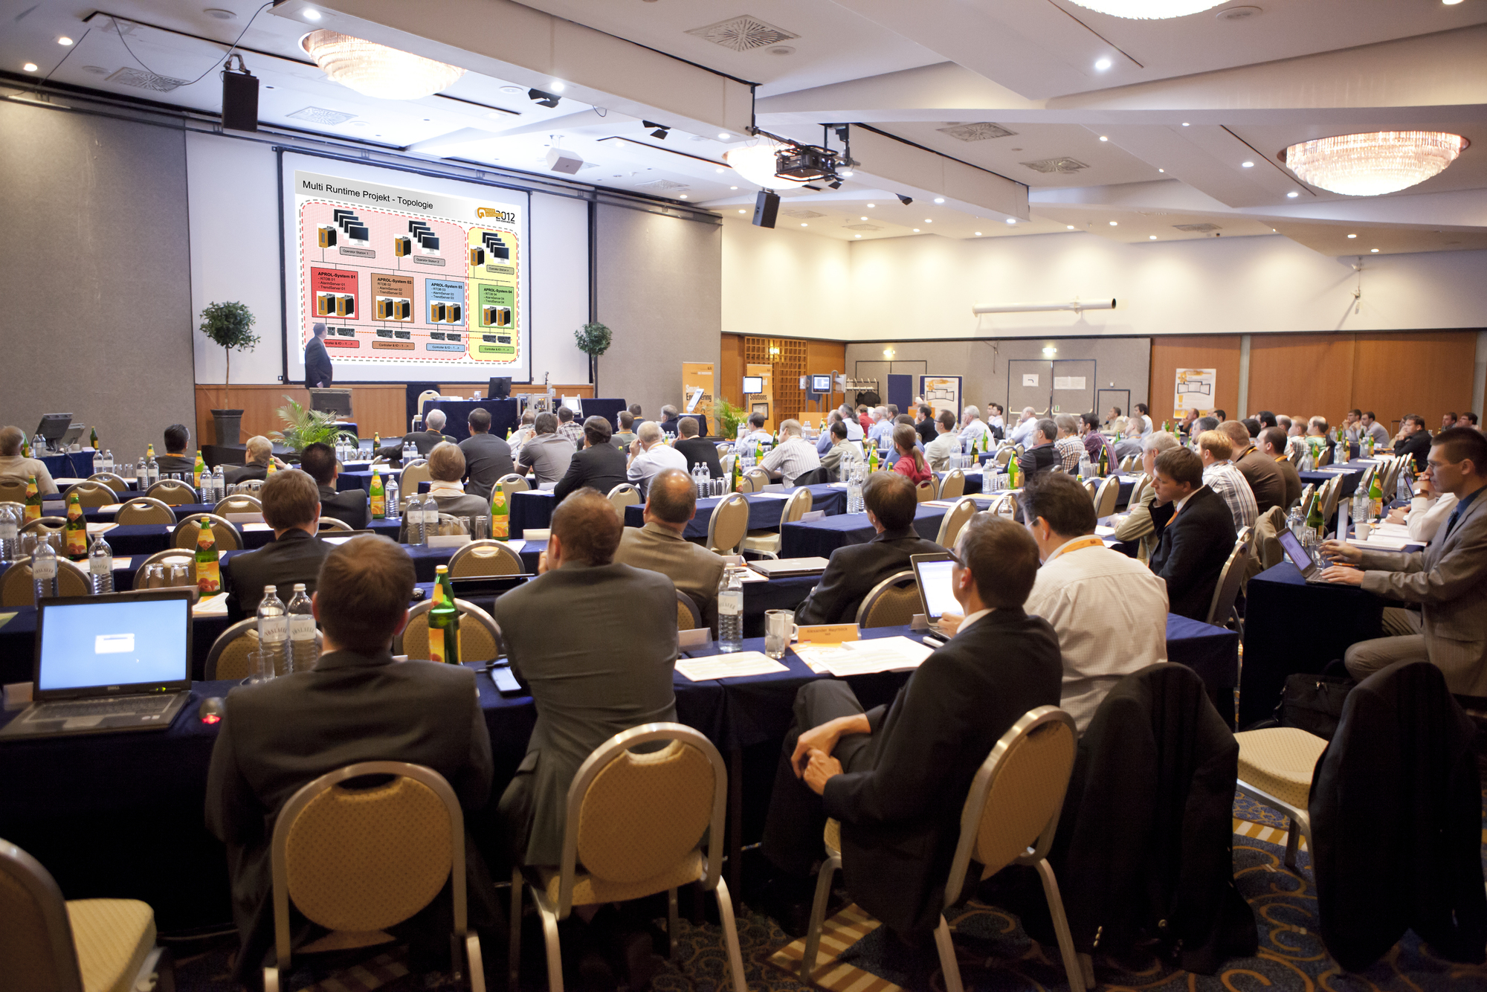
The B&R User Meeting offers an informative program for anyone interested in technical information related to machine and system manufacturing.

About B&R
B&R, a division of ABB Group, is a global leader in industrial automation headquartered in Austria. B&R combines state-of-the-art technology with advanced engineering to provide customers in virtually every industry with complete solutions for machine and factory automation, motion control, HMI and integrated safety technology. With Industrial IoT communication standards including OPC UA, POWERLINK and openSAFETY as well as its Automation Studio software, B&R is constantly redefining the future of automation engineering. The innovative spirit that keeps B&R at the forefront of industrial automation is driven by a commitment to simplifying processes and exceeding customer expectations.
For more information, visit www.br-automation.com.

