Conozca las novedades en automatización de primera mano
B&R User Meeting del 12 al 21 de mayo de 2014, en Salzburgo
At the 2013 B&R User Meeting, which is taking place March 12-13 in Salzburg, participants will once again have the chance to experience the latest highlights in industrial automation firsthand. Ad-free product information straight from the various development departments, application reports from users and the possibility to speak with both customers using B&R technology as well as experts from various industries – these are the aspects that give the B&R User Meeting its special flair.
For anyone interested in automation and process control systems
During this two-day event, B&R will be offering an informative program for those interested in technical information related to machine and system manufacturing – from small machine controllers to complex process control systems. B&R speakers, B&R customers and other well-known industry experts will be on-hand to talk about current trends in industrial automation, such as: Optimizing the engineering workflow, increasing overall efficiency using simulation, the advantages of integrated safety technology, the latest communication standards for automation industries and potential benefits of condition and energy monitoring.
In response to overwhelming requests, discussions with industry experts will be offered in groups at the User Meeting 2013 in addition to the main program. This mix of panel discussions and workgroups will be complemented by several practical tasks.
Firsthand product information
The User Meeting is also a great chance for participants to speak with industry experts during breaks. You can also check out B&R's wide range of hardware and software tools live and in action.
Participants will once again be invited to tour B&R headquarters in Eggelsberg, which is set to include a few new surprises this year.

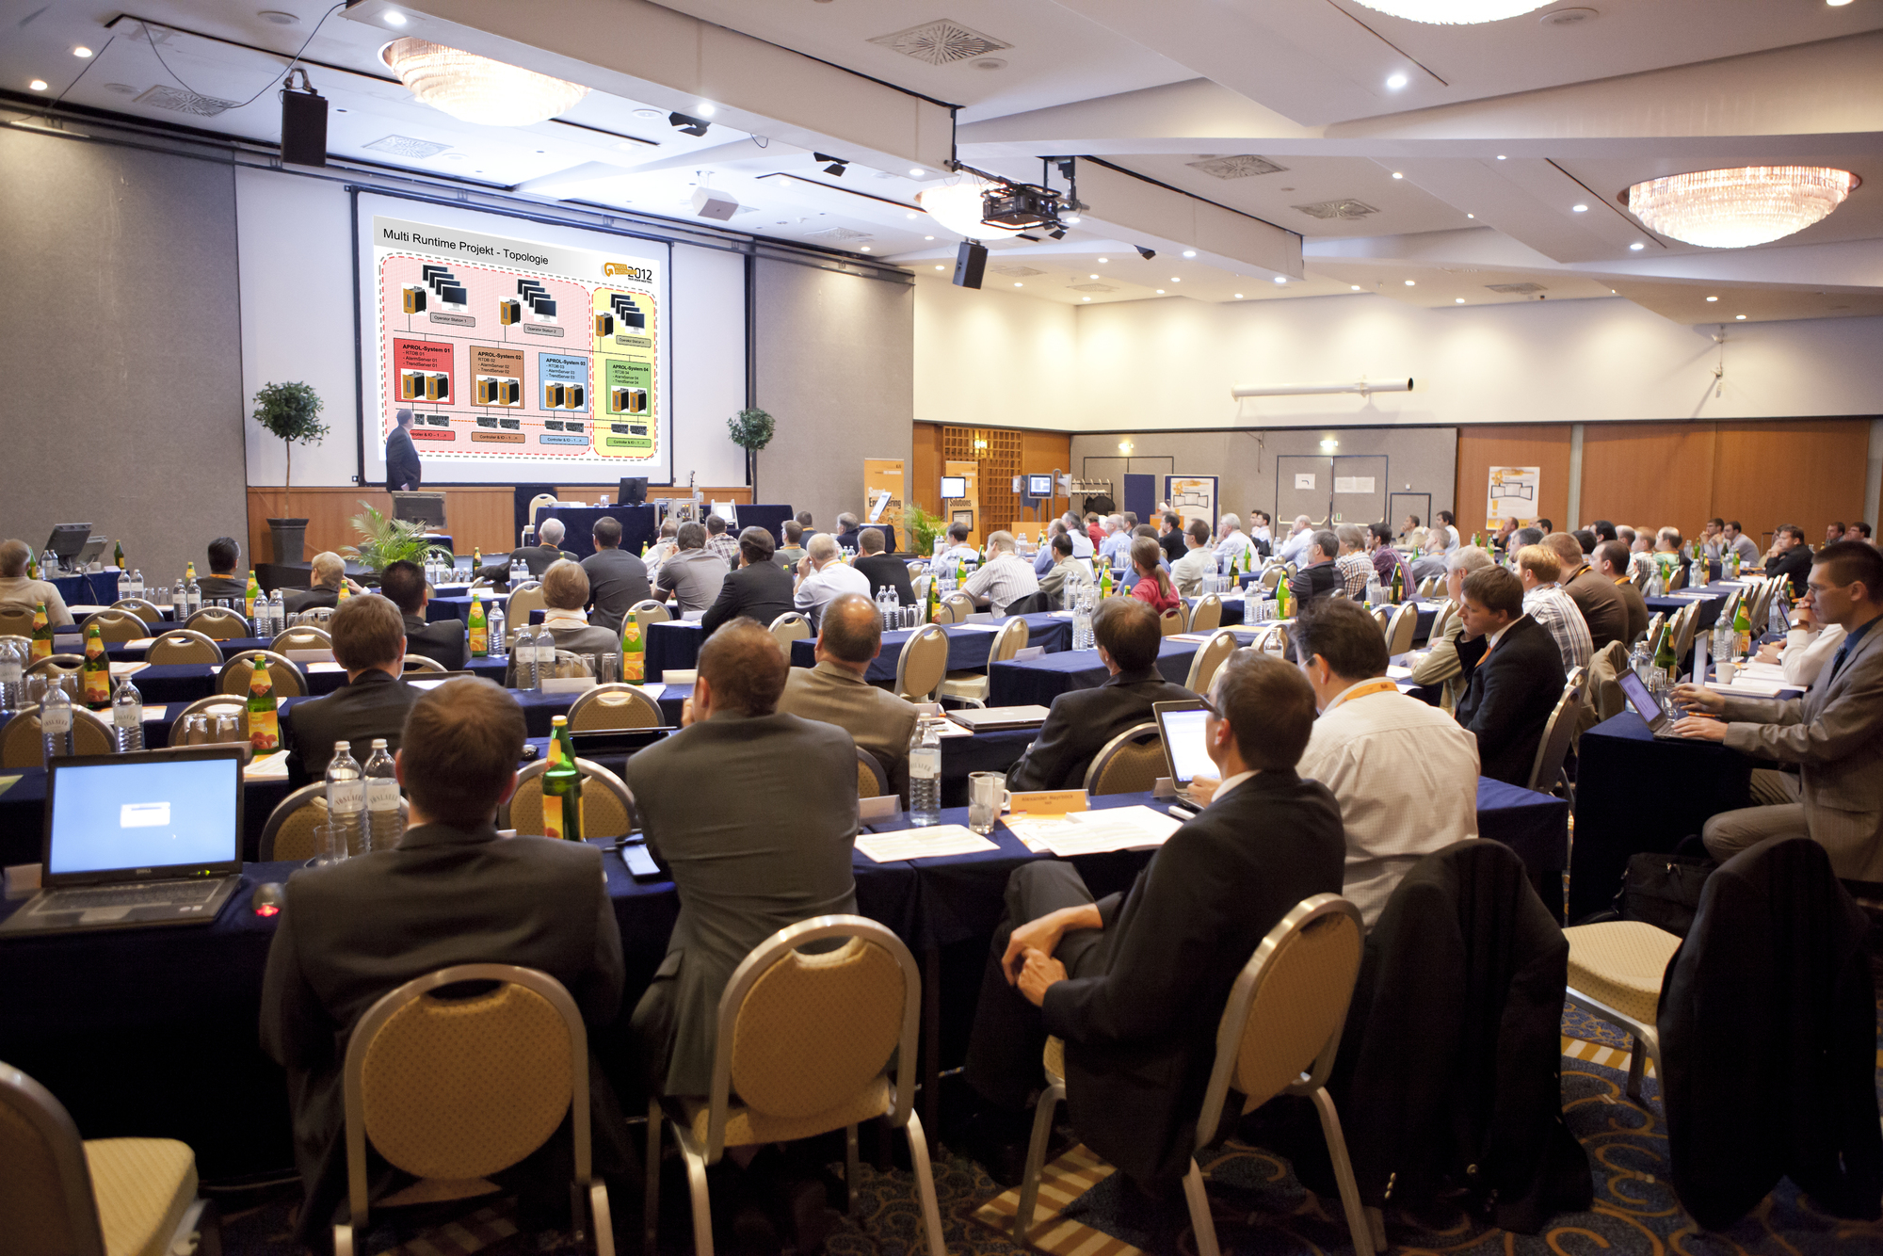
The B&R User Meeting offers an informative program for anyone interested in technical information related to machine and system manufacturing.

Acerca de B&R
B&R, empresa perteneciente al Grupo ABB y con sede en Austria, es líder mundial en automatización industrial. B&R combina tecnología de vanguardia con ingeniería avanzada para proporcionar a usuarios de todos los sectores soluciones completas para la automatización de máquinas y fábricas, Motion Control, HMI y tecnología de seguridad integrada. El catálogo de productos se completa con estándares de comunicación de IoT industrial que incluyen OPC UA, POWERLINK y openSAFETY. Gracias a su única herramienta de software Automation Studio, B&R redefine constantemente el futuro de la ingeniería de automatización. El espíritu innovador que mantiene a B&R a la vanguardia de la automatización industrial está impulsado por el compromiso de simplificar los procesos y superar las expectativas de los clientes.Para más información, visite www.br-automation.com.
Para más información, visite www.br-automation.com.

